The Summit, Fitzroy Park N6 6HS

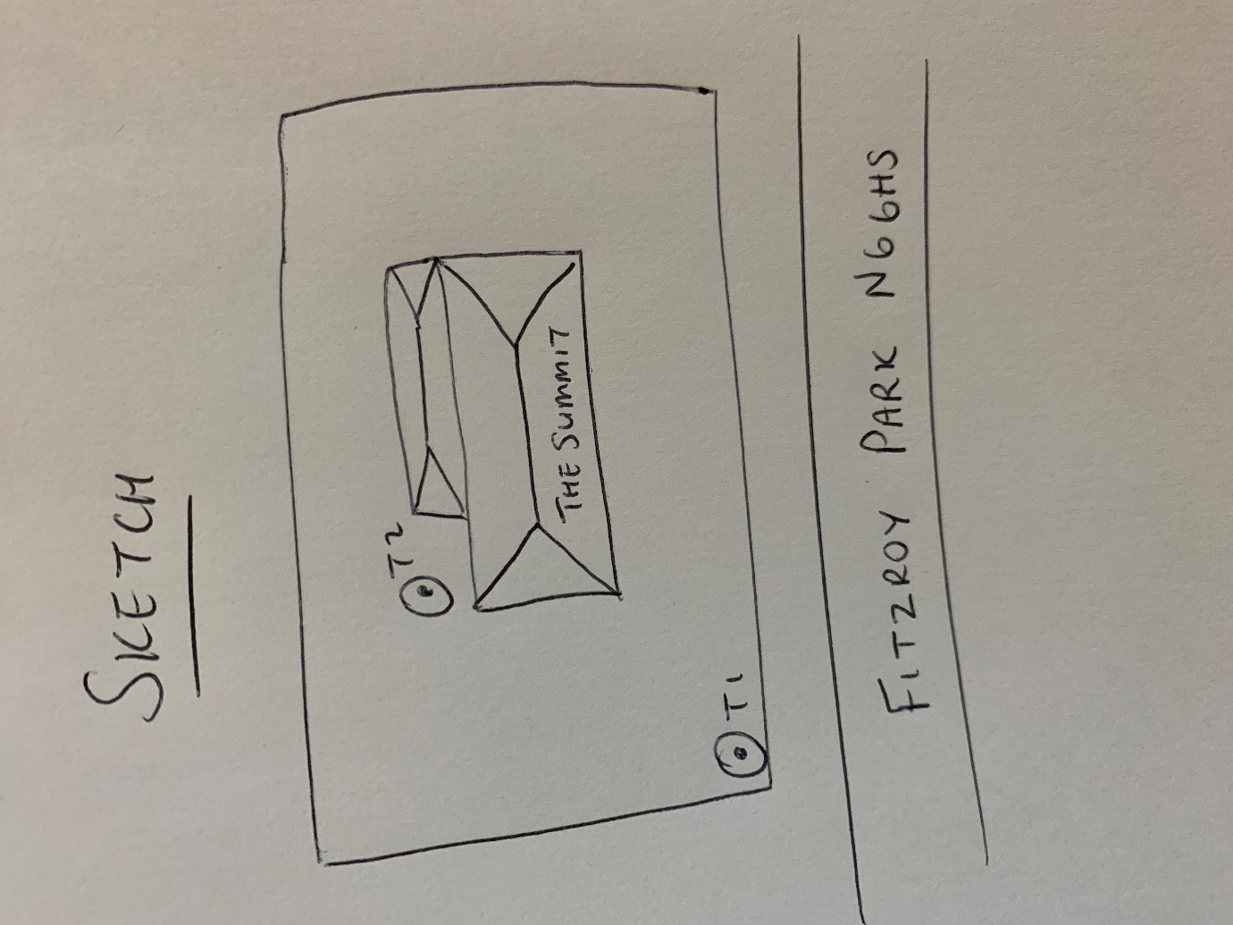

T1: Indian bean (12m): Pollard to 50% of present height to leave height of approximately 6m, the tree is in decline and is at risk of dropping limbs unless weight is reduced

T2: Apple (9m): Pollard to 1m below previous points removing up to 3m of growth, tree has decay on main trunk at base to 1m and on limbs throughout the crown including a large wound on the north stem at around 2m. Reducing weight of the crown will reduce risk of limb failure

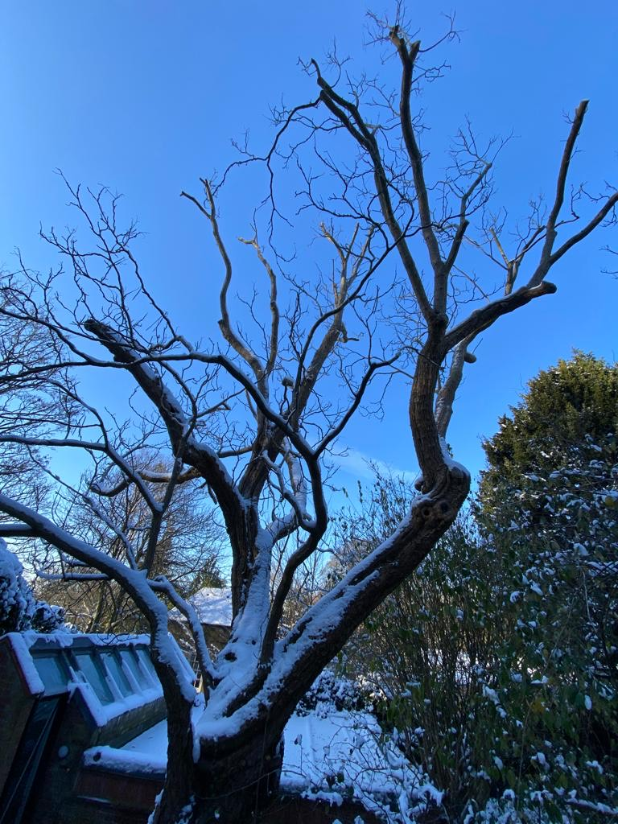 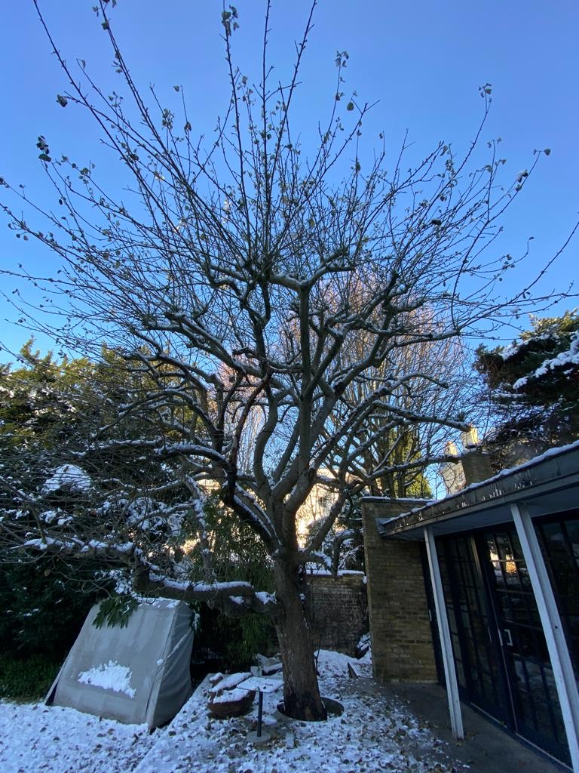

T1: Indian bean T2: Apple

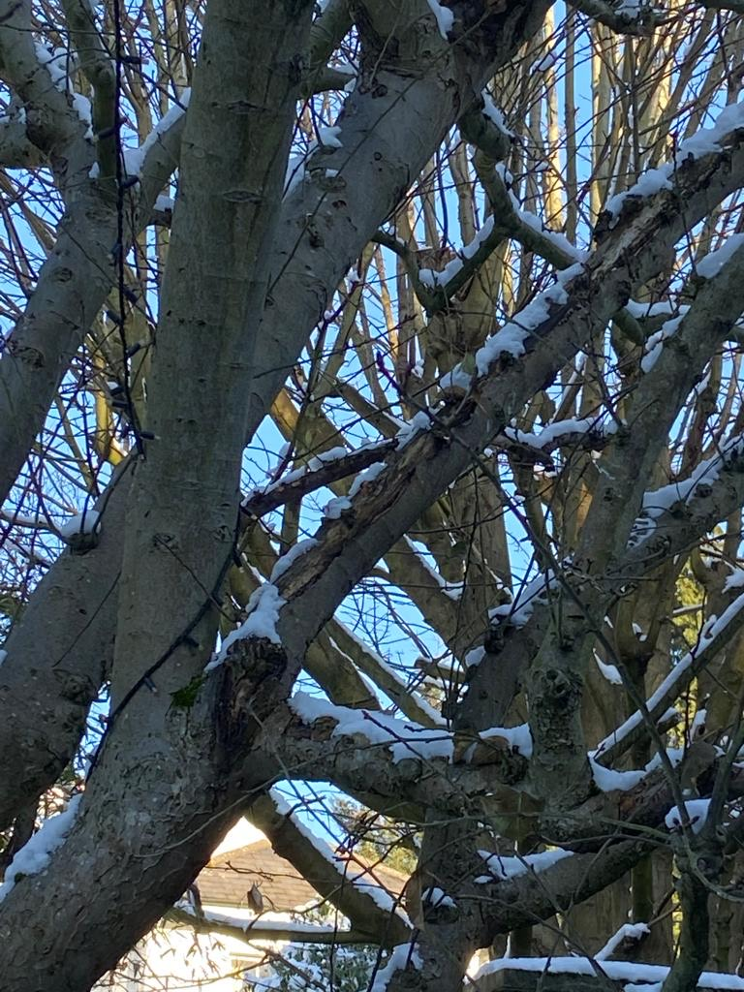 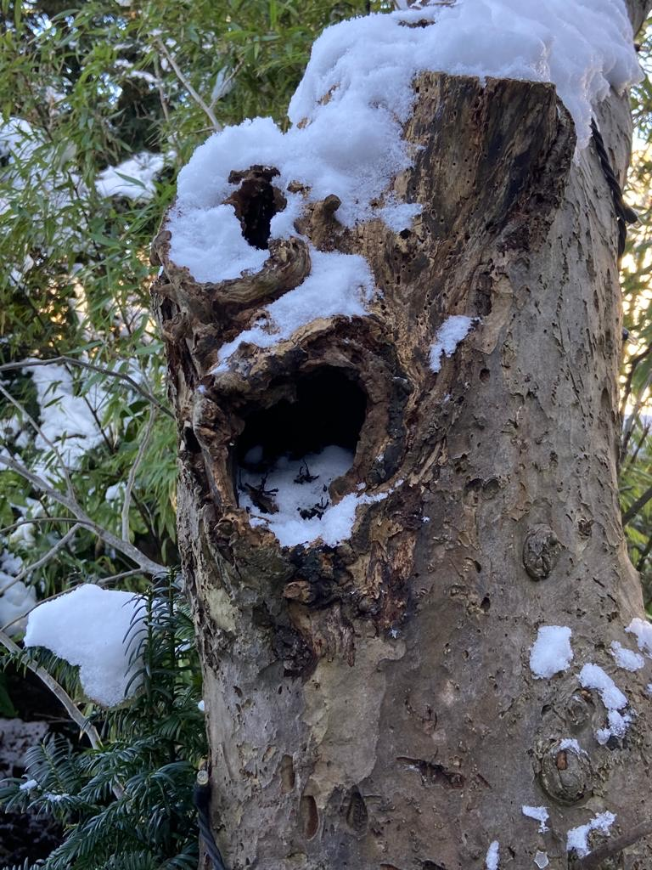

T2: Apple - decay T2: Apple - decay