9 Montpelier Grove NW5 2XD

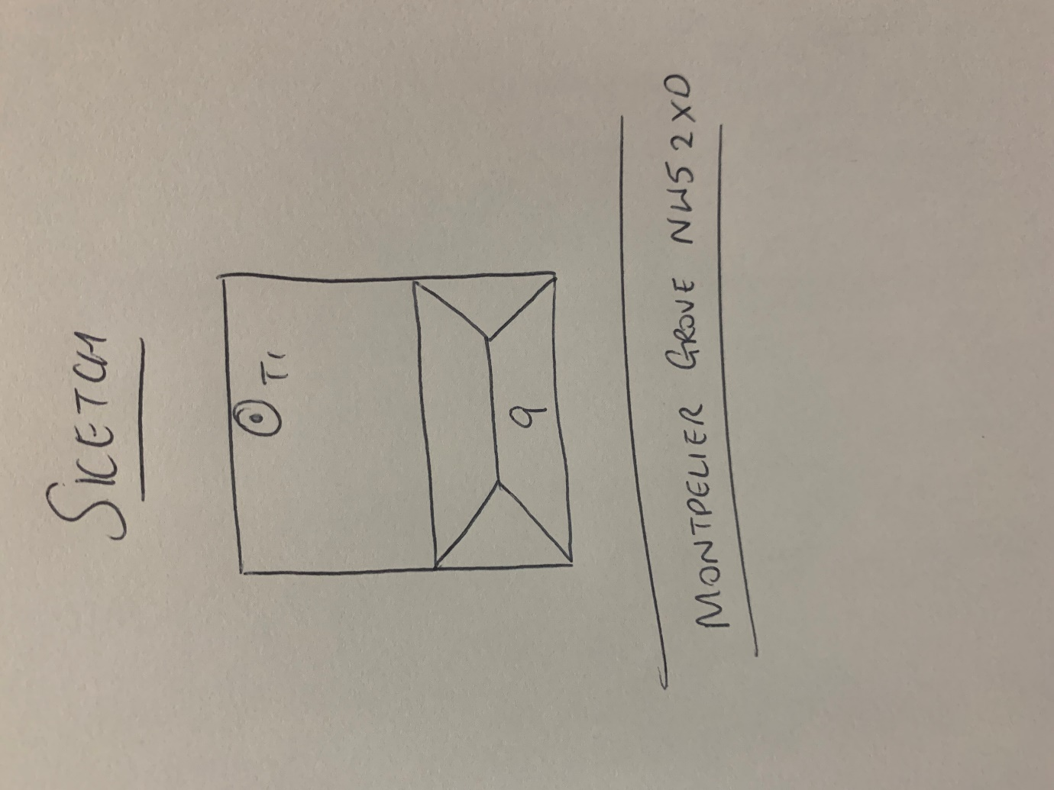

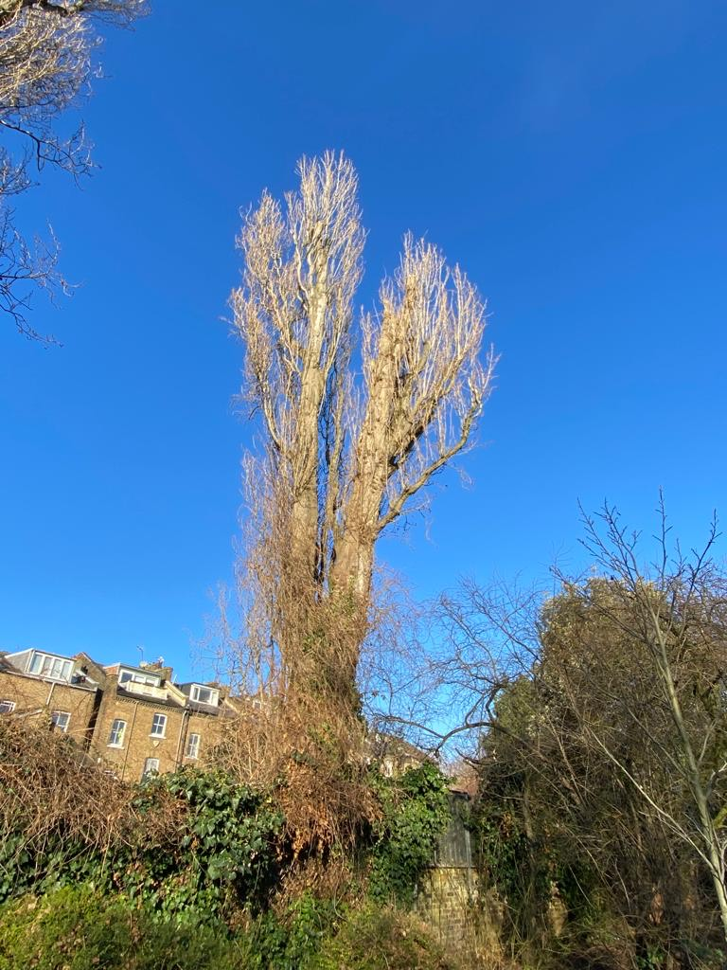

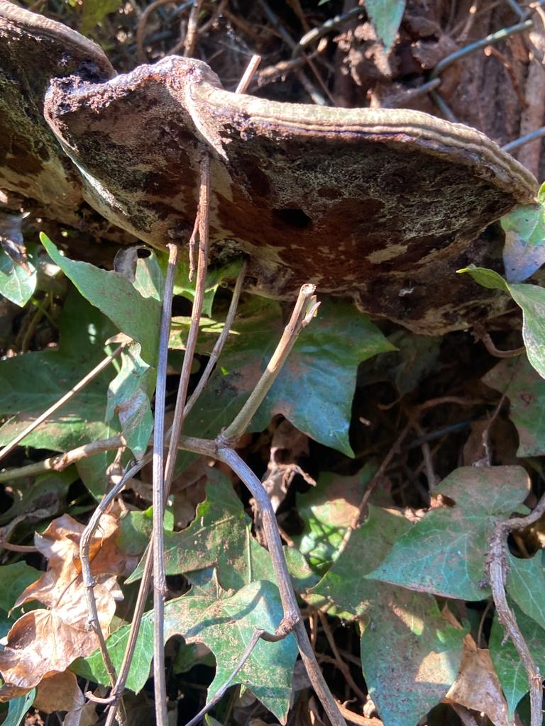 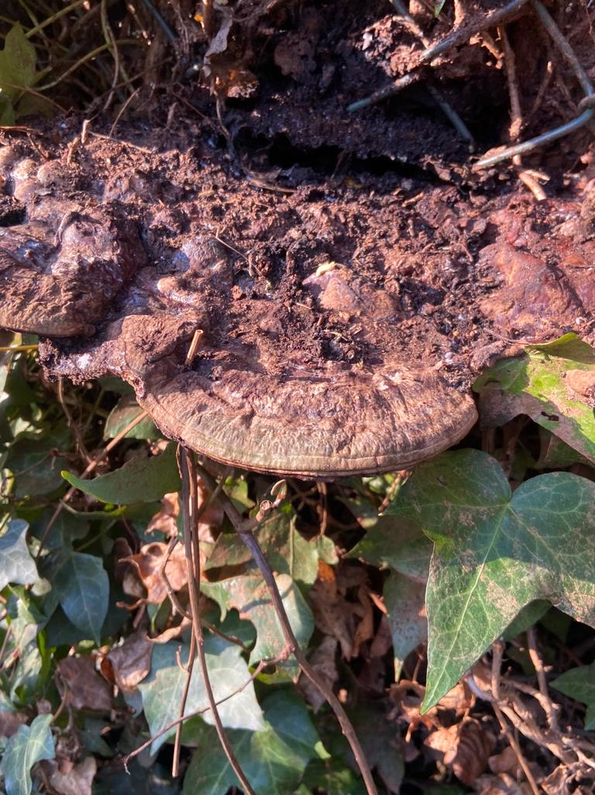

T1: Poplar (15m): Reduce decayed stem by 6m and reduce remaining stem by 4m. Tree has decay on main stem and fungal brackets at the base.