1 Lawford Road NW5 2LH

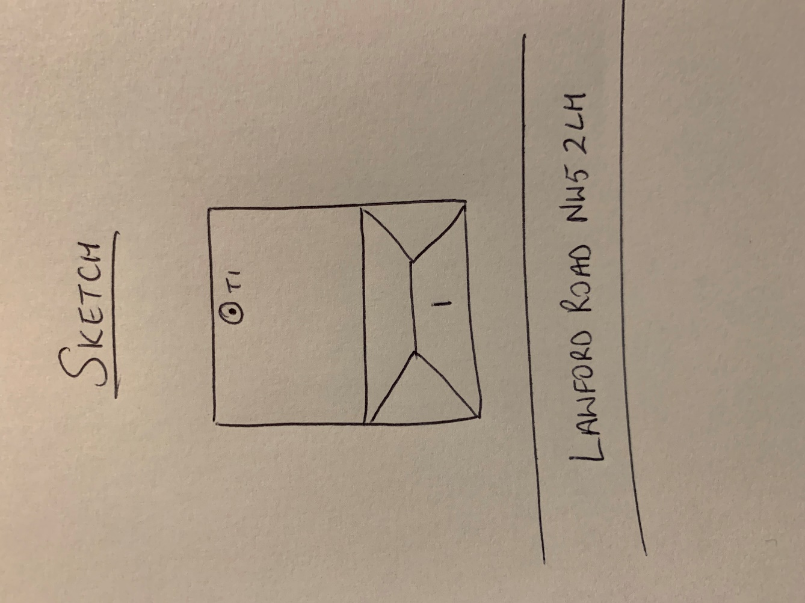

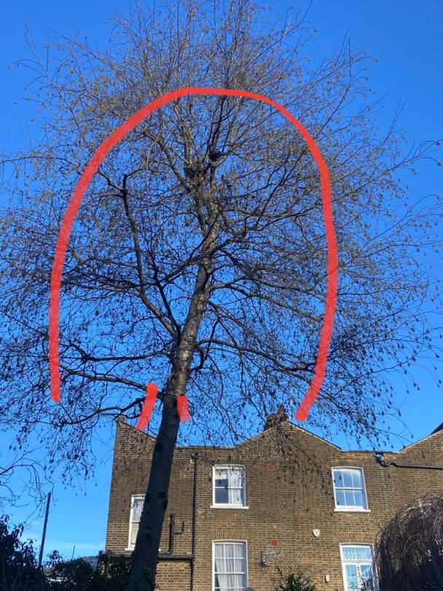

T1: Alder (12m): Crown reduce by 3m to previous pruning points and remove 3 branches as shown to raise canopy as part of regular maintenance and to allow more light into the garden