129 King Henry’s Road NW3 3RB

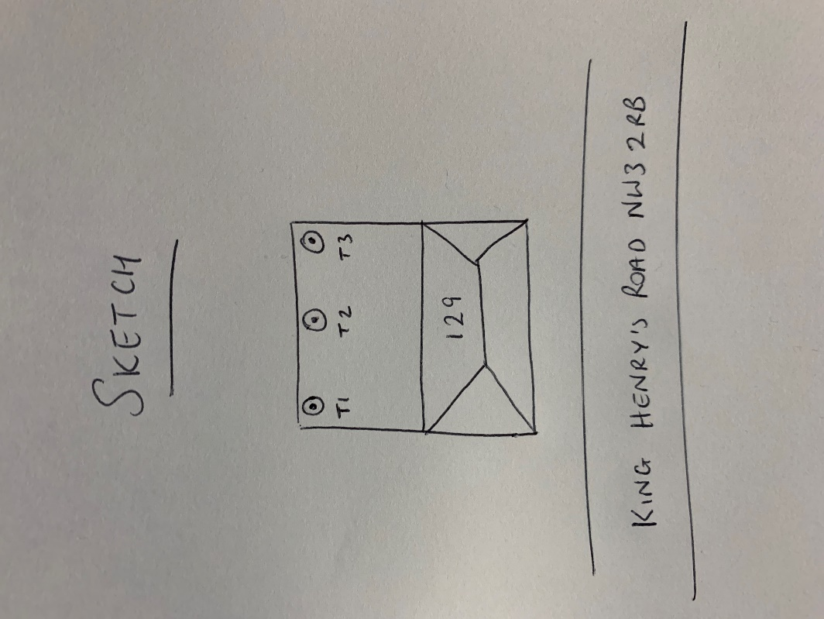

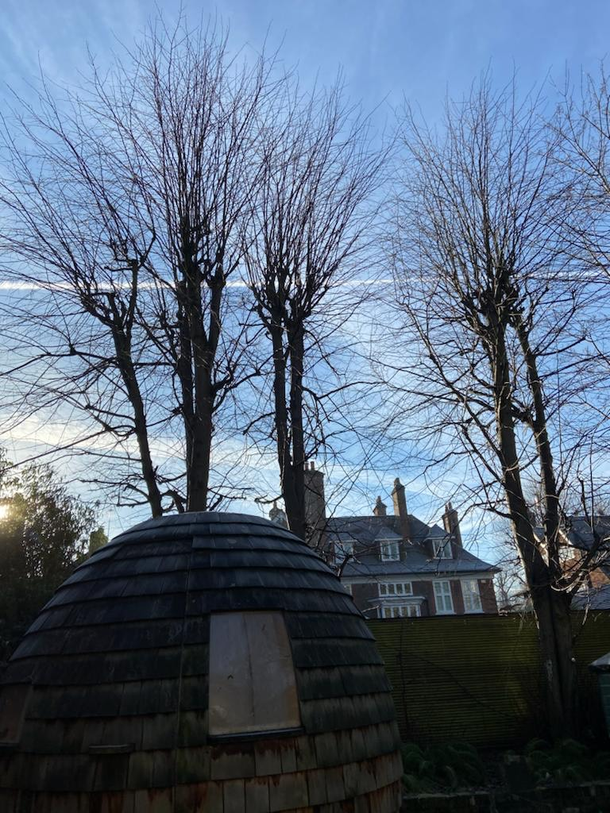

T1: Lime (14m): Re-pollard to previous points removing up to 4m of regrowth as part of regular maintenance

T2: Lime (14m): Re-pollard to previous points removing up to 4m of regrowth as part of regular maintenance

T3: Lime (14m): Re-pollard to previous points removing up to 4m of regrowth as part of regular maintenance