48 Avenue Road NW8 6HS

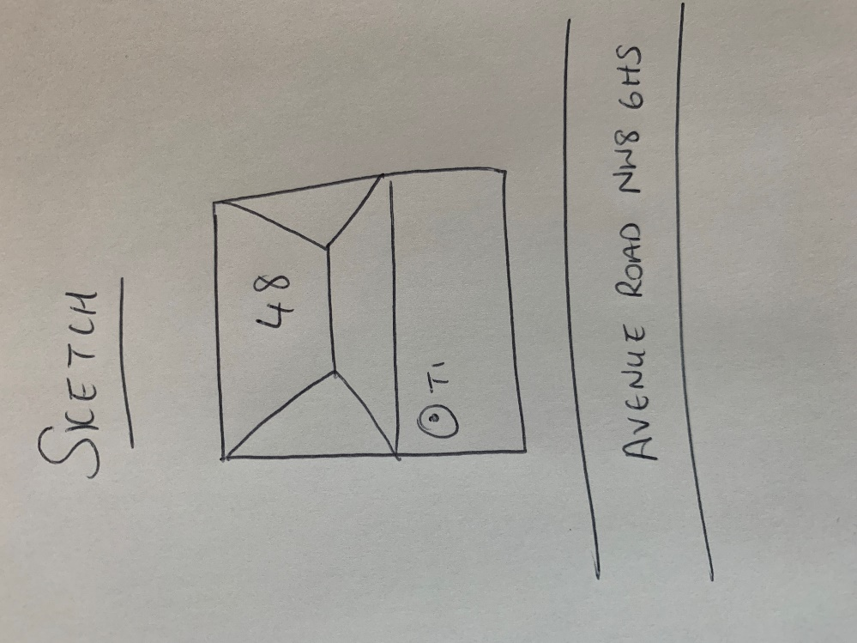

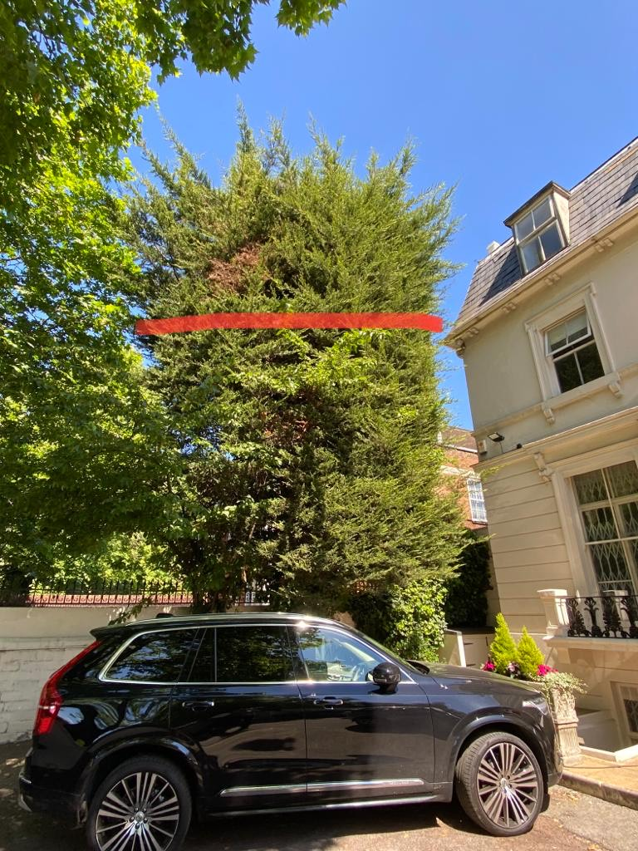

T1: Cypress (16m): Reduce height by 1/3 (approximately to height of gutter on house), trim sides over garden and neighbouring property and remove 2 lowest branches on side of 48 to keep tree at a size suitable for its location