arts lettres techniques ARCHITECT

# St Pancras Alms Houses

# *Design and Access Statement*

November 2022

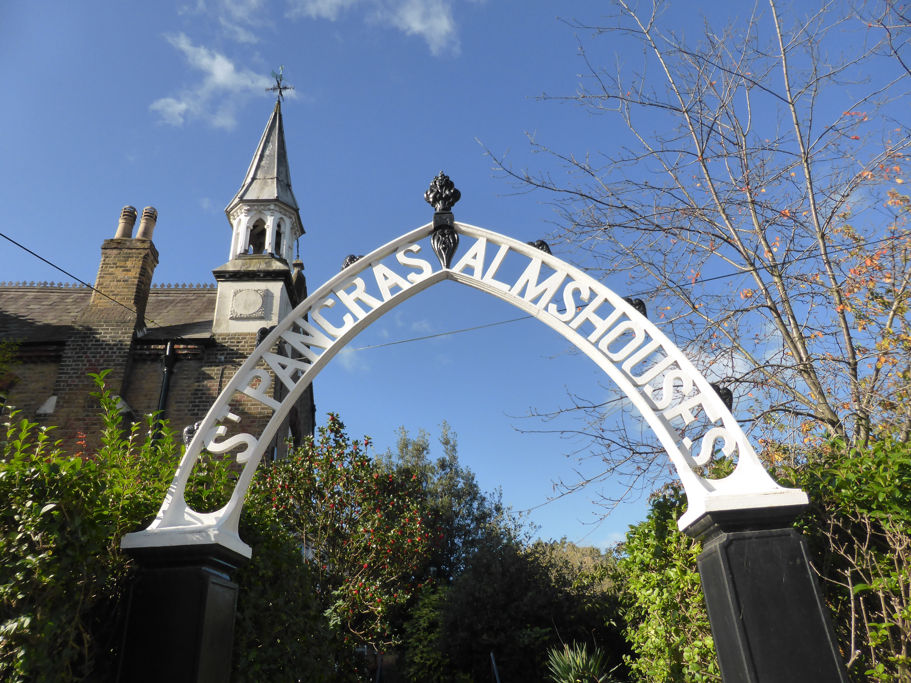

This supporting statement forms part of a Planning/Listed Building Application and is accompanied

by the following documents:

**Heritage Impact Assessment**

**Existing situation:**

SPA 200 Location plan 1:1250.pdf

SPA 201 Site Plan 1:200 A2.pdf

SPA 202 Roof Plan 1:200 A2.pdf

SPA 203 North Range Ground Floor Plan 1:100 A2.pdf

SPA 204 North Range First Floor Plan 1:100 A2.pdf

SPA 205 North Range Front and Rear Elevations 1:100 A2.pdf

SPA 206 West Range Ground Floor Plan 1:100 A2.pdf

SPA 207 West Range First Floor Plan 1:100 A2.pdf

SPA 208 West Range Front and Rear Elevations 1:100 A2.pdf

SPA 209 South Range Ground Floor Plan 1:100 A2.pdf

SPA 210 South Range First Floor Plan 1:100 A2.pdf

SPA 211 South Range Front and Rear Elevations 1:100 A2.pdf

SPA 212 Guest Accommodation Plan 1:50 A3.pdf

SPA 213 Guest Accommodation Section AA 1:50 A3.pdf

SPA 214 Guest Accommodation Side Elevation 1:50 A3.pdf

SPA 215 Guest Accommodation Rear Elevation 1:50 A3.pdf

SPA 216 Hall Plan 1:50 A3.pdf

SPA 217 Hall Section AA 1:50 A3.pdf

SPA 218 Hall Section BB 1:50 A3.pdf

SPA 219 Hall Elevation South 1:50 A3.pdf

SPA 220 Hall Elevation West 1:50 A3.pdf

**Drawings of proposed works:**

SPA 301 Site Plan 1:200 A2.pdf

SPA 302 Roof Plan 1:200 A2.pdf

SPA 303 North Range Ground Floor Plan 1:100 A2.pdf

SPA 304 North Range First Floor Plan 1:100 A2.pdf

SPA 305 North Range Front and Rear Elevations 1:100 A2.pdf

SPA 306 West Range Ground Floor Plan 1:100 A2.pdf

SPA 307 West Range First Floor Plan 1:100 A2.pdf

SPA 308 West Range Front and Rear Elevations 1:100 A2.pdf

SPA 309 South Range Ground Floor Plan 1:100 A2.pdf

SPA 310 South Range First Floor Plan 1:100 A2.pdf

SPA 311 South Range Front and Rear Elevations 1:100 A2.pdf

SPA 312 Guest Accommodation Plan 1:50 A3.pdf

SPA 313 Guest Accommodation Section AA 1:50 A3.pdf

SPA 314 Guest Accommodation Side Elevation 1:50 A3.pdf

SPA 315 Guest Accommodation Rear Elevation 1:50 A3.pdf

SPA 316 Hall Plan 1:50 A3.pdf

SPA 317 Hall Section AA 1:50 A3.pdf

SPA 318 Hall Section BB 1:50 A3.pdf

SPA 319 Hall Elevation South 1:50 A3.pdf

SPA 320 Hall Elevation West 1:50 A3.pdf

SPA 321 Details Proposed 1:10 A1.pdf

SPA 322 Hall Details Proposed 1:10 A1.pdf

arts lettres techniques ARCHITECT

###### St Pancras Alms Houses

CONTENTS

Page

1. **Introduction**

Site description

1. **Design and Access Statement**

Public spaces and use

Energy economics

Energy Strategy

1. **Conclusions**
2. **Appendix**

G.R Edwardes Ltd Energy assessment/proposal