38 Gaisford Street NW5 2ED

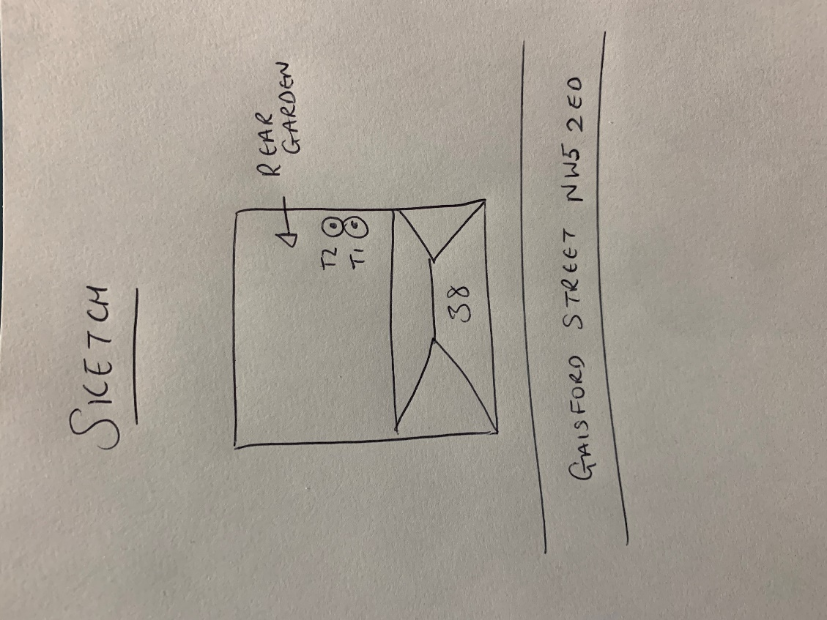

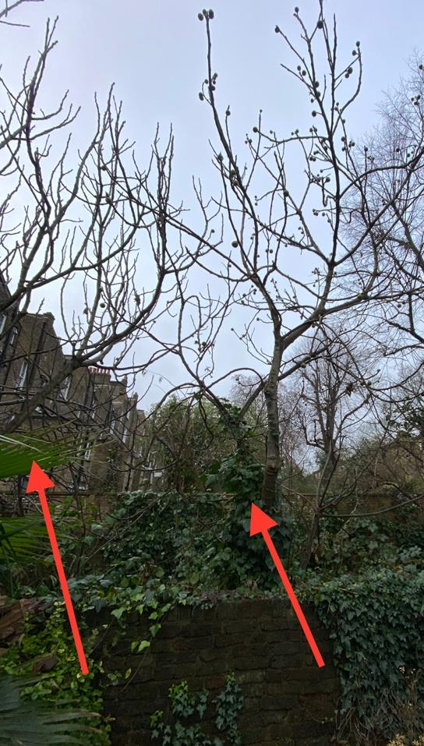

T1: Fig (6m): Pollard to 50% of current height to keep tree at a size suitable for its location and as part of regular maintenance

T2: Fig (6m): Pollard to 50% of current height to keep tree at a size suitable for its location and as part of regular maintenance