SUPPLEMENTARY INFORMATION
- Site Details

Site Name: | Church Studios | Site Address: | Church Studios  Camden Park Road  Islington  London  NW1 9AR
National Grid Reference: | E: 529816 N: 184780
Site Ref Number: | Cornerstone 13678928 | Site Type: | Macro

- Pre Application Check List

Site Selection

Was a local planning authority mast register available to check for suitable sites by the operator or the local planning authority? |  | No
If no explain why:

After a phone call to the LPA it was established the council do not hold this information.

Were industry site databases checked for suitable sites by the operator: | Yes
If no explain why:

Site Specific Pre-application consultation with local planning authority

Was there pre-application contact: | Yes
Date of pre-application contact: | 21/11/2022
Name of contact: | The Director of Planning
Summary of outcome/Main issues raised:

Prior to the submission of this application the applicant-initiated pre-consultation discussions with the local planning authority. This provides an opportunity for the LPA to discuss development proposals and identify site specific issues.

Strategic level pre-rollout meetings are held with the LPA to discuss the necessities of the project, benefits and best practice going forward.

Annual area wide information to planning authority

Has annual area wide information been provided? | No
If no explain why: | See below
Summary issues raised:

“Cornerstones commercial relationship with VMo2 has changed, effectively increasing our independence to work with other companies in the deployment of mobile infrastructure. It means we no longer have visibility of VMo2 full update plan. However, Cornerstone is fully committed to working closely with Local Planning Authorities and following best practice guidance.

We aim to engage and work with the planning department at the earliest opportunity from when we are instructed to deliver new infrastructure within your Local Authority area and often conduct strategic pre-rollout engagement meetings to discuss our wider rollout. If your Local Authority would like a meeting to discuss wider Cornerstone rollout plans then please advise. We recognise the importance of developing long term partnerships and will always work with you to deliver improved mobile connectivity.

Community Consultation

Rating of Site under Traffic Light Model: |  | Amber
Outline of consultation carried out:

Prior to the submission of this application the applicant initiate pre-consultation discussions with the local planning authority. This provides an opportunity for the LPA to discuss development proposals and identify site specific issues.

No comments were received in respect to the consultation submitted at the time of submission.

Further consultation with the local Ward Councillors for Camden Square Ward (Councillors Sagal Abdi-Wali and Danny Beales) and Keir Starmer MP

Summary of outcome/main issues raised:

No site-specific responses had been received at the time of submission.

School/College

Location of site in relation to school/college:

The Bridge School and Brecknock Primary School are in relatively close proximity to the site.

Outline of consultation carried out with school/college:

The Bridge School and Brecknock Primary School Have been notified prior to submission.

Summary of outcome/main issues raised (include copies of main correspondence):

There has been no response from the School at the time of submission.

Civil Aviation Authority/Secretary of State for Defence/Aerodrome
Operator consultation

Will the structure be within 3km of an aerodrome or airfield? |  | No
Has the Civil Aviation Authority/Secretary of State for Defence/Aerodrome Operator been notified? |  | No
Details of response:

N/A

Developer’s Notice

Copy of Developer’s Notice enclosed? |  | Yes
Date served: | 08/12/2022

- Proposed Development

The proposed site:
The proposed development consists of an upgrade to the existing rooftop telecommunications equipment installation at Church Studios, Camden Park Road, Islington, London, NW1 9AR.

There are no other viable alternative options other than to upgrade the existing installation. Discounted options were put forward and assessed at the original planning application stage and this was deemed to be the most appropriate location.

The applicant appreciates that the site is within the Camden Square Conservation Area (Article 2(3) land) however, the alternative options to meet the required demand for wireless connectivity would result in structures that would harm the Conservation Area. The location and design of the proposed installation has been carefully selected to preserve and enhance the Camden Square Conservation Area by providing significantly enhanced coverage and capacity to this busy area of Camden. The design is considered to be the least intrusive of all options, the optimum solution from a planning and radio perspective has been proposed. Any other proposal to satisfy the identified requirement would result in the addition of a separate ground based column elsewhere in close proximity to the existing structure. In our opinion, such a proposal would, in this instance, unnecessarily add to the clutter in the street scene and result in a greater visual impact.

Central Government attaches great importance to the design of the built environment and outlines this within Section 12 (para. 126) of the 2021 National Planning Policy Framework. It states:

“Good design is a key aspect of sustainable development, creates better places in which to live and work and helps make development acceptable to communities.”

In keeping with the 2021 National Planning Policy Framework (NPPF). guidelines of using: “high quality communications” (Section 10), the proposed design has been selected to minimise visual impact by integrating with the existing built environment. Although it is accepted that there will be an increase in the number of antennas, it is felt that such a minor increase would not detract from the character of the area in which the proposal sits.

The existing site can be seen below in Figures 1 – 3, the site is located on Camden Park Road. The presence of the existing telecommunications equipment sets a clear precedent and indicates that the principle of this proposal is acceptable in terms of siting.

As previously stated the proposed site is an established telecommunication installation. This submission is purely to upgrade this existing telecoms installation with new equipment to facilitate 5G coverage.

Figure 1
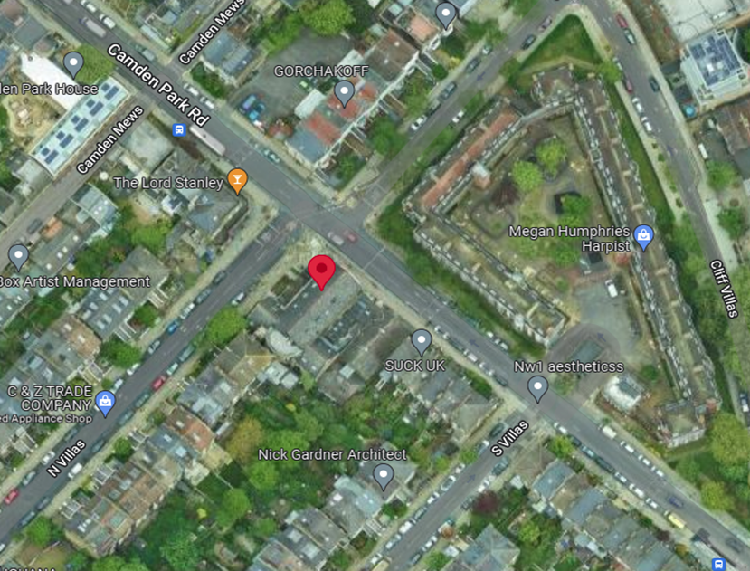

Figure 2
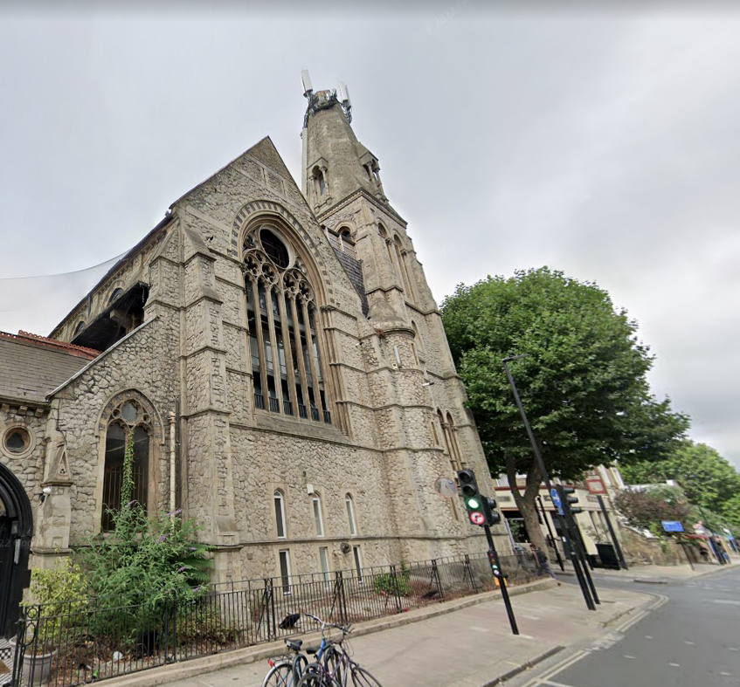

Figure 3
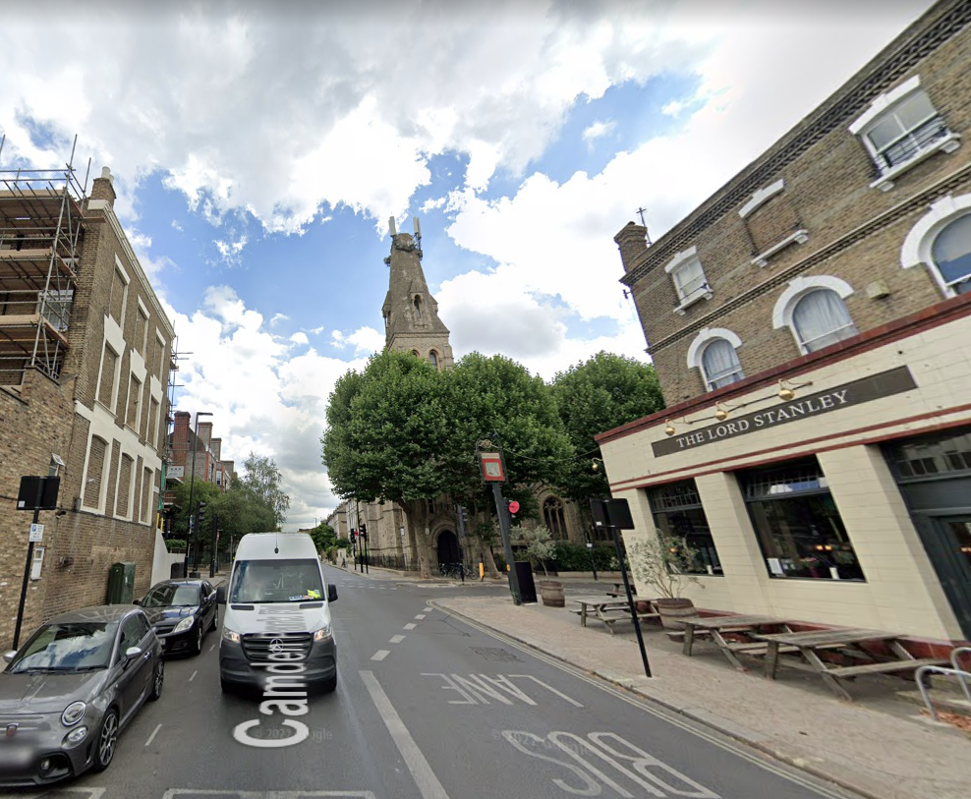

Site Ref: | 13678928 | Site Address: | Church Studios, Camden Park Road, London, NW1 9AR

Local Planning Authority: LB Camden Council

Development Plan: Camden Local Plan (2017)

Fig.1: LP Plan Extract (Reference Only):

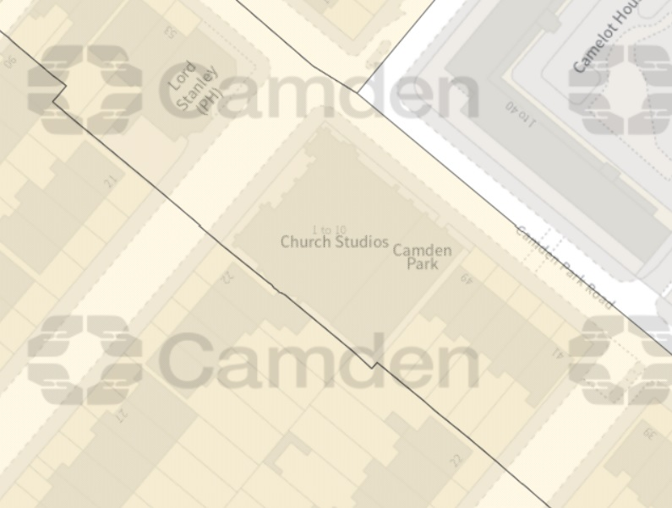

Site and its surrounds

Policy Relevant to the Development Site:

The site is designated as being within the settlement boundary, with urban uses to the north, east, south, and west. The site is in the Camden Square Conservation Area. The site designation is a material consideration.

This is an existing telecommunications site.

The LB Camden Council does not have a specific telecoms policy, although para. 5.10 of the Local Plan is relevant. This, together with the NPPF is of relevance. The National Planning Policy section of this supporting statement goes into detailed analysis of why this site is in compliance with the NPPF.

Policy Analysis:

Para. 5.10 reads:

“Digital infrastructure

5.10 The Council recognises the importance of digital infrastructure in enterprise
development and expects electronic communication networks, including
telecommunications and high-speed broadband, to be provided in business
premises.”

Policy D2 reads:

“Heritage

The Council will preserve and, where appropriate, enhance Camden’s rich and diverse heritage assets and their settings, including conservation areas, listed buildings, archaeological remains, scheduled ancient monuments and historic parks and gardens and locally listed heritage assets.

Designated heritage assets

Designed heritage assets include conservation areas and listed buildings.

The Council will not permit the loss of or substantial harm to a designated heritage asset, including conservation areas and Listed Buildings, unless it can be demonstrated that the substantial harm or loss is necessary to achieve substantial public benefits that outweigh that harm or loss, or all of the following apply:

a. the nature of the heritage asset prevents all reasonable uses of the site;
b. no viable use of the heritage asset itself can be found in the medium term through appropriate marketing that will enable its conservation;
c. conservation by grant-funding or some form of charitable or public ownership is demonstrably not possible; and
d. the harm or loss is outweighed by the benefit of bringing the site back into use.

The Council will not permit development that results in harm that is less than substantial to the significance of a designated heritage asset unless the public benefits of the proposal convincingly outweigh that harm.

Conservation areas

Conservation areas are designated heritage assets and this section should be read in conjunction with the section above headed ‘designated heritage assets’. In order to maintain the character of Camden’s conservation areas, the Council will take account of conservation area statements, appraisals and management strategies when assessing applications within conservation areas.

The Council will:

e. require that development within conservation areas preserves or, where possible, enhances the character or appearance of the area;
f. resist the total or substantial demolition of an unlisted building that makes a positive contribution to the character or appearance of a conservation area;
g. resist development outside of a conservation area that causes harm to the character or appearance of that conservation area; and
h. preserve trees and garden spaces which contribute to the character and appearance of a conservation area or which provide a setting for Camden’s architectural heritage.”

The proposed development at this existing site is required to deliver the requisite level of electronic communication service on a single site that is to be adapted to accommodate multiple users (so enable future site sharing opportunities) yet seeks to minimise its visual impact or change to the character of this location (the site remaining as physically distant from lines of sight from residential uses as possible in this part of the Borough). The form and design of the proposed configuration would not appear out of context in this location (appearing in the comparable context of the existing array), so according with wider Development Plan policy and would ensure the integrity, character and setting of the area is fully maintained.

The public benefits of a greatly enhanced communications network for businesses, residents and visitors alike in this location would qualify as a substantial benefit with near benign change or impact on amenity.

Any harm would qualify as less than substantial, and the public benefits would be considerable, and materially outweigh harm.

The enhanced digital service would very much accord with the objectives of the Development Plan policy.

The proposal fully accords with the requirements of the NPPF

Enclose map showing the cell centre and adjoining cells if appropriate:
This can be emailed to the LPA on request.

Type of Structure:
Description:

Proposed upgrade to the existing rooftop installation. Proposed removal and replacement of 3No. Antennas with 6no. Antennas. Existing Equipment Room to be refreshed internally and associated ancillary works.

Overall Height: +30.0m AGL
Height of existing building: |  | 28.9m AGL
Equipment Housing:
Length: |  | N/A
Width: |  | N/A
Height: |  | N/A
Materials: See Drawings
Tower/mast etc – type of material and external colour: | Grey
Equipment housing – type of material and external colour: | Grey

Reasons for choice of design:
Cornerstone is the UK's leading mobile infrastructure services company. We acquire, manage and own over 20,000 sites and are committed to enabling best in class mobile connectivity for over half of all the country's mobile customers. We oversee works on behalf of telecommunications providers and wherever possible aim to:

• promote shared infrastructure
• maximise opportunities to consolidate the number of base stations
• significantly reduce the environmental impact of network development

As stated above the National Planning Policy Framework advocates site sharing, and as such we believe that there are no sequentially preferable locations within the defined site search area. The proposed facility will provide coverage including 2G/3G/4G services and essential 5G coverage all from the same installation. This is fully in line with national guidance which supports the use of high-quality communications infrastructure and states that local planning authorities should support the expansion of electronic networks.

Health and Safety
International Commission on Non-Ionizing Radiation Protection Declaration attached (see below)

International Commission on Non-Ionizing Radiation Protection public compliance is determined by mathematical calculation and implemented by careful location of antennas, access restrictions and/or barriers and signage as necessary. Members of the public cannot unknowingly enter areas close to the antennas where exposure may exceed the relevant guidelines.

When determining compliance, the emissions from all mobile phone network operators on or near to the site are taken into account.

In order to minimise interference within its own network and with other radio networks, Cornerstone’ operates its network in such a way the radio frequency power outputs are kept to the lowest levels commensurate with effective service provision

As part of Cornerstone’s network, the radio base station that is the subject of this application will be configured to operate in this way.

All operators of radio transmitters are under a legal obligation to operate those transmitters in accordance with the conditions of their licence. Operation of the transmitter in accordance with the conditions of the licence fulfils the legal obligations in respect of interference to other radio systems, other electrical equipment, instrumentation, or air traffic systems. The conditions of the licence are mandated by Ofcom, an agency of national government, who are responsible for the regulation of the civilian radio spectrum. The remit of Ofcom also includes investigation and remedy of any reported significant interference.

The telecommunications infrastructure the subject of this application accords with all relevant legislation and as such will not cause significant and irremediable interference with other electrical equipment, air traffic services or instrumentation operated in the national interest.

- Technical Justification

Customers will inadvertently be aware of this by finding that sometimes they need to go near windows, a higher floor of a building or even outside in order to achieve a stronger signal for their mobile devices.

Tree Clutter

The effects of trees on signal degradation should never be underestimated. Signal absorption and shadowing effects vary according to vegetation and density, and are caused by the main tree trunk, branches and leaves.

Cell sites located in or near trees will have signals significantly reduced. As a result a number of extra sites may need to be built locally in order to counter-effect this.

Signal variation throughout the seasons is also a practical concern. Leaves on trees in the spring and summer can cause shadowing and reduce radio voice quality and increase the number of dropped calls.

As a result the bottom of an antenna should be

a) above the top level of the trees,
b) allow greater height due to the antenna down tilt at build or for future requirements and c) allow some room for future growth of the trees.

In the case where the cell site utilises point-to-point microwave backhaul transmission the microwave dish should not be obscured at all.

Propagation Models

In essence these are mathematical formulae used to characterise radio wave propagation, in order to determine the received signal strength at a receiving device.

The most well-known propagation model used for mobile telecommunications is ‘Okamura-Hata’. More specific studies have been performed to investigate specific clutter and terrain such as dense-urban and urban environments. Resulting from these are propagation models for specific clutter types.

Coverage Planning Tools

Radio planning engineers plan cellular networks using highly sophisticated computer programs that incorporate the above propagation models. Armed with data on cell site location, cell site configuration, maps, terrain etc they are used to predict areas of coverage deficiency (so called ‘coverage holes’), new site requirements and configurations.

Network Changes

Over time the topography and clutter in an area is subject to change. For example, building developments, housing and tree growth can all change. As a consequence, the signals received from local phone masts can degrade, as they are dependent on these factors. These reasons along with customer complaints, network consolidation (mast sharing) and new technologies (5G) require a re-evaluation of a network operator’s telecommunications infrastructure.

Mast sharing can result in some masts no longer being needed. As a result, they are decommissioned and physically removed.

Technical surveys undertaken for reasons above may highlight that antenna height increases are required – this is more likely for sites with low antenna heights around 15m AGL, particularly street furniture sites. More details on these reasons below.

While thus far this document is generic to mobile telephony masts it should be noted that each mast has to be dealt with on a case-by-case basis.

ICNIRP Compliance

The addition of new technologies and mast sharing affects ICNIRP compliance – a higher minimum mast height is required in some cases.

- Site Selection Process

If no alternative site options have been investigated, please explain why:

This is an upgrade to an existing site thus no other standalone new facilities have been investigated. A new additional mast to facilitate the upgrade would not be in line with NPPF. By upgrading the current facility the most sequentially preferable option has been progressed.

Land use planning designations:

Site Ref: | 13678928 | Site Address: | Church Studios, Camden Park Road, London, NW1 9AR

Local Planning Authority: LB Camden Council

Development Plan: Camden Local Plan (2017)

Fig.1: LP Plan Extract (Reference Only):
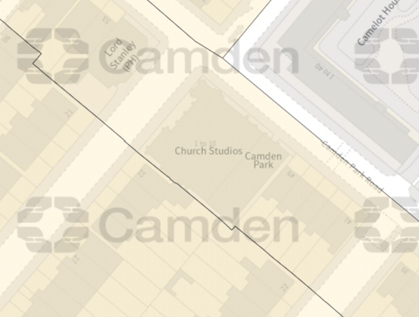

Site and its surrounds

Policy Relevant to the Development Site:

The site is designated as being within the settlement boundary, with urban uses to the north, east, south, and west. The site is in the Camden Square Conservation Area. The site designation is a material consideration.

This is an existing telecommunications site.

The LB Camden Council does not have a specific telecoms policy, although para. 5.10 of the Local Plan is relevant. This, together with the NPPF is of relevance. The National Planning Policy section of this supporting statement goes into detailed analysis of why this site is in compliance with the NPPF.

Policy Analysis:

Para. 5.10 reads:

“Digital infrastructure

5.10 The Council recognises the importance of digital infrastructure in enterprise
development and expects electronic communication networks, including
telecommunications and high-speed broadband, to be provided in business
premises.”
Policy D2 reads:

“Heritage

The Council will preserve and, where appropriate, enhance Camden’s rich and diverse heritage assets and their settings, including conservation areas, listed buildings, archaeological remains, scheduled ancient monuments and historic parks and gardens and locally listed heritage assets.

Designated heritage assets

Designed heritage assets include conservation areas and listed buildings.

The Council will not permit the loss of or substantial harm to a designated heritage asset, including conservation areas and Listed Buildings, unless it can be demonstrated that the substantial harm or loss is necessary to achieve substantial public benefits that outweigh that harm or loss, or all of the following apply:

a. the nature of the heritage asset prevents all reasonable uses of the site.
b. no viable use of the heritage asset itself can be found in the medium term through appropriate marketing that will enable its conservation.
c. conservation by grant-funding or some form of charitable or public ownership is demonstrably not possible; and
d. the harm or loss is outweighed by the benefit of bringing the site back into use.

The Council will not permit development that results in harm that is less than substantial to the significance of a designated heritage asset unless the public benefits of the proposal convincingly outweigh that harm.

Conservation areas

Conservation areas are designated heritage assets and this section should be read in conjunction with the section above headed ‘designated heritage assets’. In order to maintain the character of Camden’s conservation areas, the Council will take account of conservation area statements, appraisals and management strategies when assessing applications within conservation areas.

The Council will:

e. require that development within conservation areas preserves or, where possible, enhances the character or appearance of the area;
f. resist the total or substantial demolition of an unlisted building that makes a positive contribution to the character or appearance of a conservation area;
g. resist development outside of a conservation area that causes harm to the character or appearance of that conservation area; and
h. preserve trees and garden spaces which contribute to the character and appearance of a conservation area or which provide a setting for Camden’s architectural heritage.”

The proposed development at this existing site is required to deliver the requisite level of electronic communication service on a single site that is to be adapted to accommodate multiple users (so enable future site sharing opportunities), yet seeks to minimise its visual impact or change to the character of this location (the site remaining as physically distant from lines of sight from residential uses as possible in this part of the Borough). The form and design of the proposed configuration would not appear out of context in this location (appearing in the comparable context of the existing array), so according with wider Development Plan policy and would ensure the integrity, character and setting of the area is fully maintained.

The public benefits of a greatly enhanced communications network for businesses, residents and visitors alike in this location would qualify as a substantial benefit with near benign change or impact on amenity.

Any harm would qualify as less than substantial, and the public benefits would be considerable, and materially outweigh harm.

The enhanced digital service would very much accord with the objectives of the Development Plan policy.

The proposal fully accords with the requirements of the NPPF

Additional relevant information:

Siting

We have considered the detailed siting and design carefully to ensure that the scheme has a limited impact on the locality, and general visual amenity.

Visual appearance

We would repeat that we have carefully placed and designed the scheme to ensure the principles of good siting and appearance are adhered to. The overall impact of the installation on the environment and building is very limited.

Consultation

In accordance with the industry ’10 commitments’ and the Code of Best Practice, consultation has been attempted with the planning department prior to submission of this proposal.

Conclusion

We consider the development complies with both central government and local planning policy guidance where the underlying aim is to provide an efficient and competitive telecommunication system for the benefit of the community while minimising visual impact.

Taking into account the factors of technical constraints, available sites and planning constraints we consider that this site and design clearly represents the optimum environmental solution.

On the basis of a recognised need to expand and promote telecommunications networks across the region, it is considered that the proposal fully accords with the requirements of the National Planning Policy Framework and the Council’s Local Plan Policies.

Education

The relationship between 5G and education is evolving at a massive rate with educators exploring the relevance of Virtual Reality (VR) technologies for education and training. Crucially, VR can support remote learning, allowing students a presence in the classroom even when working elsewhere.
5G’s ability to deliver real-time information (low latency), ultra-fast speeds (critical for high definition images and video), increased capacity and heightened security will also allow learning on the job, thanks to technologies such as Augmented Reality (AR) goggles, which can give engineers real-time instructions on how to fix a machine on a production line, for example.

Health

Patients across the country are now becoming accustomed to relying on remote healthcare services such as NHS 111, virtual GP appointments, and ordering online deliveries of essential medical supplies.
5G will prove critical in providing the infrastructure required to deliver remote health services over the next decade. By design, 5G’s ability to deliver real-time information (low latency), ultra-fast speeds (critical for high definition images and video), increased capacity and heightened security are going to be fundamental in scaling the patient benefits of remote healthcare and keeping medical records secure and private. For instance, trials have shown that connecting ambulance crews to expert resources using 5G allows paramedics to work with doctors and conduct specialist procedures in real time whilst on the road.

Sam Wismayer BSc (Hons)
Planning Manager
Email: s.wismayer@whptelecoms.com

Confirmation that submitted drawings have been checked for accuracy

Name: (Agent) | Sam Wismayer BSc (Hons) | Telephone: | Emailed on request
Company: | Cornerstone
Company Address: | WHP Telecoms Ltd  1a Station Court  Station Road  Guiseley  Leeds  LS20 8EY | Email Address: | s.wismayer@whptelecoms.com
Signed: |  | Date: | 12th December 2022
Position: | Planning Manager | (on behalf of Cornerstone)

Macro or Micro

