1 Nutley Terrace NW3 5BX
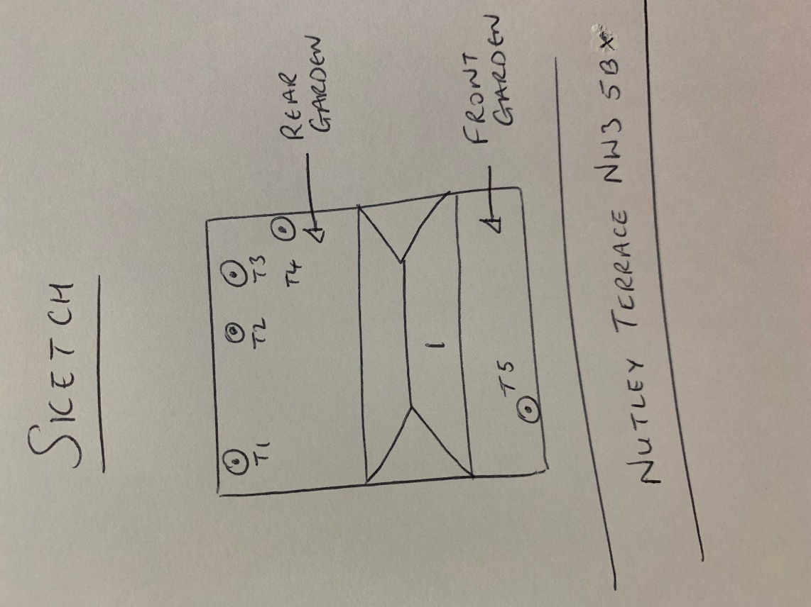
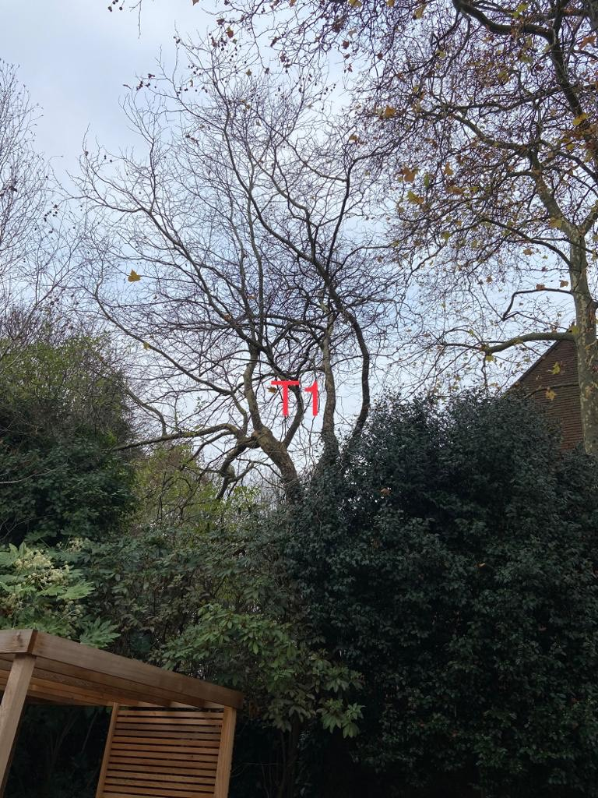
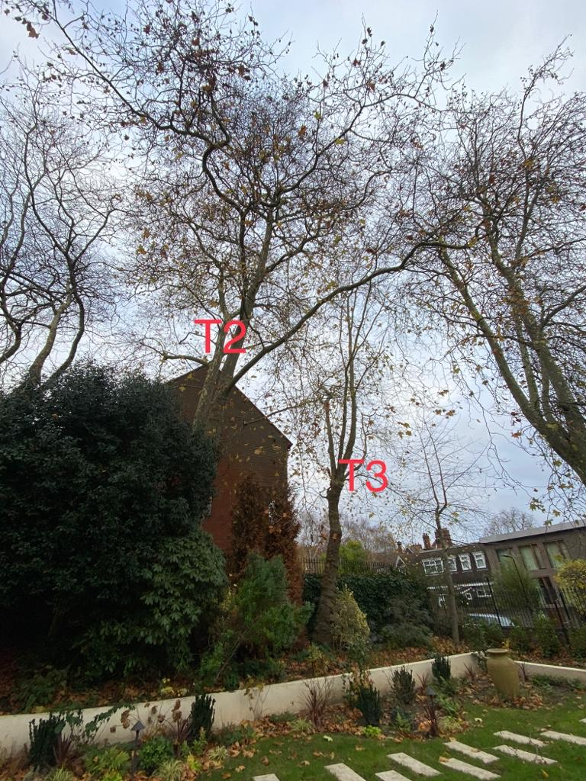

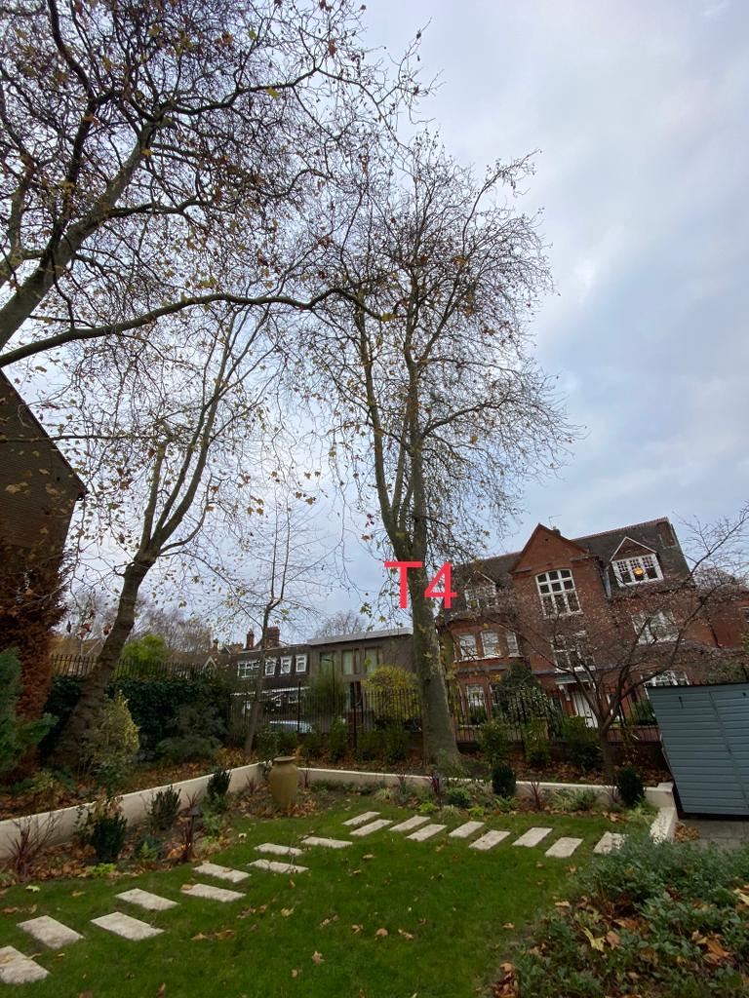
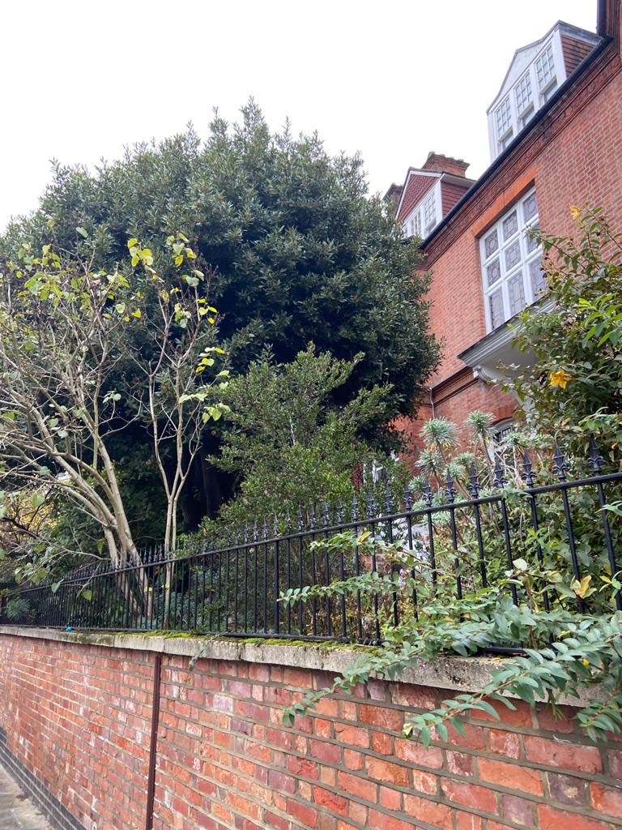
T5: Bay

T1: Plane (10m): Reduce height by 2m and shape to keep tree at a size suitable for its location
T2: Plane (18m): Crown reduce by 3m to keep tree at a size suitable for its location
T3: Plane (16m): Reduce height by 3m and shape to keep tree at a size suitable for its location
T4: Plane (20m): Crown reduce by 3m to keep tree at a size suitable for its location
T5: Bay (8m): Crown reduce by 2m to keep tree at a size suitable for its location

