Sketch Plan

21 Belsize Park, NW3

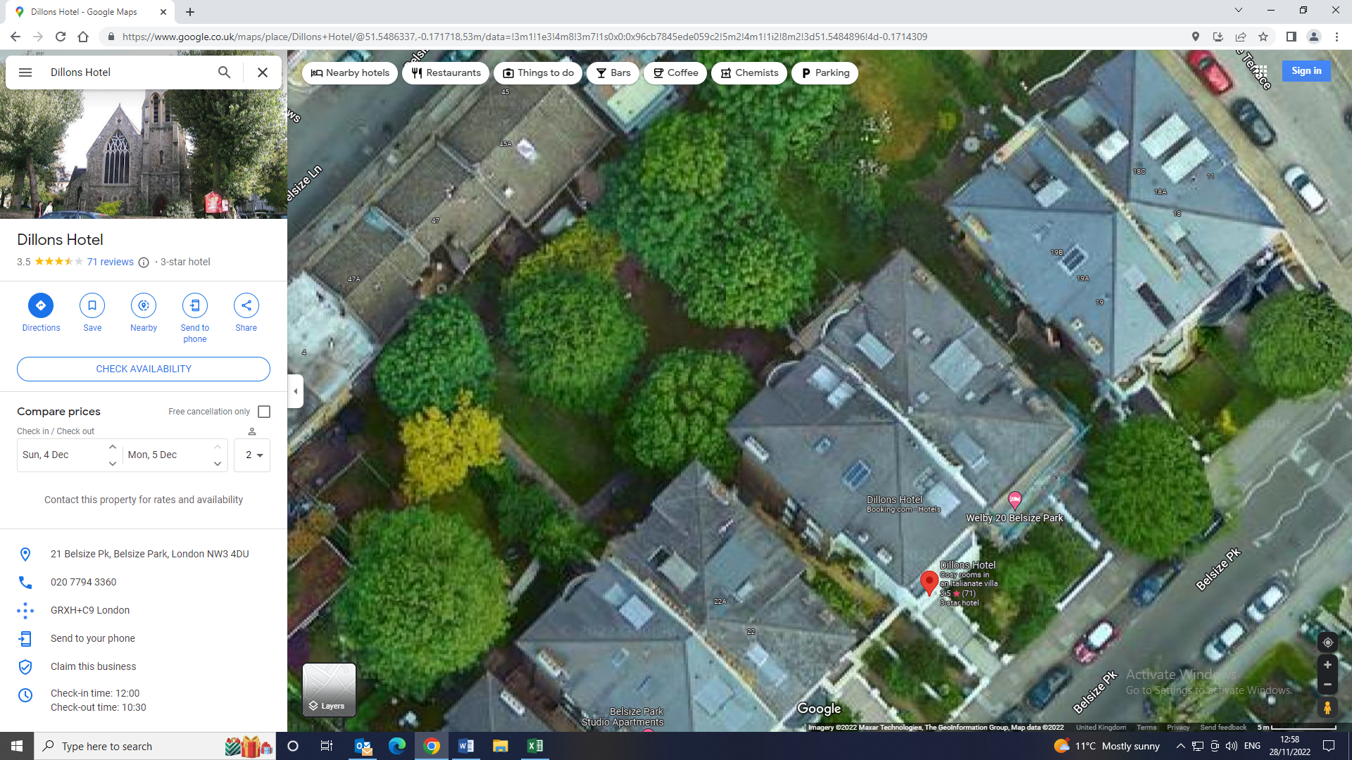

G1

G1: Group comprising of number of scrappy unmaintained conifers: Remove and replace.