Charlotte
Street
Association
39 Tottenham Street
London W1T 4RX
email: csafitzrovia@yahoo.co.uk

Development Management,
Regeneration & Planning,
London Borough of Camden,
2nd Floor, 5 Pancras Square,
London N1C 4AG. 29th November 2022
Planning ref. No. corrected

For the attention of Daren Zuk, Case Planning Officer, Planning Solutions Team.

By email to: planning@camden.gov.uk and daren.zuk@camden.gov.uk

Dear Daren Zuk,

Re: ref. 2022/3583/P: 85 Tottenham Court Road, W1T 4TQ:
Proposals: (a). External alterations to entrance; (b). works to rear terrace and doors;
(c). relocation of existing plant equipment, alterations to roof top plant and other works
incidental to the proposals.

I am writing on behalf of the Charlotte Street Association, concerning (a). the External alterations to the entrance in the above planning application.

Re: (a). Proposed external alterations to entrance;

I wish to strongly object to the proposals relating to the external alterations at the office entrance.

In setting out my objections, I would like to first give a background context for my objections. I think that the front facade/elevation of no. 80 - 85 Tottenham Court Road is a very good example of a well designed facade in glass and steel/metal of a modern design. I do not know who the architects were, but the front facade/elevation is a very good, and subtle piece of modern architectural design, in the way it is composed. It is a subtle piece of design in terms of balance, proportions and consistency. Although the proportions of the end bays vary, this subtlety also relies on the consistent use of the two materials – glass and metal. Also, one of the features is the metal-clad columns which are seen in the Ground Floor storey and to a degree in the 1st Floor storey and in the top floor storey.

Please see the attached photograph (at the end of this letter on the last page), which I have included and which shows the existing composition of the front facade/elevation of the building.

Contiued to next page ..............
CHARLOTTE STREET ASSOCIATION 29th November 2022: Page 2

Re: ref. 2022/3583/P: 85 Tottenham Court Road, W1T 4TQ: - continued:

I have concerns and objections as follows:

(a). Proposed changes to the three columns at the northen end/entrance end:
In the architect’s drawing no. P200/- “Proposed Ground Floor Plan”, the notes say that
the “Existing aluminium cladding to be removed from..” the 3 external columns at the
northern end of the front elevation. It is not clear if these columns are going to be left
exposed (presumably in concrete) or reclad; or if the size of the external, finished
circumference/radius is going to be kept the same as the existing.
There is strong objection to changing both the size (circumference/radius) and cladding
material of these columns. In terms of the overall composition and visual balance of
this facade and of the facade, it is important that these columns are not different in
size or material from the other columns.

(b). The proposed new “entrance portal”:
Looking at the plan drawings, the sides of the proposed new “entrance portal” will be
very close, almost touchng the columns - thus, I think that the new “entrance portal”
will look, both physically and visually, uncomfortably close to the columns.
Also, it does look as though the “entrance portal” is likely to physically clash with existing
low boundary wall.

(c). Re: Statement in the application:
The application says “... The proposals are focused on small areas of the existing
building, and will not materially alter the appearance of the building and therefore it is
considered the proposals will not result in adverse effect on the Conservation Area or
harm to the setting of the adjacent heritage assets.”
I do not agree. In fact these small changes will upset the composition (for the reasons
described above) of what is a very well design facade etc
These proposed changes at the entrance area will greatly affect the architectural
integrity of the host building; and will have an affect on the setting of the adjacent
Conservation Areas.

(d). The applicant’s wish to draw attention to the office entrance:
I appreciate the applicant’s wish to draw attention to the office entrance.
But, I think that the combination of, and the presence of:
- the revolving door;
- the existing low boundary wall;
- the proposal to change the adjacent retail area as part of a larger Reception area,
with its new clear glazed frontage
will all combine to draw attention to the office entrance, because it will be sufficently
different from the retail units.

Conclusions:
For the above reasons, I wish to object to the proposals, and I think that the proposed changes at the entrance area will destroy the architectural integrity of the host building.

Yours sincerely,
Clive Henderson,
On behalf of Charlotte Street Association. Copy: CSA Committee.

Contiued to next page – re. the Photographs .......
CHARLOTTE STREET ASSOCIATION 29th November 2022: Page 3

Re: ref. 2022/3583/P: 85 Tottenham Court Road, W1T 4TQ: - continued:

Photos attached:

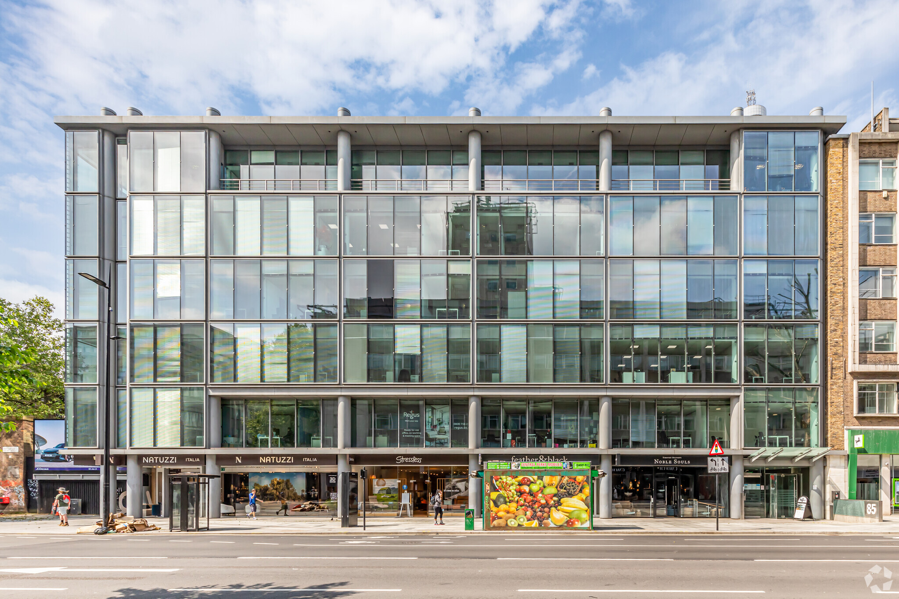

Photo 1: 80 – 85 Tottenham Court Road, London W1: front facade/elevation

Note: please ignore kiosk (with picture of fruit) in foreground which is on pavement near road kerb.

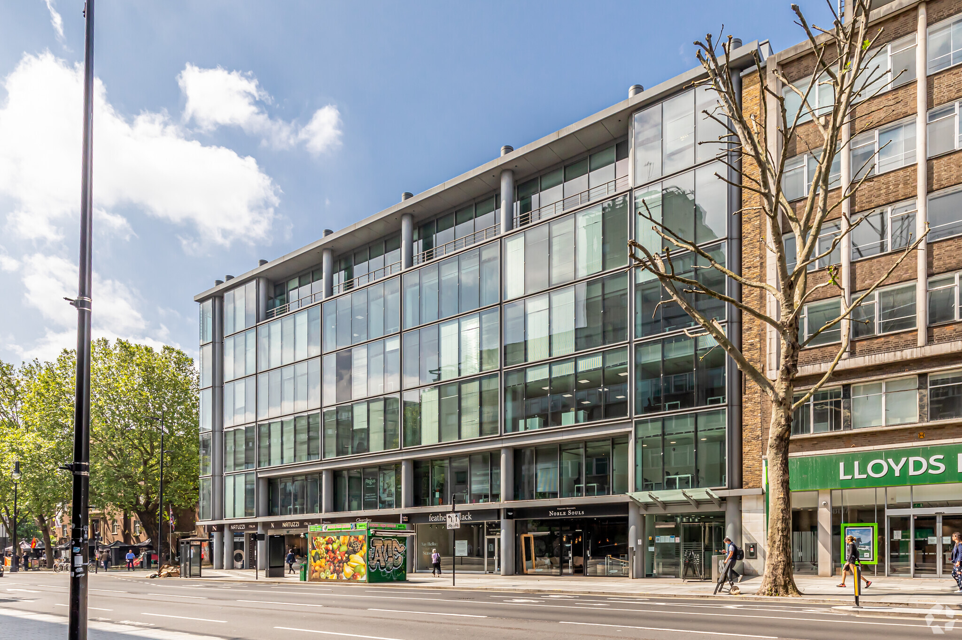
Photo 2: 80 – 85 Tottenham Court Road, London W1: looking south along the front facade/elevation.

