Front of property

45 Nassington Road ,London NW3 2TY

NW3 2ty   
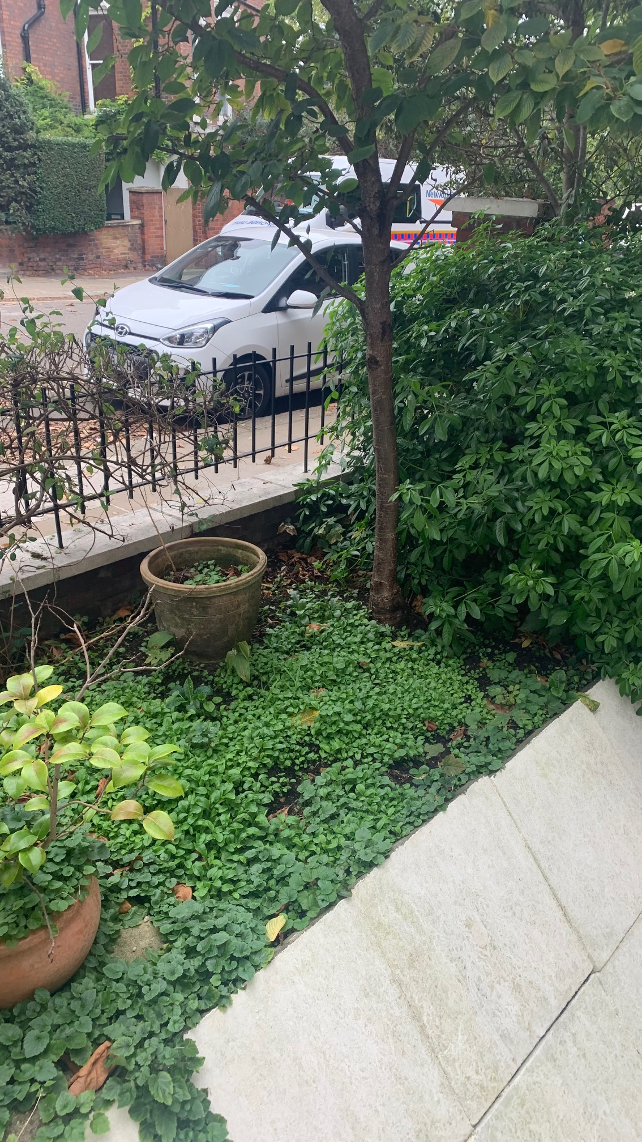

Pushing slabs over   
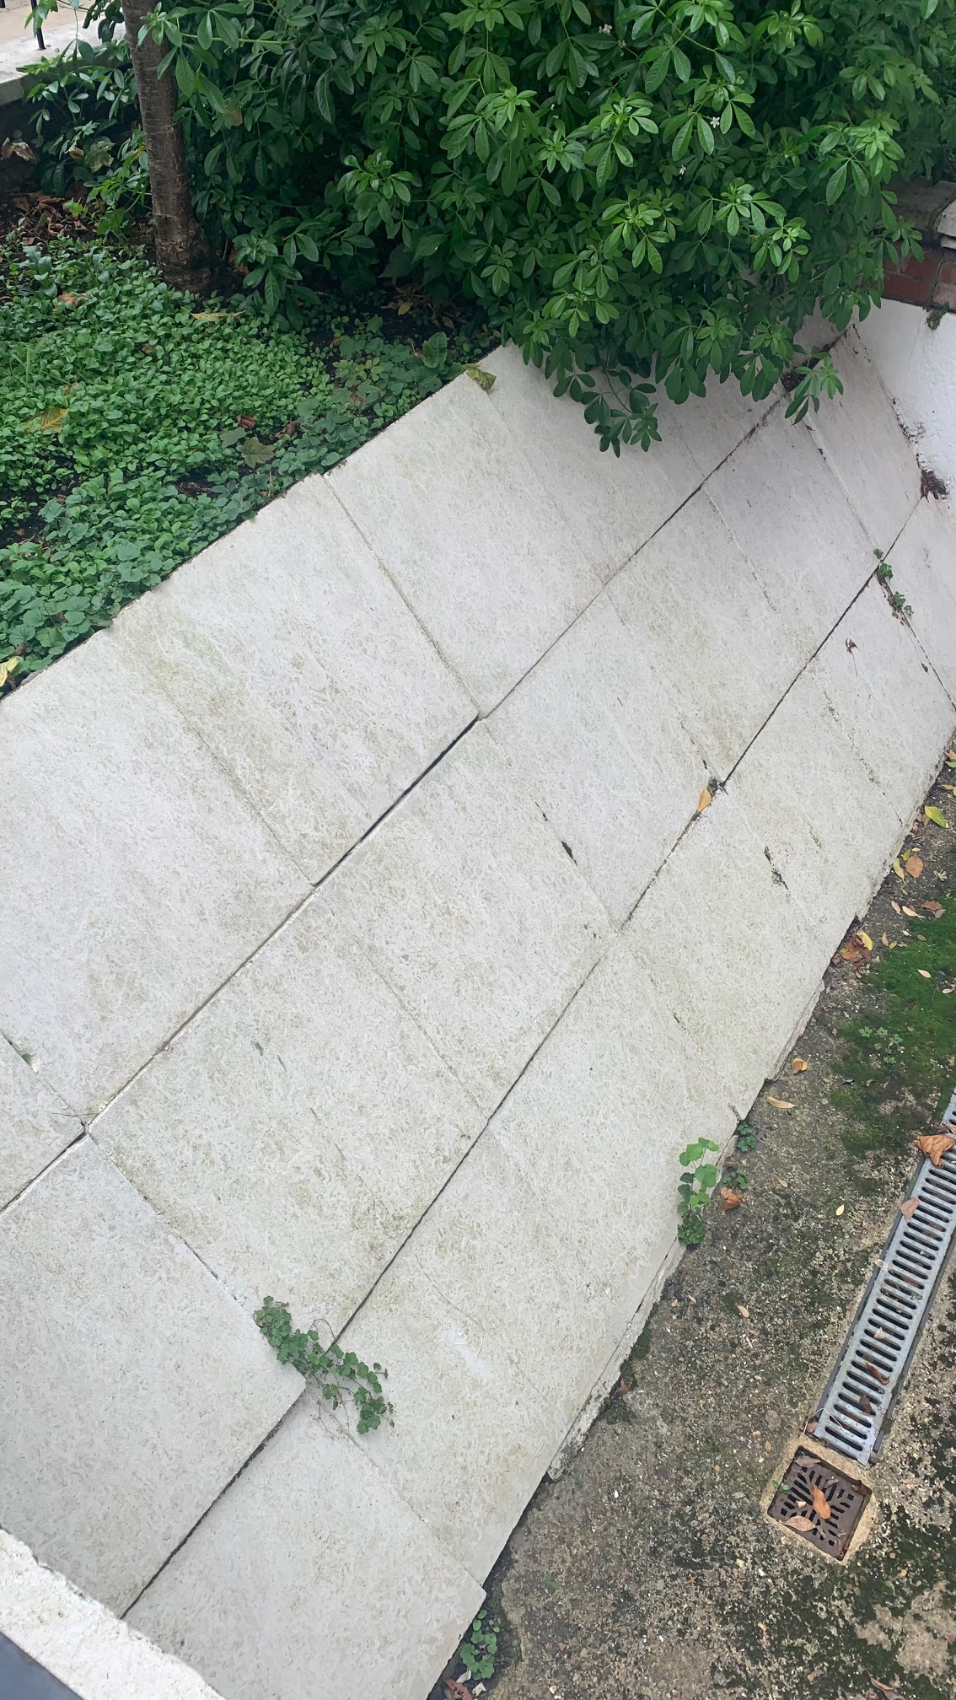

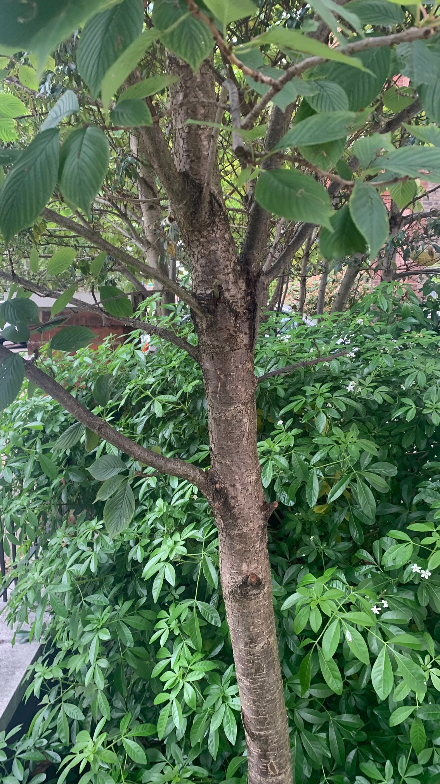

|  |  |  |
| --- | --- | --- |
| |  | | --- | | **Kevin Woodham  Arborist representative**  Local Manager  **BARTLETT TREE EXPERTS** Bartlett Tree Experts Ltd Coursers farm, coursers road ,colney heath, St Albans, Hertfordshire AL4 0PD **p**Office:01727 825090 option 1 Mobile: 07808915881 **e**[kwoodham@Bartlett.com](mailto:kwoodham@Bartlett.com) | | facebook.com/bartletttreeexperts [**bartlett.com**](https://www.bartlett.com/) | |