Sketch Plan

22 Belsize Park, NW3

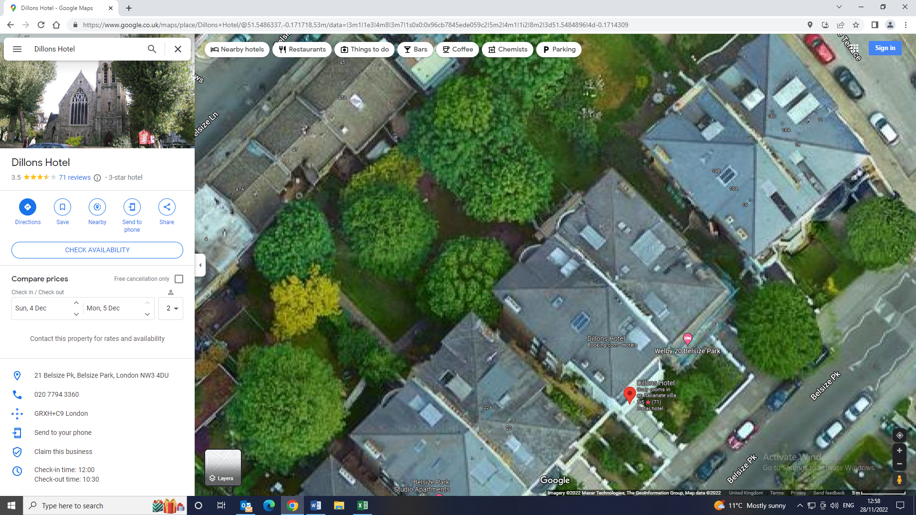

T1

T1: Hornbeam: To thin the crown density by 30% to for general tree husbandry and to improve light filtration to the gardens below