Sketch Plan

20 Belsize Park, NW3

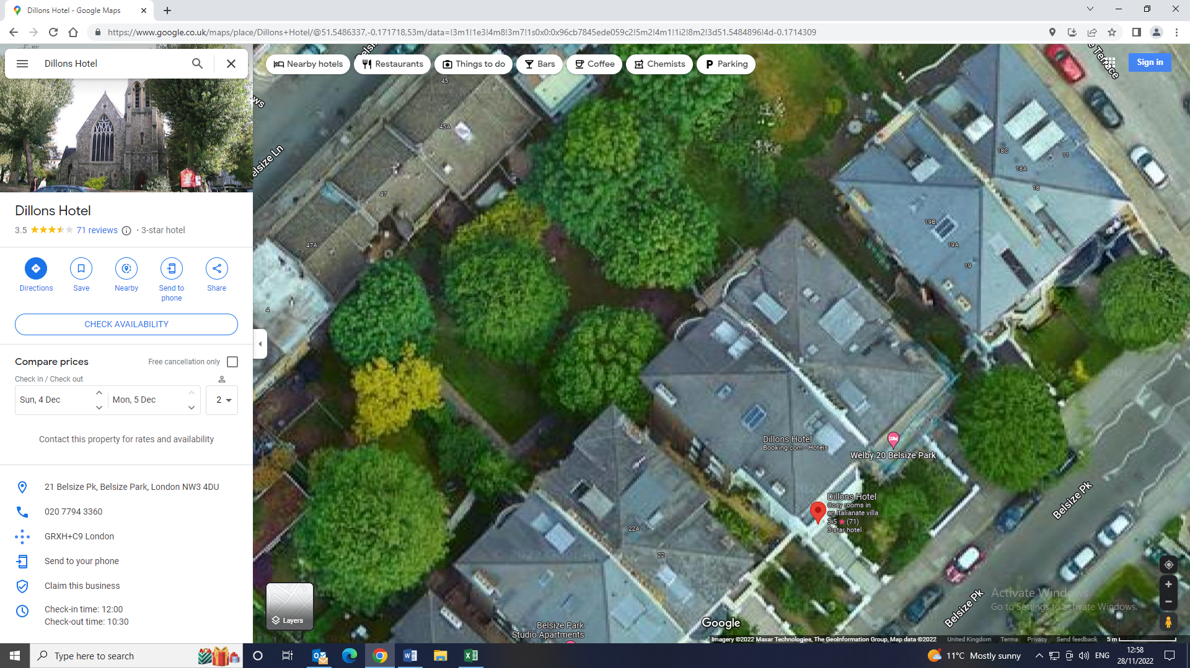

T2

T1

T1: Sycamore: To reduce the crown by 20% removing approx. 1.5m from the whole crown circumference leaving a nice crown shape, to thin the crown density by 25%.

T1: Sycamore: To reduce the crown by 20% removing approx. 1.5m from the whole crown circumference leaving a nice crown shape, to thin the crown density by 25%.

The works are being proposed as general tree maintenance and to allow light filtration to the garden below