**Method Statement for Cadent Gas Mains Replacement Work – IMGM232038 – 15 GLOUCESTER AVENUE**

|  |  |
| --- | --- |
| **Camden Tree Officer: TBC**  **Email: TBC**  **Phone: TBC** | **CMO Graduate Environmental Advisor: Joe Papworth**  **Email:** [**joe.papworth@morrisones.com**](mailto:joe.papworth@morrisones.com)  **Phone: 07890892025** |

**Summary**

Due to an enforcement policy issued by the Health and Safety Executive (HSE), Cadent Gas have been commissioned to install, new PE Plastic main into 15 Gloucester Avenue, London.

The existing gas main along Gloucester Avenue passes underneath the canopy and possibly in the Root Protection Zone (RPZ) of a tree located in the Primrose Hill Conservation Area and protected by Tree Preservation Order (TPO) status. Therefore, it may be necessary for Cadent to excavate within RPZ’s of the tree protected by Conservation Area and TPO status and severe small diameter roots.

Plans of the affected trees which are protected by Conservation Area and TPO status can be found in the ‘Gloucester Avenue - Site Plan’ document.

**Site Control Measures**

Cadent work to NJUG Volume 4 Standards and therefore the following measures have been put in place to minimise the impact on trees throughout the affected streets:

***Prohibited Zone of a Tree RPZ (0-1m from Trunk):***

**-** Where excavations are required within the Prohibited Zone, this will be completed via **hand-dig or vacuum excavation** and supervised by an Arborist.

- In the event where a root >25mm diameter is found and Cadent Operations may impact on the root, works will cease immediately and consultation with an Arborist will take place. Roots will only be severed if the Arborist confirms that the severance is unlikely to impact on the trees heath and stability.

- If the severance of roots <25mm diameter is required, this will be cut back using a sharp tool to leave the smallest wound.

- If possible, clumps of roots <25mm diameter (including fibrous roots) will be retained in situ without damage. Care will be taken to protect the bark around the roots.

- In an attempt to protect any roots against desiccation and temperature change, any exposed roots located in an excavation will be wrapped with dry sacking immediately after excavation has occurred. If the works are taking place during the summer months, the hessian must be kept damp with a water supply. The sacking will be removed prior to backfilling, which should take place as soon as possible.

- Prior to backfilling, retained roots must be surrounded with topsoil or uncompacted sharp sand, or other loose inert granular fill, before soil or other suitable material is replaced. This material should be free of contaminants and other foreign objects potentially injurious to tree roots.

- There will be no storage of plant, soil, fuel or machinery within the Prohibited Zone.

***Precautionary Zone of a Tree RPZ (1m from Trunk – 4 x Tree Circumference):***

**-** Where excavations are required within the Precautionary Zone, this will be completed with a **Blow Out Air Lance or Vacuum Excavator**.

- In the event where a root >25mm diameter is found and Cadent Operations may impact on the root, works will cease immediately and consultation with an Arborist will take place. Roots will only be severed if the Arborist confirms that the severance is unlikely to impact on the trees heath and stability.

- If the severance of roots <25mm diameter is required, this will be cut back using a sharp tool to leave the smallest wound.

- If possible, clumps of roots <25mm diameter (including fibrous roots) will be retained in situ without damage. Care will be taken to protect the bark around the roots.

- In an attempt to protect any roots against desiccation and temperature change, any exposed roots located in an excavation will be wrapped with dry sacking immediately after excavation has occurred. If the works are taking place during the summer months, the hessian must be kept damp with a water supply. The sacking will be removed prior to backfilling, which should take place as soon as possible.

- Prior to backfilling, retained roots must be surrounded with topsoil or uncompacted sharp sand, or other loose inert granular fill, before soil or other suitable material is replaced. This material should be free of contaminants and other foreign objects potentially injurious to tree roots.

- There will be no storage of plant, soil, fuel or machinery within the Precautionary Zone.

***Permitted Zone of a Tree RPZ***

**-** Where excavations are required within the Permitted Zone, this will be completed with a **Mini Excavator, Vacuum Excavator or Blow Out Air Lance**.

- In the event where a root >25mm diameter is found and Cadent Operations may impact on the root, works will cease immediately and consultation with an Arborist will take place. Roots will only be severed if the Arborist confirms that the severance is unlikely to impact on the trees heath and stability.

- If the severance of roots <25mm diameter is required, this will be cut back using a sharp tool to leave the smallest wound.

- If possible, clumps of roots <25mm diameter (including fibrous roots) will be retained in situ without damage. Care will be taken to protect the bark around the roots.

- In an attempt to protect any roots against desiccation and temperature change, any exposed roots located in an excavation will be wrapped with dry sacking immediately after excavation has occurred. If the works are taking place during the summer months, the hessian must be kept damp with a water supply. The sacking will be removed prior to backfilling, which should take place as soon as possible.

- Prior to backfilling, retained roots must be surrounded with topsoil or uncompacted sharp sand, or other loose inert granular fill, before soil or other suitable material is replaced. This material should be free of contaminants and other foreign objects potentially injurious to tree roots.

Please note the following:

- As per Cadent Operating Procedures, there will be no cutting down, topping or looping of third party trees without prior approval from the stakeholder. Any vegetation clearance taking place between 1st March – 30th September must have Bird Nesting check completed by an authorised ecologist.

- In the event in which a Nesting Bird is found within an excavation, plant or machinery or if Protected Species are found on site, works will cease immediately and the incident reported to the CMO Incident Line.

- In the event of an environmental incident on site, works will cease immediately and the incident reported to the CMO Incident Line.

**Appendix 1 – NJUG Guidelines Volume 4**

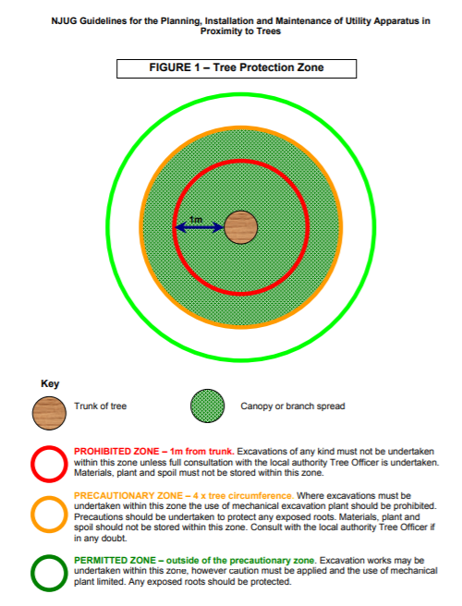

**For CMO Reference Only:**

|  |  |  |  |  |  |  |  |  |  |  |  |  |  |  |  |  |  |  |  |  |  |  |  |  |  |  |
| --- | --- | --- | --- | --- | --- | --- | --- | --- | --- | --- | --- | --- | --- | --- | --- | --- | --- | --- | --- | --- | --- | --- | --- | --- | --- | --- |
| Site: IMGM232038 – GLOUCESTER AVENUE | | | | Activity: Ecology, Trees and Hedgerows | | | | | | | | | | Persons Conducting Assessment: Joe Papworth | | | | | | | | | | | | |
| Risk Assessment No:  EHS-ERA-003 | | Review Due Date:  November 2023 | | | | Revision No:  1.0 | | | | | | | | Name:  Joe Papworth | | | | | Signature: | | | | | Date:  25/11/22 | | |
| Person Supervising Work:  Project Manager | | | | Employer:  CMO | | | | | | | | | | Name:  James Thorpe | | | | | Signature: | | | | | Date:  TBC | | |
| Persons Exposed: | | Employees: | | | | Public/Visitors: X | | | | | | | | Public/Visitors: X | | | | | Public/Visitors: X | | | | | Total at Risk: | | |
| |  |  |  |  |  |  | | --- | --- | --- | --- | --- | --- | | 5 | 5 | 10 | 15 | 20 | 25 | | 4  Severity | 4 | 8 | 12 | 16 | 20 | | 3 | 3 | 6 | 9 | 12 | 15 | | 2 | 2 | 4 | 6 | 8 | 10 | | 1 | 1 | 2 | 3 | 4 | 5 | |  | 1 | 2 | 3 | 4 | 5 | | | | | | | | | | | | Likelihood  Rating 1 = Very Unlikely  Rating 2 = Unlikely  Rating 3 = Likely  Rating 4 = Very Likely  Rating 5 = Almost Certain | | | | | | | | | Severity  Rating 1 = No Environmental Impact  Rating 2 = Minor Impact  Rating 3 = Significant Impact  Rating 4 = Extreme Impact  Rating 5 = Catastrophic, Game Changing | | | | | | |
| Likelihood | | | | | | | |  | | | | | | | | | | | | | | | | | | |
| Risk = Likelihood x Severity | | | | | | |  | |  | Acceptable | |  |  | |  | Further review |  |  | | |  | Unacceptable Risk | | | | |
| Hazard | 1 | | 2 | | 3 | 4 | | | | | | | | | | | 5 | | | | 6 | | 7 | | 8 | 9 |
| Factors of Harm | | | | Risk  Multiple of Columns  1 ´ 2 | Control Measures | | | | | | | | | | | Factors of Harm | | | | | | Residual Risk  Multiple of Columns 5 ´ 6 | | Control measures implemented By: | Control Frequency Check Rate |
| Likelihood | | Severity | | Likelihood | | | | Severity | |
| Working near Trees and Hedgerows | **4** | | **2** | | **8** | * When working near to any trees, Operatives to be briefed on NJUG Guidance. NJUG Guidance must be followed at all times. The following additional controls must be adhered to at all times:   + Any excavations within 1m of Trunk must be completed by hand-dig and supervised by an Arborist. All roots >25mm diameter must be retained.   + All excavations within the Precautionary Zone (under the tree canopy) must only be dug by Hand, Air Lance or Vac Ex.   + Tree roots >25mm diameter must not be cut unless granted by an Arborist.   + No materials, plant or soil must be stored within the Prohibited and Precautionary Zone (under the tree canopy).   + Any exposed roots left overnight should be protected with Hessian sacking (wet Hessian sacking during the Summer). * Any vegetation clearance (cutting branches, removing sections) must be authorised from the Local Authority. If taking place between 1st March – 30th September, a bird nesting check must be completed prior by a licensed ecologist. Contact Environmental Advisor for support. * In the event on an Environmental Incident on site, Operatives must follow ENV-001 Environmental Emergency Plan. | | | | | | | | | | | **2** | | | | **2** | | **4** | | Site Manager, Team Leader & Operatives | Daily |