3 Keats Close NW3 2RP

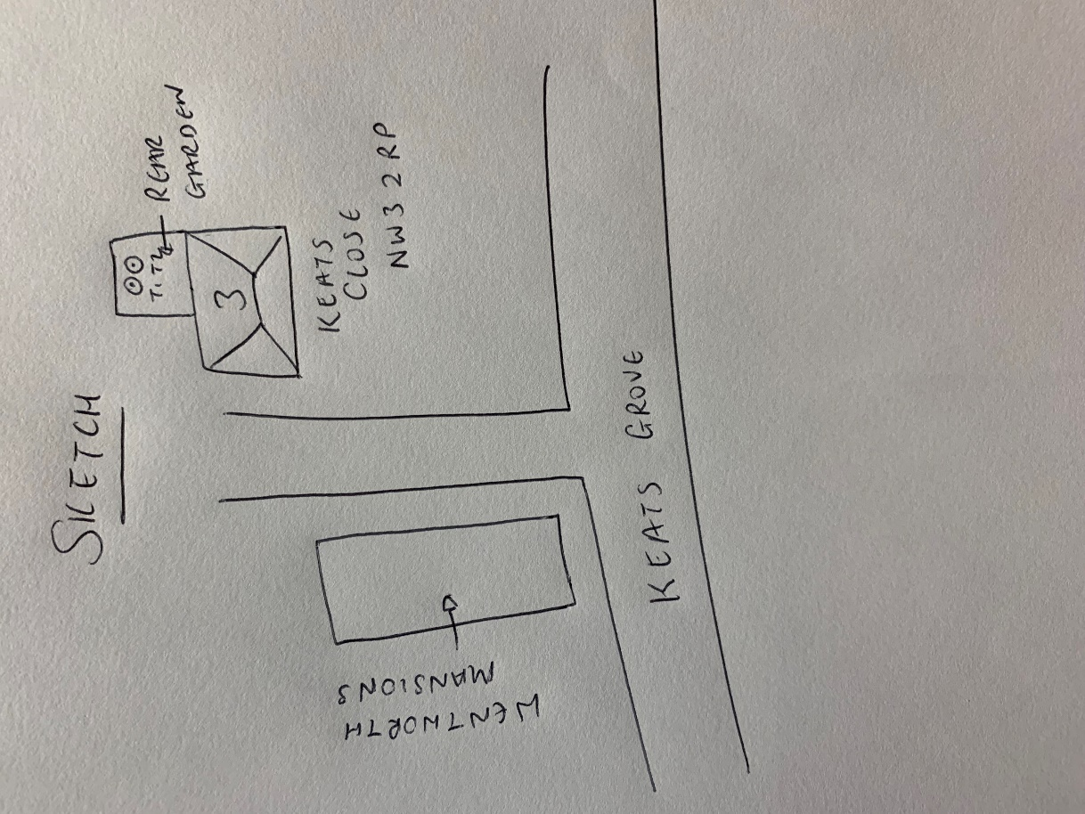

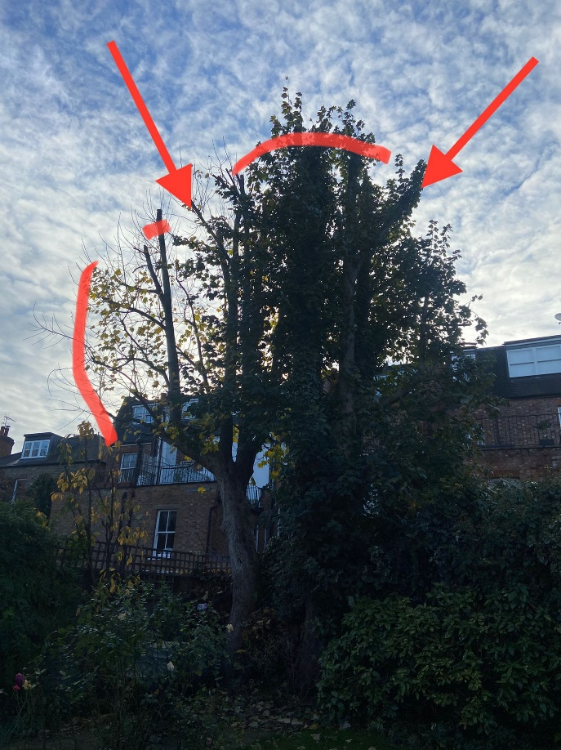

T1: Sycamore (12m): Remove one branch, reduce height by 1m and crown thin by 30% to allow more light in the garden

T2: Sycamore (12m): Remove one branch, reduce left hand side of crown by 1.5m to allow more light into the garden