Delegated Report |  | Analysis sheet |  |  |  |  | Expiry Date: |  |  | 07/12/2022
 |  | N/A |  |  |  |  | Consultation Expiry Date: |  |  | 12/11/2022
Officer |  |  |  |  | Application Number(s)
Josh Lawlor |  |  |  |  | 2022/3275/P
Application Address |  |  |  |  | Drawing Numbers
2 Cricklewood Broadway  London  NW2 3HD |  |  |  |  | See decision Notice

Proposal(s)
Erection of ground floor side extension storage unit with metal shutters and alterations to façade of rear extension with new windows and door (retrospective)
Recommendation(s): | Refuse Planning Permission with Enforcement Action to be Taken
Application Type: | Full Planning Permission
Conditions or Reasons for Refusal: | Refer to Draft Decision Notice

Informatives:

Consultations
Adjoining Occupiers: | No. notified |  | 00 | No. of responses |  |  |  | 0 | No. of objections |  | 0
Summary of consultation responses: | A site notice was displayed near to the site from on 19/10/2022 and expired on 12/11/2022

Site Description
The site is a single storey retail unit which is part of a parade of commercial units. It is attached to a three storey Victorian terraced building. The property is located within the Cricklewood Neighbourhood Centre. The property is locally listed.
Relevant Planning History:

2018/4519/P Conversion of ancillary storage space to residential unit (Class C3) to enlarge existing 2-bed flat (Class C3); installation of 3 x new windows and 1 x new door to side elevation; installation of 1 x new rooflight. Granted 30/01/2019

PW9902556 Change of use of part of the ground floor extension onto Manstone Road and the first and second floors from Class B1 offices to a six room family residential unit and the replacement of an entrance door and roller shutter door on the Manstone Road elevation with windows. granted 21/03/2000

Neighbouring properties
2017/6363/P. 72 Cricklewood Broadway. Change of use of approx.30sqm of retail (A1) floorspace to rear of shop into residential (C3), erection of single storey rear/side extension at ground floor level and conversion of existing maisonette at second and third floor levels in association with creation of 3 units (2x2-bed; 1x1-bed) (C3). Granted Subject to a Section 106 Legal Agreement

2005/3959/P 64 Cricklewood Broadway. Change of use of the rear part of the ground floor, including works of conversion, from storage ancillary to a class B1 office in the front part of the ground floor, to a self-contained flat (Class C3), including external alterations to the roof and rear elevation. Refused 02/12/2005

Reason for refusal
The proposed change of use would result in a substandard residential unit with inadequate daylight, sunlight and outlook for the habitable rooms which would be detrimental to the amenity of its future occupiers, contrary to policies RE2 (Impact on amenity and environment), EN1 (General environmental protection and improvement) and EN19 (Amenity of occupiers and neighbours), and HG9 (Change of use to residential accommodation) of the London Borough of Camden Unitary Development Plan 2000 and advice contained in the Council's Supplementary Planning Guidance.

2007/2914/P 10 Cricklewood Broadway. Change of use of the ground floor of the rear wing of the property from Class B1 business use to a Class C3 self-contained studio flat, plus the erection of a single storey rear extension. Full Planning Permission Granted Subject to a Section 106 Legal Agreement 08/10/2007

Relevant policies
The National Planning Policy Framework 2021

London Plan 2021

Camden Local Plan 2017

- A1 Managing the Impact of Development
- C6 Access for all
- D1 Design
- D2 Heritage
- D3 Shopfronts
- T1 Prioritising walking, cycling and public transport

Supplementary Guidance - Camden Planning Guidance

- Amenity - January 2021
- Design - January 2021
- Home improvements - January 2021
- Transport - January 2021

Assessment
- The proposal

  - Retrospective planning permission is sought for the installation of a fixed metal storage unit attached to the side of the shop unit and located on its private forecourt. It has metal roller shutters on all sides, a height of 3m, a depth of 2m from the pre-existing side elevation and a width of 6m. There are also changes to the rear extension (named annex 2) in association with reconfiguration of the flat within to provide a new street elevation with door and windows replacing the roller shutter and high level windows. These alterations have also been implemented.

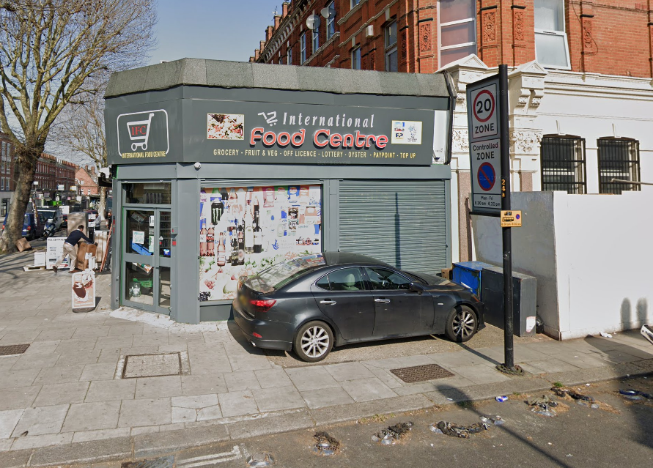
Pre-existing shopfront

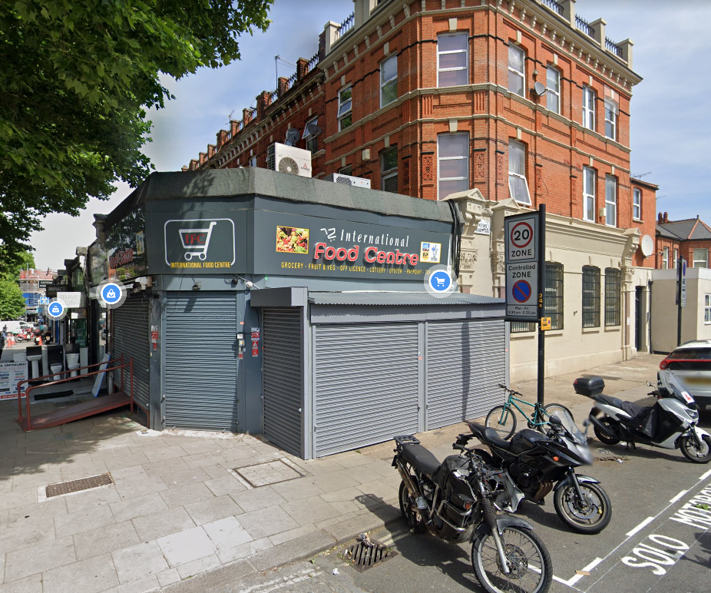
Existing metal store

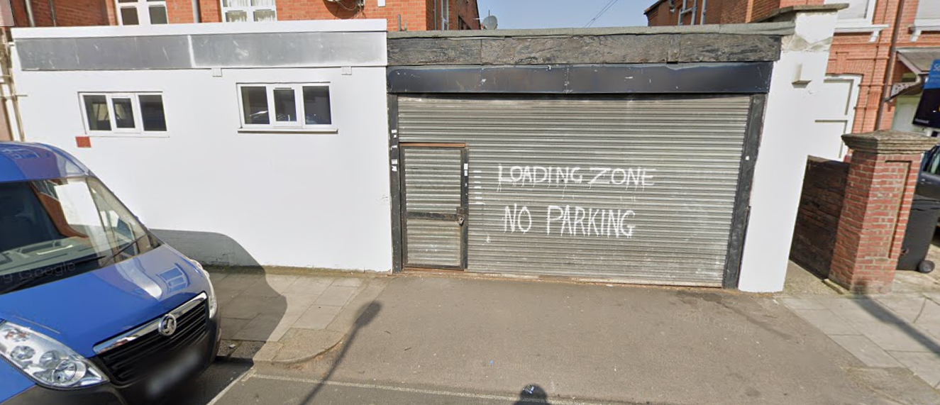
Pre-existing rear/side extension

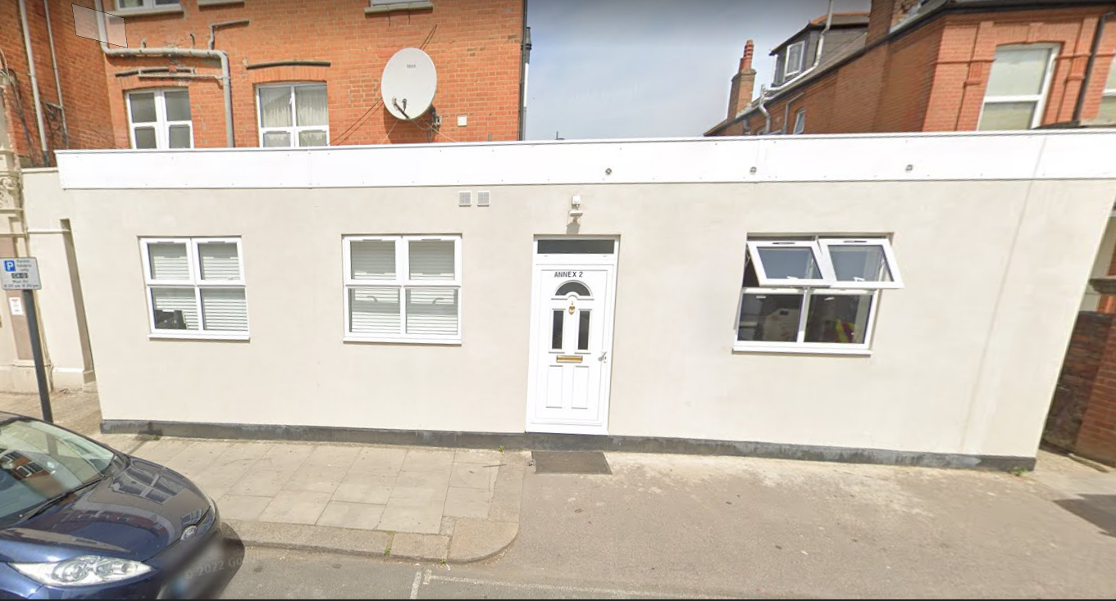
Existing rear/side extension

- Assessment

  - The principal considerations material to the determination of this application are as follows:

- Design
- Highways
- Residential amenity

- Design and Heritage

  - Local Plan Policy D1 seeks to secure high-quality design in development which respects local context and character. Policy D2 of the local plan states that Council will seek to protect other heritage assets including non-designated heritage assets (including those on and off the local list). Policy D3 states that when determining proposals for shopfront development the Council will consider:

- the design of the shopfront or feature, including its details and materials;
- the existing character, architectural and historic merit and design of the building and its shopfront;
- the relationship between the shopfront and the upper floors of the building and surrounding properties,
- the general characteristics of shopfronts in the area;

  - The original shop frontage responds successfully to its corner location. The new metal store as erected however appears incongruous; it disrupts the proportions of the shopfront and appears as an unsightly and bulky extrusion with inappropriate grey metal materials. The store is also out of character with its surroundings, disrupting the relationship of the shopfront unit with its neighbouring building and obscuring views of the ornate ground floor frontage to the east. Furthermore it harms the character and appearance of the host Locally Listed building. It is a bolt-on addition that is intrinsically unacceptable on a shopfront due to its location and scale and causes harm to the building, streetscene and wider area. As such refusal is recommended on this basis.

  - The alterations to the rear extension facade are an improvement on the previous existing situation which had small high level windows and an ugly roller shutter blind (see photos above); however despite timber windows being specified on the plans, Upvc ones have been installed. Aluminium or timber framed windows would have been preferable given the high visibility of the windows on this street frontage. Nevertheless the whole of this locally listed building has pvc windows, the previous façade of this extension had pvc windows and many immediate neighbouring properties have them also. Thus it is considered that the pvc windows as installed here are acceptable in this context, enhance the previous facade and on balance do not harm the character and appearance of the building and area.

- Transport

  - Policy T1 point e) states that the Council will seek to ensure that developments provide high quality footpaths and pavements that are wide enough for the number of people expected to use them, including features to assist vulnerable road users where appropriate, and paragraph 9.1 of CPG Transport highlights that footways should be wide enough for two people using wheelchairs, or prams, to pass each other.

  - Camden’s Streetscape Design manual – section 3.01 footway width states: “‘Clear footway’ is not the distance from kerb to boundary wall, but the unobstructed pathway width within the footway:
- 1.8 metres – minimum width needed for two adults passing;
- 3 metres – minimum width for busy pedestrian street though greater widths are usually required keeping the footway width visually free of street furniture is also important, allowing clear sightlines along the street’

  - The plans indicate that there is a distance of 4 metres from the pre-existing side elevation and the edge of the pavement and there is a street parking post which further reduces the width of the pavement. The proposed plans show that the width would be reduced to 2 metres and less than this at the lamppost. It is noted that when looking at images of the site there appears to be less space than what is shown on the plans. The Council’s Transport Planner has been consulted on the proposal and considers that there would be insufficient space for pedestrians to safely pass by without hindrance and potentially stepping into the road. The busy footway would be obstructed by users of the store kiosk to an unacceptable extent, contrary to Policy T1, which seeks to ensure that the pedestrian environment promotes walking. The width would also be insufficient for the needs of vulnerable or disabled users and therefore be contrary to policy C6 which encourages inclusive access.

- Residential Amenity

  - Policy A1 seeks to protect the quality of life of occupiers and neighbours by only granting permission to development that would not harm the amenity of residents. This includes factors such as privacy, outlook and natural light.

  - The proposal would not give rise to adverse impacts on residential amenity in terms of loss of light, outlook or privacy.

- Recommendations

  - Refuse planning permission

  - Issue a planning enforcement notice to require the removal of the unauthorised side extension

That the Director, Culture and Environment instruct the Head of Legal Services to issue an Enforcement Notice under Section 172 of the Town & Country Planning Act 1990 as amended, requiring the removal of the side extension store with metal shutters, and to pursue any legal action necessary to secure compliance. Additionally, officers to be authorised that in the event of non-compliance, to prosecute under section 179 or appropriate power and/or take direct action under 178 in order to secure the cessation of the breach of planning control.

The notice shall allege the following breaches of planning control:

- Erection of ground floor side extension storage unit with metal shutters

What you are required to do:
- Completely remove the side extension store with metal shutters and return the external retail side frontage to its pre-existing condition
Period of compliance:
3 Months
Reasons why the Council consider it expedient to issue the notice:
- The side extension store, by reason of its location, size, design and materials, is considered to be an incongruous and bulky addition that detracts from the character and appearance of the locally listed host building and the streetscene, contrary to policies D1 (Design) and D2 (Heritage) of the London Borough of Camden Local Plan 2017.

- The side extension store, by reason of its location and size, reduces the amount of useable unobstructed footway, which is detrimental to the quality of the public realm and hinders pedestrian movement and accessibility by vulnerable or disabled users, contrary to policies A1 (Managing the impact of development), C6 (Access for all) and T1 (Prioritising walking, cycling and public transport) of the London Borough of Camden Local Plan 2017.

