3 Bartholomew Road NW5 2AH

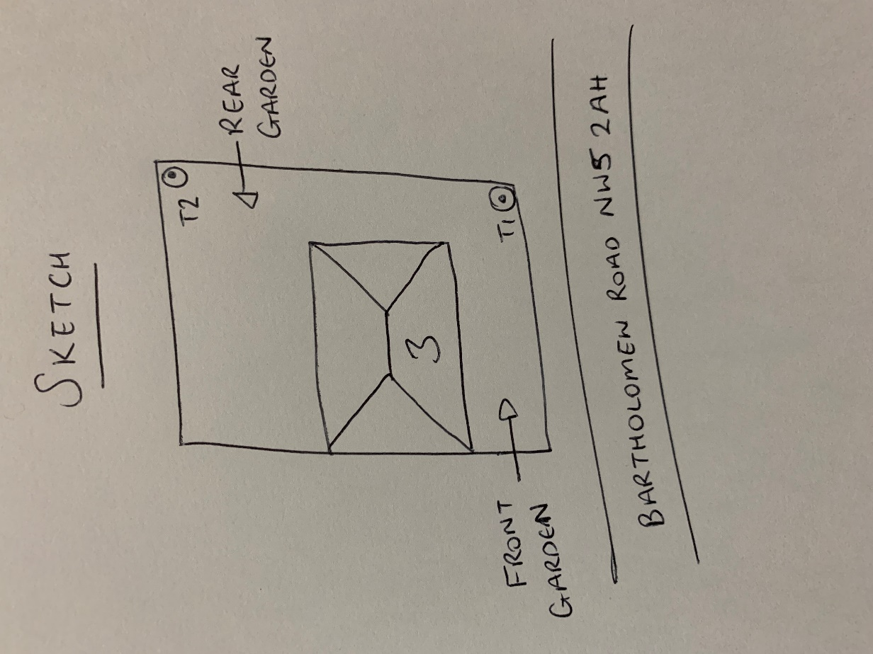

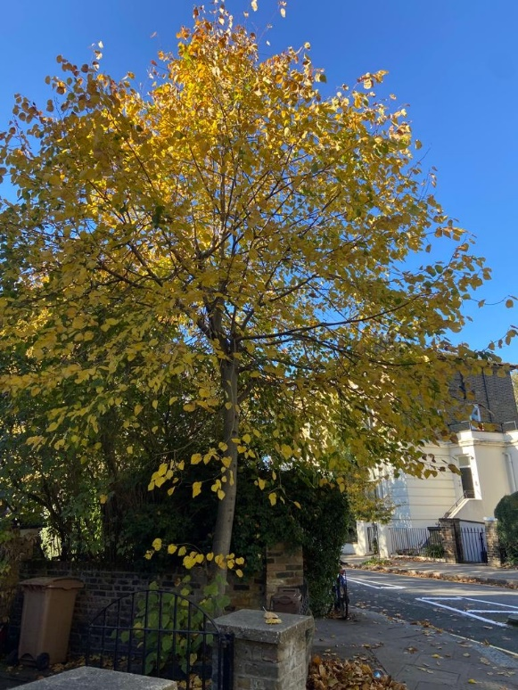

T1: Lime (8m): Crown reduce by 1m to keep tree at a size suitable for its location and as part of regular maintenance

T2: Willow (6m): Fell as it is an inappropriate species so close to the boundary