Oakford Court 2 Nassington Road NW3 2UE

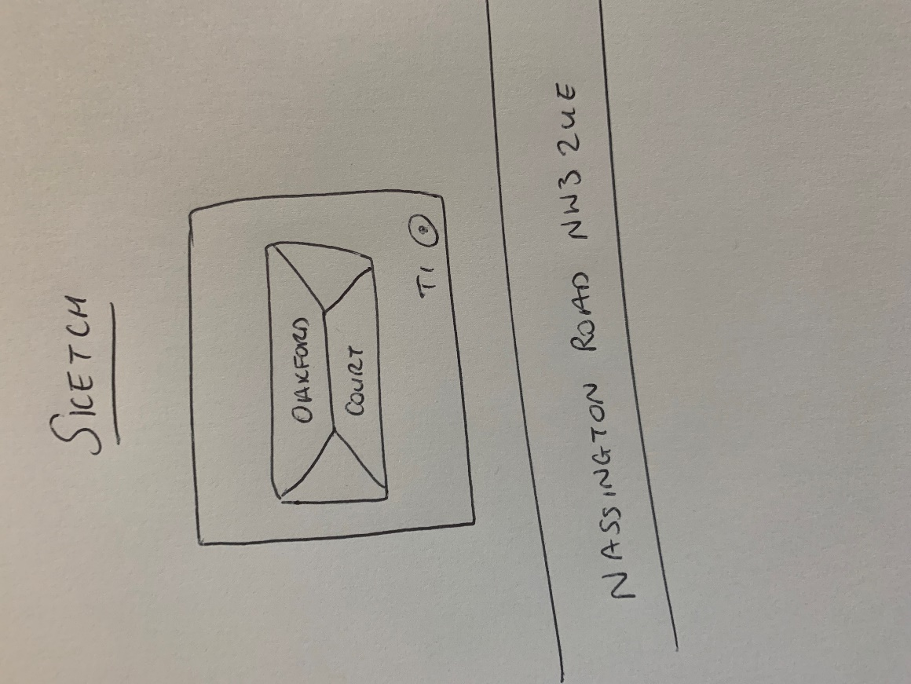

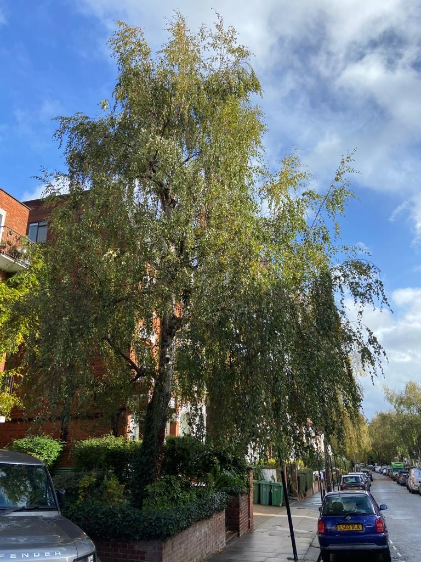

T1: Silver birch (12m): Crown reduce by 2m to keep at size suitable for its location due to close proximity to the building.