5 Bartholomew Road NW5 2AH

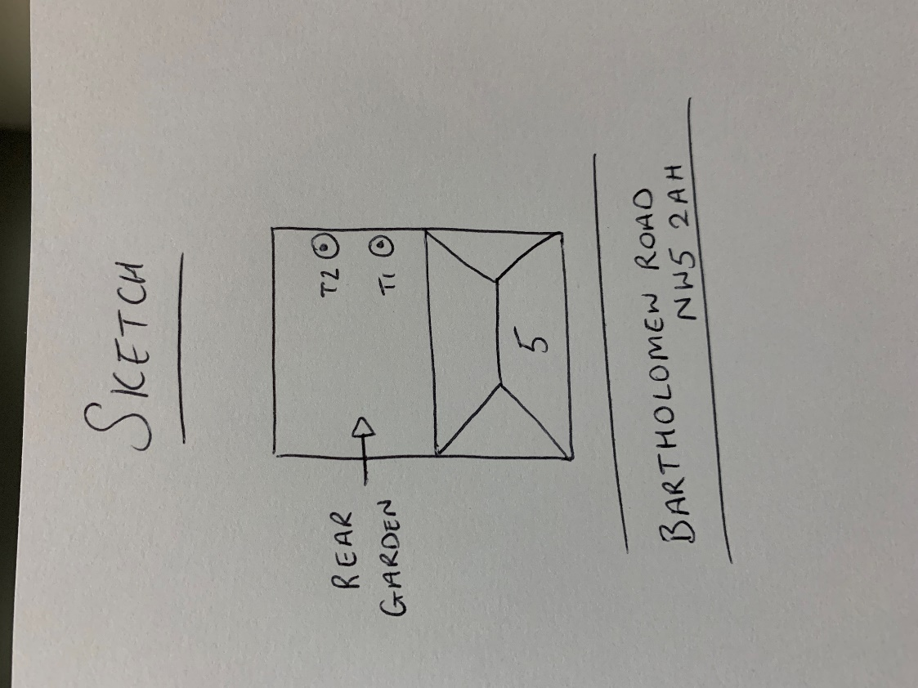

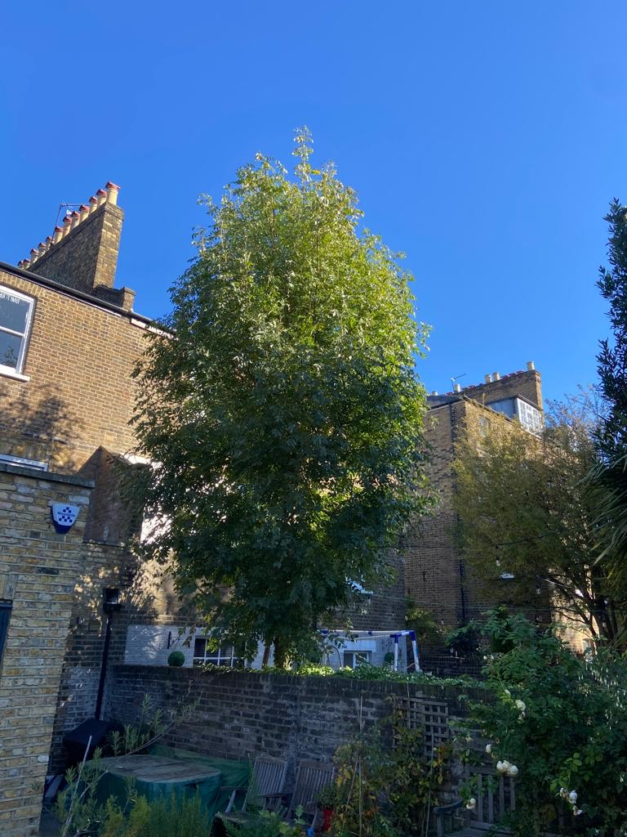

T1: Ash: Re-Pollard to previous points - 50% of present height to keep tree at a size suitable for its location and as part of regular maintenance

T2: Bay: Reduce back to boundary and reduce height by 3m to keep tree at a size suitable for its location and as part of regular maintenance