11 Priory Terrace NW6 4DG

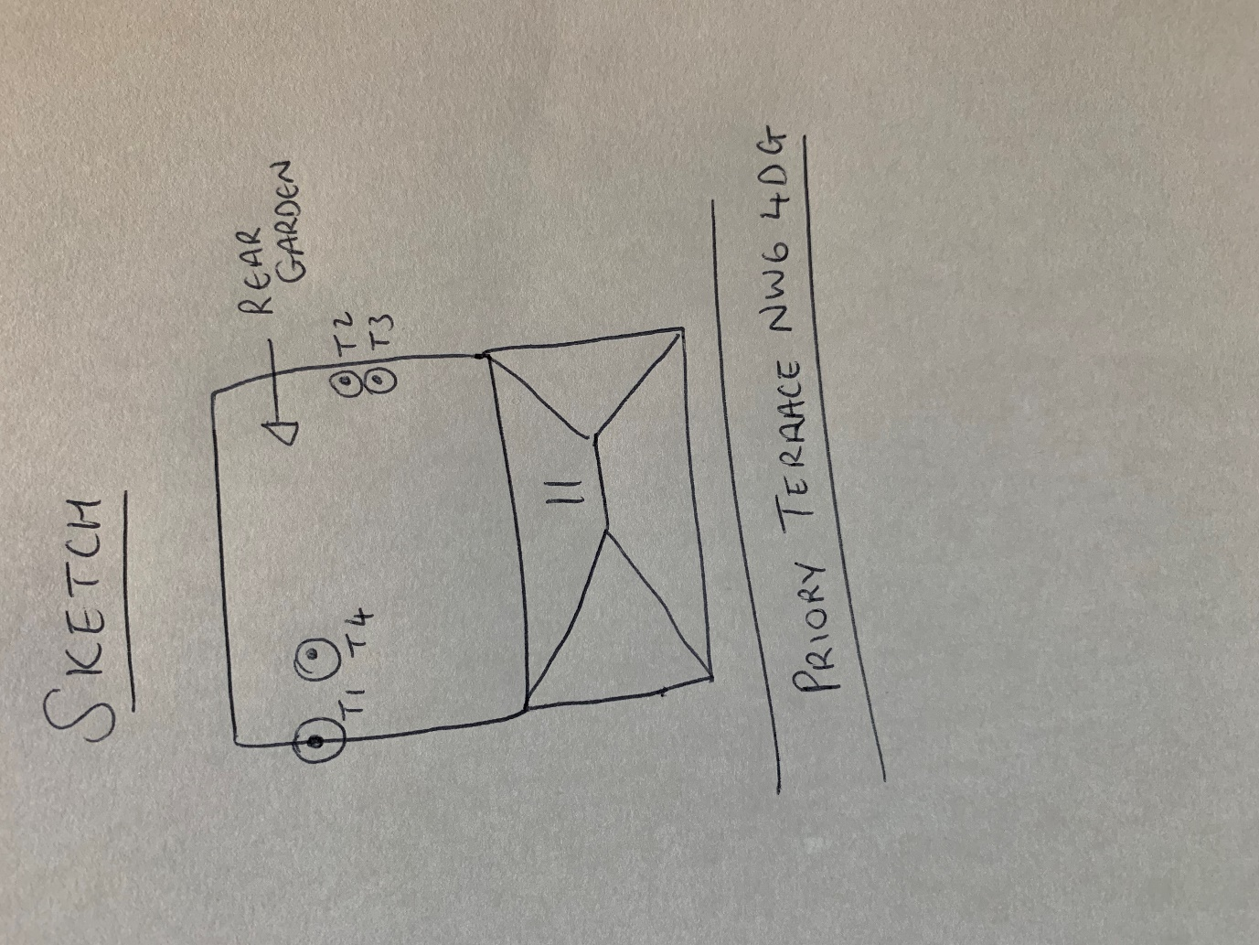

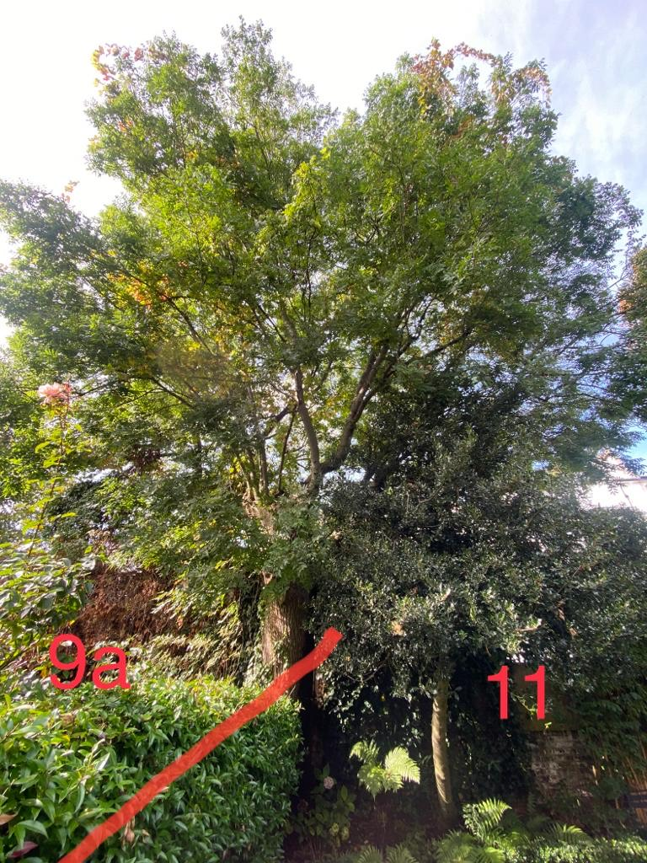 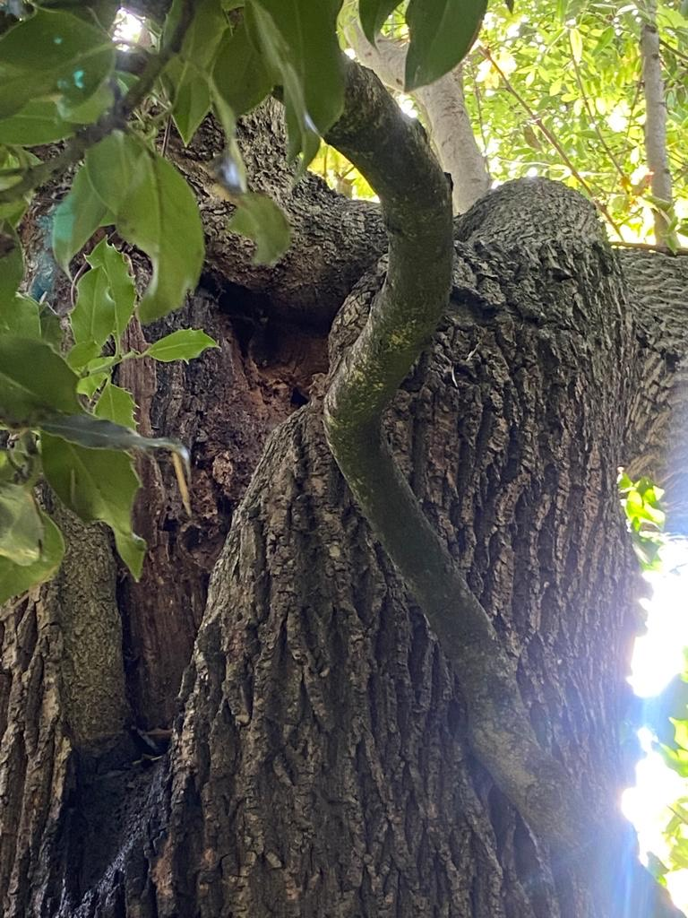

T1: Ash T1: Ash: Decay

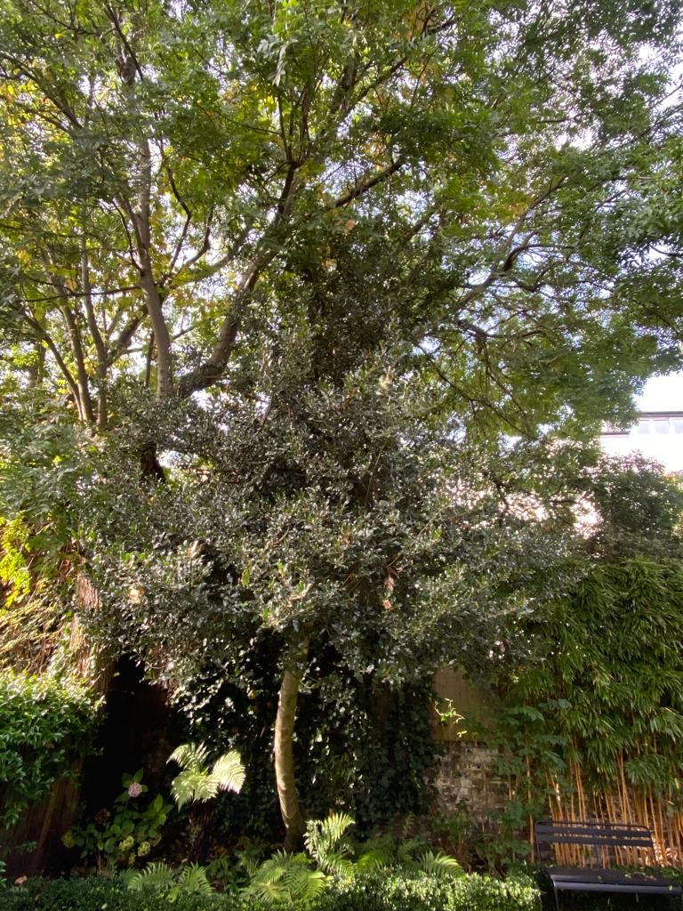 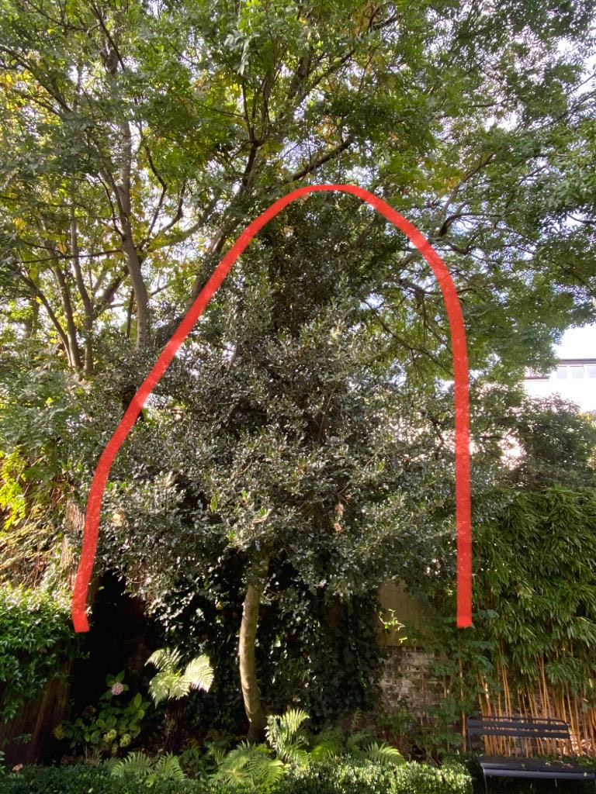

T4: Holly

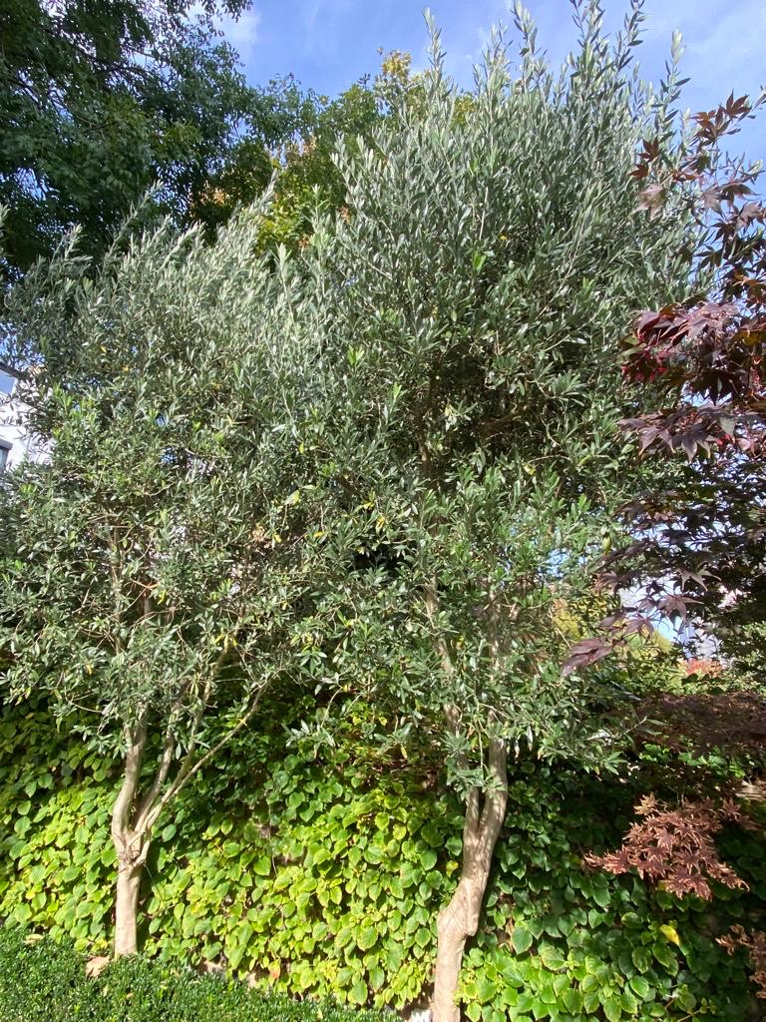

T2: Olive and T3: Olive

T1: Ash (15m): Pollard to 2m above crown break at approximately 7m from ground level due to extensive decay at crown break which is approximately 3m /4m from ground level

T2: Olive (4.5m): Reduce to 1.5m from ground level to keep tree at a size suitable for its location

T3: Olive (4.5m): Reduce to 1.5m from ground level to keep tree at a size suitable for its location

T4: Holly (6m): Reduce height by 50% and trim to create ball shape to keep tree at a size suitable for its location