21a Buckland Crescent NW3 5DH

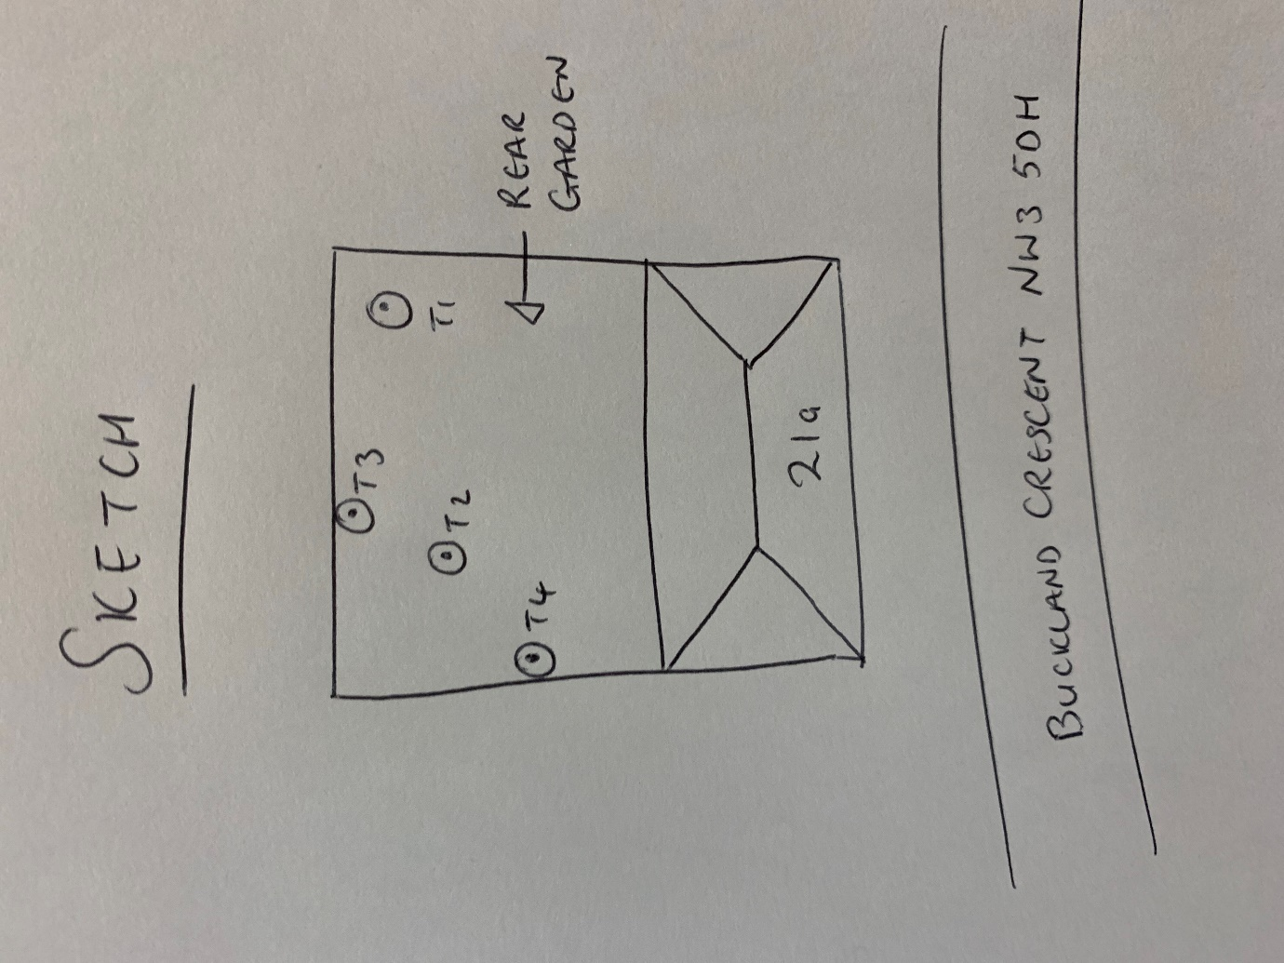

T1: Lime (15m): Re-pollard to previous points removing 2-3m of regrowth to keep tree at a size suitable for its location and as part of regular maintenance

T2: Poplar (18m): Re-pollard to previous points removing up to 7m of regrowth to keep tree at a size suitable for its location and as part of regular maintenance

T3: Poplar (12m): Re-pollard to previous points removing up to 5m of regrowth to keep tree at a size suitable for its location and as part of regular maintenance

T4: Sycamore (15m): Crown reduce by 2m to keep tree at a size suitable for its location and as part of regular maintenance

