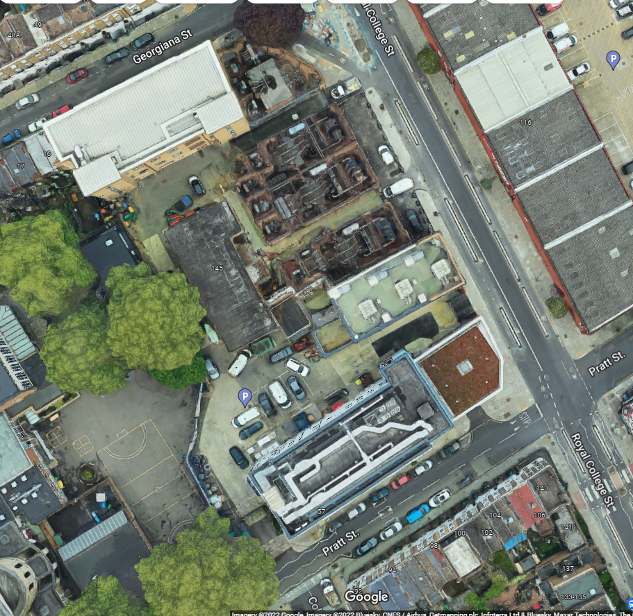

N/A – All vehicles will drive through site entrance and out works exit in a forward motion.

Double gate exit

1 x 1 x CPCS A73 PLANT / TRAFFIC MARSHALL COURSE (TRAFFIC MARSHALL)

Equipped with ‘STOP – WORKS’ signs. Marshals will have radio contact with one another where necessary.

Double gate entry

1 x CPCS A73 PLANT / TRAFFIC MARSHALL COURSE (TRAFFIC MARSHALL)

Equipped with ‘STOP – WORKS’ signs. Marshals will have radio contact with one another where necessary.