**Appendix 2 Sensitive receptors**

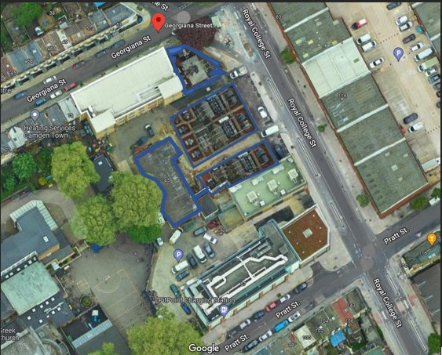

Monitor Positions

Site address: UKPN Georgiana St. Substation, 145 Royal College St, London NW1 0SG

Demolition perimeters in blue.

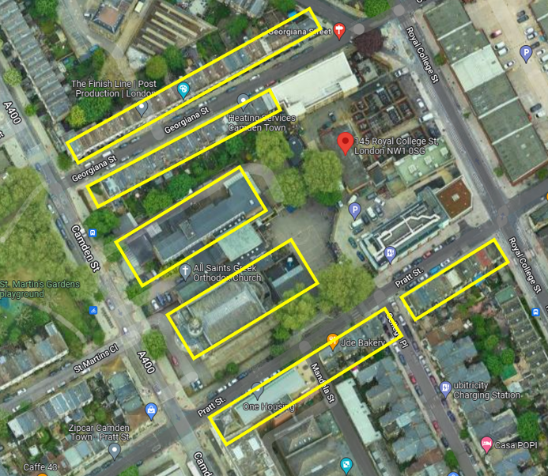

Monitor Positions

Sensitive receptors in yellow

* Dust / Noise /Vibration Monitoring 2 stations Duration 9 weeks

85dB at school facade 35m from source

94.7dB at fence 11.5m from source