**~~Construction/~~ Demolition Management Plan**

pro forma

**Contents**

**Revisions 3**

**Introduction 4**

**Timeframe 6**

**Contact** **7**

**Site** **9**

**Community liaison** **12**

**Transport** **14**

**Environment** **26**

**Agreement 31**

# Revisions & additional material

Please list all iterations here:

|  |  |  |
| --- | --- | --- |
| **Date** | **Version** | **Produced by** |
| **17/10/2022** | **1** | **Niall Maguire** |

**Additional sheets**

Please note – the review process will be quicker if these are submitted as Word documents or searchable PDFs.

|  |  |  |
| --- | --- | --- |
| **Date** | **Version** | **Produced by** |
| **03/10/2022** | **Appendix 1 - CMP Demolition phase draft programme** | **Niall Maguire** |
| **03/10/2022** | **Appendix 2 - Sensitive receptors** | **Niall Maguire** |
| **03/10/2022** | **Appendix 3 - Correspondence with St. Michaels Primary School**   * **St Michaels PS visit 2022.03.15 minutes** * **23/02/2022 - 15/03/2022 correspondence email thread** | **Niall Maguire** |
| **03/10/2022** | **Appendix 4 - Proposed site access and egress points** | **Niall Maguire** |
| **03/10/2022** | **Appendix 5 - plan of existing or anticipated const. sites** | **Niall Maguire** |
| **03/10/2022** | **Appendix 6 – Vehicle approach and departure routes** | **Niall Maguire** |
| **14/10/2022** | **Appendix 7 – Noise survey** | **Niall Maguire** |
| **14/10/2022** | **Appendix 8 (8.1, 8.2, 8.3) – Demolition Risk Assessment and Method Statement** | **Niall Maguire** |
| **n/a** | **Appendix 9 - Engines Off Toolkit for Business** | **Idling Action London** |

# Introduction

The purpose of the **Construction Management Plan (CMP)** is to help developers to minimise construction impacts, and relates to all construction activity both on and off site that impacts on the wider environment.

It is intended to be a live document whereby different stages will be completed and submitted for application as the development progresses.

The completed and signed CMP must address the way in which any impacts associated with the proposed works, and any cumulative impacts of other nearby construction sites, will be mitigated and managed. The level of detail required in a CMP will depend on the scale and nature of development. Further policy guidance is set out in Camden Planning Guidance **(CPG)** 6: Amenity and **(CPG)** 8: Planning Obligations.

This CMP follows the best practice guidelines as described in the [Construction Logistics and Community Safety](https://www.clocs.org.uk/) (**CLOCS**) Standard and the [Guide for Contractors Working in Camden.](https://www.camden.gov.uk/documents/20142/1269042/Guide+for+Contractors+in+Camden.pdf/18b7bb06-119e-9957-7037-fdb633f17ae6)

Camden charges a [fee](https://www.camden.gov.uk/documents/20142/1269042/3.+Construction+and+Demolition+Management+Plans+-+updated+Implementation+Support+Contribution+levels.pdf/6375c32e-9c58-91f0-219f-268269143a6c) for the review and ongoing monitoring of CMPs. This is calculated on an individual basis according to the predicted officer time required to manage this process for a given site.

The approved contents of this CMP must be complied with unless otherwise agreed with the Council in writing. The project manager shall work with the Council to review this CMP if problems arise during construction. Any future revised plan must also be approved by the Council and complied with thereafter.

It should be noted that any agreed CMPdoes not prejudice or override the need to obtain any separate consents or approvals such as road closures or hoarding licences.

If your scheme involves any demolition, you need to make an application to the Council’s Building Control Service. Please complete the “[**Demolition Notice**](https://www.camden.gov.uk/apply-for-building-control-camden)**.**”

Please complete the questions below with additional sheets, drawings and plans as required. The boxes will expand to accommodate the information provided, so please provide as much information as is necessary. It is preferable if this document, and all additional documents, are completed electronically and submitted as Word files to allow comments to be easily documented. These should be clearly referenced/linked to from the CMP. Please only provide the information requested that is relevant to a particular section.

(Note the term 'vehicles' used in this document refers to all vehicles associated with the implementation of the development, e.g. demolition, site clearance, delivery of plant & materials, construction etc.)

Revisions to this document may take place periodically.

**IMPORTANT NOTICE:** If your site falls within a Cumulative Impact Area *(as of 03/02/2020 to 03/08/2020 there is only one established CIA for the Central London area)* you are required to complete the CIA Checklist and circulate as an appendix to the CMP and included as part of any public consultation – a CMP submission will not be accepted until evidence of this has been supplied.

The CIA Checklist can be found at <https://www.camden.gov.uk/about-construction-management-plans>

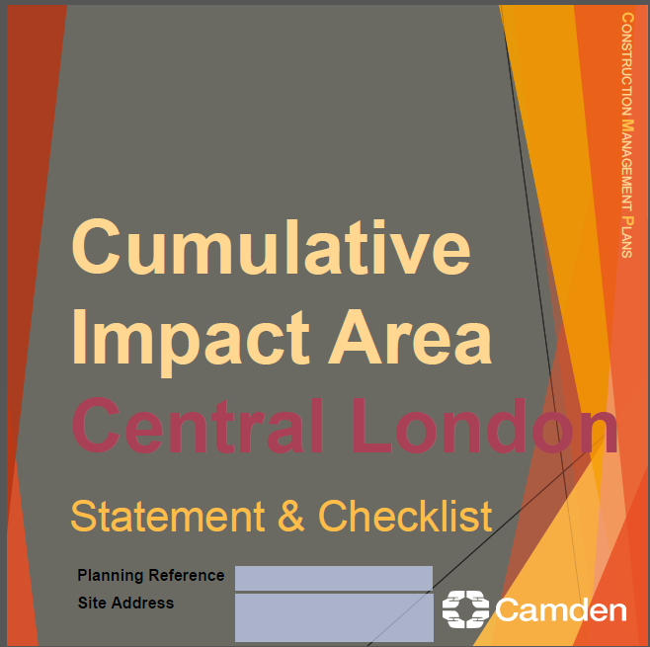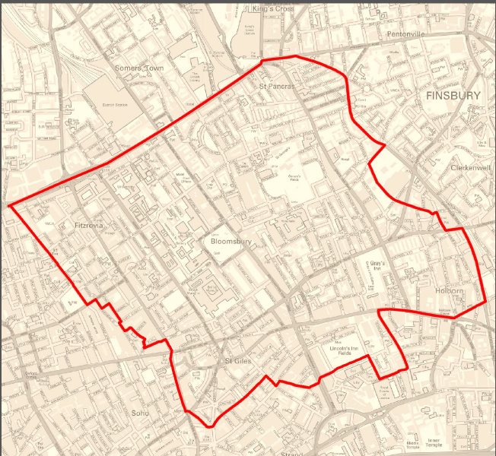Timeframe

**DEVELOPER ACTIONS**

**COUNCIL ACTIONS**

**Planning Permission granted**

**0ommunity liaison**

**Appoint principal contractor**

**Begin community liaison**

**Work can commence if CMP is approved**

**Council response to second draft**

**Submit draft CMP**

**Work can commence if draft CMP is approved**

**Resubmission of CMP if first draft required further development**

**2ommunity liaison**

**3ommunity liaison**

**1ommunity liaison**

INDICATIVE TIMEFRAME (MONTHS)

**4ommunity liaison**

**Council response to draft**

# Contact

1. Please provide the full postal address of the site and the planning reference relating to the construction works.

Address: UKPN St Pancras Substation, 145 Royal College St London NW1 0SG

Planning reference number to which the CMP applies: 2022/4148/NEW

2. Please provide contact details for the person responsible for submitting the CMP.

Name: Niall Maguire

Address: Clancy Group, Darent House, Hawley Mill Road, Dartford, Kent, DA2 7QX

Email: niall.maguire@theclancygroup.co.uk

Phone:07927696365

3. Please provide full contact details of the site project manager responsible for day-to-day management of the works and dealing with any complaints from local residents and businesses.

Name: John Kelly

Address: Clancy Group, Darent House, Hawley Mill Road, Dartford, Kent, DA2 7QX

Email: john.kelly@theclancygroup.co.uk

Phone: 07884 473672

4. Please provide full contact details of the person responsible for community liaison and dealing with any complaints from local residents and businesses if different from question 3. In the case of the Community Investment Programme (CIP), please provide the contact details of the Camden officer responsible.

Name: Hannah Harris

Address: Clancy Group, Darent House, Hawley Mill Road, Dartford, Kent, DA2 7QX

Email: hannah.harris@ukpowernetworks.co.uk & hannah.harris@theclancygroup.co.uk

Phone:07999 407554

5. Please provide full contact details including the address where the main contractor accepts receipt of legal documents for the person responsible for the implementation of the CMP.

Name: Niall Byrne

Address: Clancy Group, Darent House, Hawley Mill Road, Dartford, Kent, DA2 7QX

Email: niall.byrne@theclancygroup.co.uk

Phone: 07807 830729

# Site

6. Please provide a site location plan and a brief description of the site, surrounding area and development proposals for which the CMP applies.

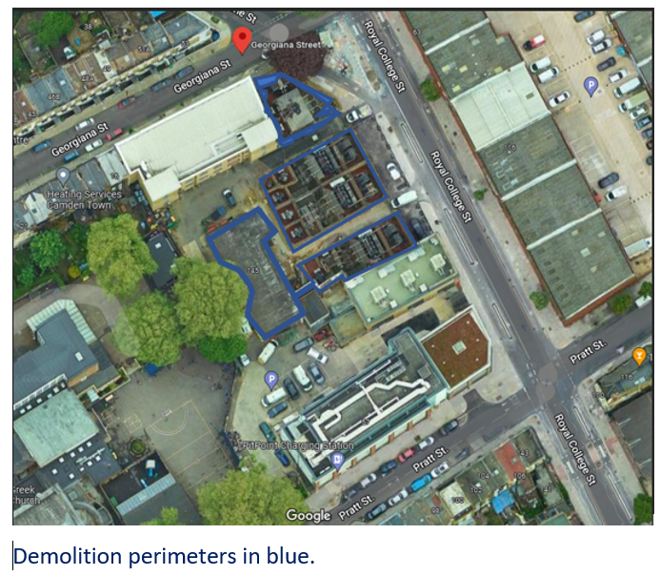

The site is a disused electrical substation.

The buildings immediately North, East and South of the blue demo areas are operational and belong to National Grid and UKPN.

The building beyond the trees is St Michaels Catholic primary school and St Mary’s nursery.

The proposed development includes demolition of the areas in blue and creation of a new external, ground level private carpark in its place, for UKPN only.

7. Please provide a very brief description of the construction works including the size and nature of the development and details of the main issues and challenges (e.g. narrow streets, close proximity to residential dwellings etc).

Brief description of the construction works

On behalf of UKPN, Clancy Group shall carry out the works appointing a subcontractor to demolish the existing disused substation buildings.

Clancy shall;

1. Set up a CDM working area on the site acting as the Principal Contractor
2. Carry out a precondition survey.
3. Install hoarding 3m high on the Royal College St. elevation of the site (approximately 2.5m back from Royal college street footpath, hence no need for a hoarding license).
4. Demolish the areas in blue. Provide noise, dust, and vibration monitoring. Provide dust supression.
5. Place and compact site crushed rubble in the form of 6F2 into St Pancras Substation building basement and voids created by the removal of external walls and foundations.
6. Level the site.
7. Remove surplus rubble / 6F2 from site.13.
8. Carry out a post-demolition condition survey.
9. Demobilize upon completion of Clancy works stated in this WPO.

The area

The area of the demolition and new build is: 1127.4m2 on ground level.

Main issues and challenges

1. The absence of a public footpath on the opposite side of Royal College Street has meant that we have postponed temporary installation of site hoarding tight to the footpath on our side. Initially we will focus on installing hoarding approximately 2.5m back from the footpath. This will serve the demolition phase of the project at least.
2. The project is adjacent to a primary school, Nursery, Church, UKPN and National Grid offices.
3. Royal College Street is a one-way Street.
4. Noisy works restricted to specific times as per the section 61 application response from Camden Council.

8. Please provide the proposed start and end dates for each phase of construction as well as an overall programme timescale. (A Gantt chart with key tasks, durations and milestones would be ideal).

Please see attached Appendix 1 – CMP Demolition phase draft programme

9. Please confirm the standard working hours for the site, noting that the standard working hours for construction sites in Camden are as follows:

* 8.00am to 6pm on Monday to Friday
* 8.00am to 1.00pm on Saturdays
* No working on Sundays or Public Holidays

The project is currently based on 8.00am to 6pm on Monday to Friday.

No weekend works planned.

# Community Liaison

**A neighbourhood consultation process must have been undertaken prior to submission of the CMP first draft.**

**This consultation must relate to construction impacts, and should take place following the granting of planning permission in the lead up to the submission of the CMP. A consultation process specifically relating to construction impacts must take place regardless of any prior consultations relating to planning matters. This consultation must include all of those individuals that stand to be affected by the proposed construction works. These individuals should be provided with a copy of the draft CMP, or a link to an online document. They should be given adequate time with which to respond to the draft CMP, and any subsequent amended drafts. Contact details which include a phone number and email address of the site manager should also be provided.**

Significant time savings can be made by running an effective neighbourhood consultation process. This must be undertaken in the spirit of cooperation rather than one that is dictatorial and unsympathetic to the wellbeing of local residents and businesses.

These are most effective when initiated as early as possible and conducted in a manner that involves the local community. Involving locals in the discussion and decision making process helps with their understanding of what is being proposed in terms of the development process. **The consultation and discussion process should have already started, with the results incorporated into the CMP first draft submitted to the Council for discussion and sign off.**This communication should then be ongoing during the works, with neighbours and any community liaison groups being regularly updated with programmed works and any changes that may occur due to unforeseen circumstances through newsletters, emails and meetings.

Please note that for larger sites, details of a construction working group may be required as a separate S106 obligation. If this is necessary, it will be set out in the S106 Agreement as a separate requirement on the developer.

**Cumulative impact**

Sites located within high concentrations of construction activity that will attract large numbers of vehicle movements and/or generate significant sustained noise levels should consider establishing contact with other sites in the vicinity in order to manage these impacts.

Correspondence has already taken place between The Clancy Group and St Michaels Primary school and Saint Mary’s Nursery (two major stakeholders who are directly next door to the substation).

These properties have no objections to the upcoming noisy works. We have clarified that the only sensitive time will be examination periods. Our demolition dates will not clash with exam dates.

Clancy Group have also emailed and phoned the Greek Orthodox Church (also located directly next door to the substation) but have been unable to get a response from the priest in charge.

The UK Power Networks engagement team will do a community impact assessment and highlight those that may be sensitive to the project team and tailor liaison style to each group. All properties surrounding the substation will receive a letter drop one month prior to the demolition works notifying them of upcoming works and then another letter closer to the time to remind them of upcoming works. Some stakeholders will be identified as sensitive and face to face meetings will be set up for those. Any delays to the programme of works (if applicable) will be communicated via a letter drop as soon as we can confirm the new dates.

Any queries around the work will be dealt personally and suitably.

An example of the type of letters that would be distributed is attached.

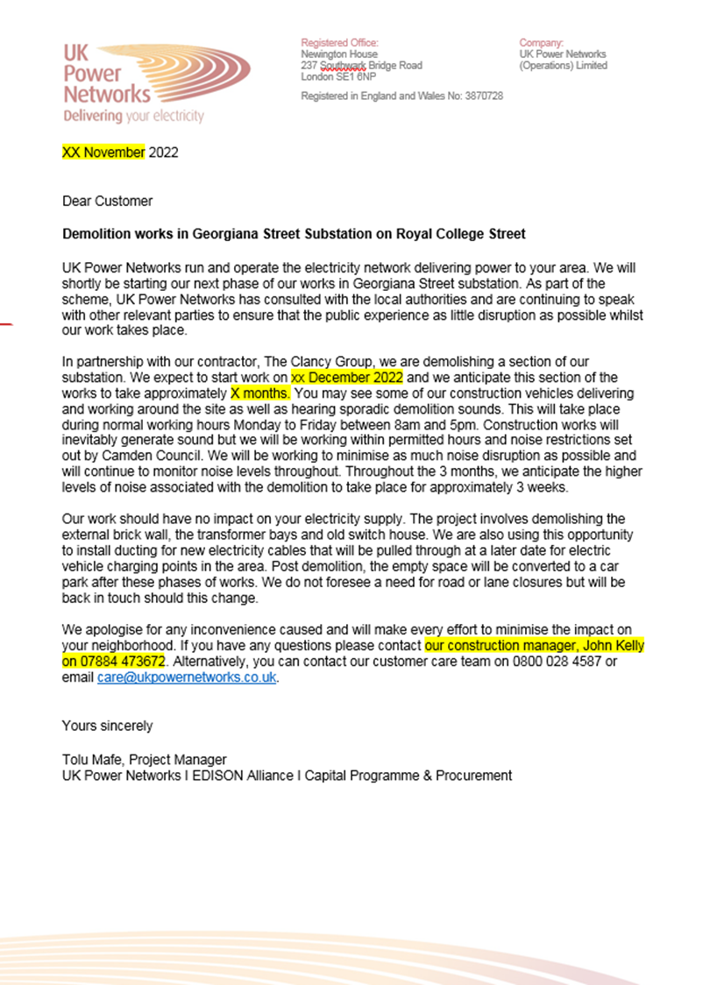

**The Council can advise on this if necessary.**

**10. Sensitive/affected receptors**

Please identify the nearest potential receptors (dwellings, business, etc.) likely to be affected by the activities on site (i.e. noise, vibration, dust, fumes, lighting etc.).

Please see attached Appendix 2 - Sensitive receptors

**11. Consultation**

The Council expects meaningful consultation. For large sites, this may mean two or more meetings with local residents **prior to submission of the first draft CMP**.

Evidence of who was consulted, how the consultation was conducted and a summary of the comments received in response to the consultation should be included. Details of meetings including minutes, lists of attendees etc. should be appended.

In response to the comments received, the CMP should then be amended where appropriate and, where not appropriate, a reason given. The revised CMP should also include a list of all the comments received. Developers are advised to check proposed approaches to consultation with the Council before carrying them out. If your site is on the boundary between boroughs then we would recommend contacting the relevant neighbouring planning authority.

Please provide details of consultation of the draft CMP with local residents, businesses, local groups (e.g. residents/tenants and business associations) and Ward Councillors.

Please see attached Appendix 3 correspondence with St Michaels Primary school.

**12. Construction Working Group**

For particularly sensitive/contentious sites, or sites located in areas where there are high levels of construction activity, it may be necessary to set up a construction working group.

If so, please provide details of the group that will be set up, the contact details of the person responsible for community liaison and how this will be advertised to the local community, and how the community will be updated on the upcoming works i.e. in the form of a newsletter/letter drop, or weekly drop in sessions for residents.

Letter drops shall be carried out by UKPN to notify residents of anything worthy of their attention.

**13. Schemes**

Please provide details of your Considerate Constructors Scheme (CCS) registration. Please note that Camden requires [CCS site registration](https://protect-eu.mimecast.com/s/RhAACROA3cPkr7OT9fD9T?domain=ccscheme.org.uk/) for the full duration of your project including additional [CLOCS visits](https://protect-eu.mimecast.com/s/PK6ZCVAG3FjLlOZCzThUa?domain=ccscheme.org.uk/). Please provide the CCS site ID number that is specific to the above site.

Contractors will also be required to follow the [Guide for Contractors Working in Camden](https://www.camden.gov.uk/documents/20142/1269042/Guide+for+Contractors+in+Camden.pdf/18b7bb06-119e-9957-7037-fdb633f17ae6). Please confirm that you have read and understood this, and that you agree to abide by it.

Clancy shall register the site for CCS. Clancy will state the CCS registration in the next revision of this Demolition / Construction Management Plan.

Clancy understand and agree with the guide for Contractors Working in Camden.

**14. Neighbouring sites**

Please provide a plan of existing or anticipated construction sites in the local area and please state how your CMP takes into consideration and mitigates the cumulative impacts of construction in the vicinity of the site. The council can advise on this if necessary.

Please see attached Appendix 5 plan of existing or anticipated const. sites.

Clancy do not foresee an issue as the adjacent BAM site entrances / exits as they are not on Royal College Street.

Currently road traffic is not excessive, and it has remained like this since early 2022. Site has been visited a lot and the traffic is never excessive.

# Transport

**This section must be completed in conjunction with your principal contractor. If one is not yet assigned, please leave the relevant sections blank until such time when one has been appointed.**

Camden is a CLOCS Champion, and is committed to maximising road safety for Vulnerable Road Users (VRUs) as well as minimising negative environmental impacts created by motorised road traffic. As such, all vehicles and their drivers servicing construction sites within the borough are bound by the conditions laid out in the CLOCS Standard.

This section requires details of the way in which you intend to manage traffic servicing your site, including your road safety obligations with regard to VRU safety. It is your responsibility to ensure that your principal contractor is fully compliant with the terms laid out in the CLOCS Standard. It is your principal contractor’s responsibility to ensure that all contractors and sub-contractors attending site are compliant with the terms laid out in the CLOCS Standard.

Checks of the proposed measures will be carried out by CCS monitors as part of your enhanced CCS site registration, and possibly council officers, to ensure compliance. Please refer to the CLOCS Standard when completing this section.

Please contact [CLOCS@camden.gov.uk](mailto:CLOCS@camden.gov.uk) for further advice or guidance on any aspect of this section.

**CLOCS Contractual Considerations**

15. Name of Principal contractor:

Clancy Group

16. Please submit the proposed method for checking operational, vehicle and driver compliance with the CLOCS Standard throughout the duration of the contract.

All Clancy deliveries and collection of materials will be checked by company administration to ensure that they are accredited by the FORS scheme. A layout of the site route is to be provided to all delivery and collection drivers to ensure the correct route is used to minimise disruption along with allowable delivery and collection times. All drivers of vehicles over 3.5t will have undertaken Safe Urban Driver training before entering any site area. All vehicles over 3.5t will also be fitted with blind spot minimization equipment and audible turn left alerts. This will be cascaded to all delivering/collection suppliers wishing to visit site. Where FORS Bronze operators are appointed, written assurances will be sought which cover these requirements.

17. Please confirm that you as the client/developer and your principal contractor have read and understood the CLOCS Standard and included it in your contracts.

I confirm that I have included the requirement to abide by the CLOCS Standard in my contracts to my contractors and suppliers:

Confirmed; Niall Maguire – Clancy Pre-Construction Project Manager.

Confirmed; Tolu Mafe – UKPN Project Manager.

Please contact [CLOCS@camden.gov.uk](mailto:CLOCS@camden.gov.uk) for further advice or guidance on any aspect of this section.

**Site Traffic**

**Sections below shown in blue directly reference the CLOCS Standard requirements. The CLOCS Standard should be read in conjunction with this section.**

**18. Traffic routing**: *“Clients shall ensure that a suitable, risk assessed vehicle route to the site is specified and that the route is communicated to all contractors and drivers. Clients shall make contractors and any other service suppliers aware that they are to use these routes at all times unless unavoidable diversions occur.”* (P19, 3.4.5)

Routes should be carefully considered and risk assessed, taking into account the need to avoid where possible any major cycle routes and trip generators such as schools, offices, stations, public buildings,museums etc.

Consideration should also be given to weight restrictions, low bridges and cumulative impacts of construction (including neighbouring construction sites) on the public highway network. The route(s) to and from the site should be suitable for the size of vehicles that are to be used.

Please show vehicle approach and departure routes between the site and the Transport for London Road Network (TLRN). Please note that routes may differ for articulated and rigid HGVs.

Routes should be shown clearly on a map, with approach and departure routes clearly marked. If this is attached, use the following space to reference its location in the appendices.

Appendix 4 - Proposed site access and egress points

See Appendix 6 – Vehicle approach and departure routes

b. Please confirm how contractors and delivery companies will be made aware of the route (to and from the site) and of any on-site restrictions, prior to undertaking journeys.

All suppliers will be sent route plans prior to commencement of deliveries.

Clancy will endeavour where possible to minimise the number of articulated vehicles delivering materials to site.

**19. Control of site traffic, particularly at peak hours**: “*Clients shall consider other options to plan and control vehicles and reduce peak hour deliveries”* (P20, 3.4.6)

Construction vehicle movements should be restricted to the hours of 9.30am to 4.30pm on weekdays and between 8.00am and 1.00pm on Saturdays. If there is a school in the vicinity of the site or on the proposed access and/or egress routes, then deliveries must be restricted to the hours of 9.30am and 3pm on weekdays during term time.

Vehicles may be permitted to arrive at site at 8.00am if they can be accommodated on site. Where this is the case they must then wait with their engines switched off.

A delivery plan should ensure that deliveries arrive at the correct part of site at the correct time. Instructions explaining such a plan should be sent to all suppliers and contractors**.**

Please provide details of the types of vehicles required to service the site and the approximate number of deliveries per day for each vehicle type during the various phases of the project.

For Example:

32t Tipper: 10 deliveries/day during first 4 weeks

Skip loader: 2 deliveries/week during first 10 weeks

Artic: plant and tower crane delivery at start of project, 1 delivery/day during main construction phase project

18t flatbed: 2 deliveries/week for duration of project

3.5t van: 2 deliveries/day for duration of project

**For the 9-week demolition phase only**:

32t Tipper: 3 collections /day during first 9 weeks

Skip loader: 1 collection/week during first 9 weeks

Artic: 2 plant deliveries at start of project and plant removal at week 9

18t flatbed: 2 deliveries/week for first 9 weeks

3.5t van: 2 deliveries/day for first 9 weeks

Low-loaders

Muckaway trucks

b. Cumulative effects of construction traffic servicing multiple sites should be minimised where possible. Please provide details of other developments in the local area or on the route that might require deliveries coordination between two or more sites. This is particularly relevant for sites in very constrained locations.

Please see appendix 5 - plan of existing or anticipated const. sites

c. Please provide swept path analyses for constrained manoeuvres along the proposed route.

Not required as the largest vehicle entering site directly from the road will be 32T tipper lorries or similar and ample space is available.

d. Consideration should be given to the location of any necessary holding areas/waiting points for sites that can only accommodate one vehicle at a time/sites that are expected to receive large numbers of deliveries. Vehicles must not queue or circulate on the public highway. Whilst deliveries should be given set times to arrive, dwell and depart, no undue time pressures should be placed upon the driver at any time.

Please identify the locations of any off-site holding areas or waiting points. This can be a section of single yellow line that will allow the vehicle to wait to phone the site to check that the delivery can be accommodated.

Please refer to question 24 if any parking bay suspensions will be required to provide a holding area.

During the demolition phase no holding area or waiting points are required.

There shall be ample room onsite for a delivery vehicle to arrive without having to queue or circulate on the public highway.

Set delivery times will be adhered to.

Please note Clancy’s demolition subcontractor (name to be confirmed) will offload a 25t and 35t excavator on Royal College Street while using road surface protection mats.

The site entrance and space inside site may be too tight to otherwise enable delivery and collection of these items directly.

All licenses including escort vehicles relating to this in conjunction with the police and councils would be looked after by our demo subcontractor.

e. Delivery numbers should be minimised where possible. Please investigate the use of construction material consolidation centres, and/or delivery by water/rail if appropriate.

As this phase is demolition very few deliveries to site shall take place.

The maximum amount of demolition rubble shall be crushed and used as backfill on site.

Most vehicle movements shall be removal of rubble from site as opposed to deliveries to site.

f. Emissions from engine idling should be minimised where possible. Please provide details of measures that will be taken to reduce delivery vehicle engine idling, both on and off site (this does not apply to concrete mixers).

Clancy shall ensure that vehicles which are not moving will not be idling.

Traffic Marshalls shall enforce this.

Site signage will display this.

**20. Site access and egress:** “*Clients shall ensure that access to and egress from the site is appropriately managed, clearly marked, understood and clear of obstacles.”* (P18, 3.4.3)

This section is only relevant where vehicles will be entering the site. Where vehicles are to load from the highway, please skip this section and refer to Q23.

Vehicles entering and leaving the site should be carefully managed, using gates that are clearly marked and free from obstacles. Traffic marshals must ensure the safe passage of all traffic on the public highway, in particular pedestrians and cyclists, when vehicles are entering and leaving site, particularly if reversing.

Traffic marshals, or site staff acting as traffic marshals, should hold the relevant qualifications required for directing large vehicles when reversing. Marshals should be equipped with ‘STOP – WORKS’ signs (not STOP/GO signs) if control of traffic on the public highway is required. Marshals should have radio contact with one another where necessary.

a. Please detail the proposed site access and egress points on a map or diagram. If this is attached, use the following space to reference its location in the appendices.

Please see appendix 4 - Proposed site access and egress points

b. Please describe how the access and egress arrangements for construction vehicles in and out of the site will be managed, including the number and location of traffic marshals where applicable. If this is shown in an attached drawing, use the following space to reference its location in the appendices.

Please see appendix 4 - Proposed site access and egress points

c. Please provide swept path drawings for vehicles accessing/egressing the site if necessary. If these are attached, use the following space to reference their location in the appendices.

Not required as the largest vehicle entering site directly from the road will be 32T tipper lorries or similar and ample space is available.

d. Provision of wheel washing facilities should be considered if necessary. If so, please provide details of how this will be managed and any run-off controlled. Please note that wheel washing should only be used where strictly necessary, and that a clean, stable surface for loading should be used where possible.

A jet wash shall be used onsite for jetting down any dirty vehicles.

This will be done in an area above a grated manhole or gulley’s.

Run-off water will not leave the site as a result.

**21. Vehicle loading and unloading:** *“Clients shall ensure that vehicles are loaded and unloaded on-site as far as is practicable.”* (P19, 3.4.4)

This section is only relevant if loading/unloading is due to take place off-site on the public highway. If loading is taking place on site, please skip this section.

1. please provide details of the parking and loading arrangements for construction vehicles with regard to servicing and deliveries associated with the site (e.g., delivery of materials and plant, removal of excavated material). This is required as a scaled site plan, showing all points of access and where materials, skips and plant will be stored, and how vehicles will access and egress the site. If this is attached, use the following space to reference its location in the appendices. Please outline in question 24 if any parking bay suspensions will be required.

Please note Clancy’s demolition subcontractor (name to be confirmed) will offload a 25t and 35t excavator on Royal College Street while using road surface protection mats.

The site entrance and space inside site may be too tight to otherwise enable delivery and collection of these items directly.

All licenses including escort vehicles relating to this in conjunction with the police and councils would be looked after by our demo subcontractor.

b. Where necessary, Traffic Marshalls must ensure the safe passage of pedestrians, cyclists and motor traffic in the street when vehicles are being loaded or unloaded. Please provide detail of the way in which marshals will assist with this process, if this differs from detail provided in Q20 b.

Same as 20 (b).

**Street Works**

**Full justification must be provided for proposed use of the public highway to facilitate works. Camden expects all options to minimise the impact on the public highway to have been fully considered prior to the submission of any proposal to occupy the highway for vehicle pit lanes, materials unloading/crane pick points, site welfare etc.**

**Please note that Temporary Traffic Orders (TTOs) and hoarding/scaffolding licenses may be applied for prior to CMP submission but won’t be granted until the CMP is signed-off.**

**Please note that there is a two week period required for the statutory consultation process to take place as part of a TTO.**

**If the site is on or adjacent to the TLRN, please provide details of preliminary discussions with Transport for London in the relevant sections below.**

**If the site conflicts with a bus lane or bus stop, please provide details of preliminary discussions with Transport for London in the relevant sections below.**

**22. Site set-up**

Please provide a scaled plan detailing the local highway network layout in the vicinity of the site. This should include details of on-street parking bay locations, cycle lanes, footway extents, relevant street furniture, and proposed site access locations. If these are attached, use the following space to reference their location in the appendices.

As per 21(a).

**23. Parking bay suspensions and temporary traffic orders**

Parking bay suspensions should only be requested where absolutely necessary and these are permitted for a maximum of 6 months only. For exclusive access longer than 6 months, you will be required to obtain a [Temporary Traffic Order (TTO)](https://www.camden.gov.uk/temporary-traffic-restrictions) for which there is a separate cost.

Please provide details of any proposed parking bay suspensions and/or TTO’s which would be required to facilitate the construction - including details of the expected duration in months/weeks. Building materials and equipment must not cause obstructions on the highway as per your CCS obligations unless the requisite permissions are secured.

Information regarding parking suspensions can be found [here.](http://www.camden.gov.uk/ccm/navigation/transport-and-streets/parking/parking-bay-suspensions/)

None required.

**24. Occupation of the public highway**

Please note that use of the public highway for storage, site accommodation or welfare facilities is at the discretion of the Council and is generally not permitted. If you propose such use you must supply full justification, setting out why it is impossible to allocate space on-site. We prefer not to close footways but if this is unavoidable, you should submit a scaled plan of the proposed diversion route showing key dimensions.

a. Please provide justification of the proposed occupation of the public highway.

None required.

b. Please provide accurate scaled drawings of any highway works necessary to enable construction to take place (e.g. construction of temporary vehicular accesses, removal of street furniture etc). If these are attached, use the following space to reference their location in the appendices.

None required.

**25. Motor vehicle and/or cyclist diversions**

Where applicable, please supply details of any diversion, disruption or other anticipated use of the public highway during the construction period. Please show locations of diversion signs on drawings or diagrams. If these are attached, use the following space to reference their location in the appendices.

None required.

**26. Scaffolding, hoarding, and associated pedestrian diversions**

Pedestrians’ safety must be maintained if diversions are put in place. Vulnerable footway users should also be considered. These include wheelchair users, the elderly, those with walking difficulties, young children, those with prams, the blind and partially sighted. Appropriate ramps must be used if cables, hoses, etc. are run across the footway.

Any work above ground floor level may require a covered walkway adjacent to the site. A licence must be obtained for scaffolding and gantries. The adjoining public highway must be kept clean and free from obstructions, and hoarding should not restrict access to adjoining properties, including fire escape routes. Lighting and signage should be used on temporary structures/skips/hoardings etc.

A secure hoarding will generally be required at the site boundary with a lockable access.

a. Where applicable, please provide details of any hoarding and/or scaffolding that intrudes onto the public highway, describing how pedestrian safety will be maintained through the diversion, including any proposed alternative routes. Please provide detailed, scale drawings that show hoarding lines, gantries, crane locations, scaffolding, pedestrian routes, parking bay suspensions, remaining road width for vehicle movements, temporary vehicular accesses, ramps, barriers, signage, lighting etc. If these are attached, use the following space to reference their location in the appendices.

None required.

b. Please provide details of any other temporary structures which would overhang/oversail the public highway (e.g. scaffolding, gantries, cranes etc.) If these are attached, use the following space to reference their location in the appendices.

None required.

**27. Services**

Please indicate if any changes to services are proposed to be carried out that would be linked to the site during the works (i.e. connections to public utilities and/or statutory undertakers’ plant). Larger developments may require new utility services. If so, a strategy and programme for coordinating the connection of services will be required. If new utility services are required, please confirm which utility companies have been contacted (e.g. Thames Water, National Grid, EDF Energy, BT etc.) You must explore options for the utility companies to share the same excavations and traffic management proposals. Please supply details of your discussions.

None required.

# Environment

To answer these sections please refer to the relevant sections of **Camden’s Minimum Requirements for Building Construction (**[**CMRBC**](https://www.camden.gov.uk/about-construction-management-plans)**).**

28. Please list all [noisy operations](http://www.camden.gov.uk/ccm/content/environment/environmental-health--consumer-protection/noise/reducing-noise/noise-from-construction-sites.en?page=2)  and the construction method used, and provide details of the times that each of these are due to be carried out.

**Restricted hours of work for noisy works: 09:00 to 12:00 and 14:00 to 17:00.**

Mechanically shovelling debris - Komatsu PC210 track machine 102 dB(A)

Breaking up the building components - Furukawa FXJ 275 Hydraulic breaker 126 LWA(dB)

Mechanically shovelling debris - Doosan DX255LC-5 track machine 103 dB(A)

Crushing the material - Extec C-12+ mobile crusher 97 dB at 1m

Breaking up the building components - Pulverizer 76 dBA at 10m

29. Please confirm when the most recent noise survey was carried out (before any works were carried out) and provide a copy. If a noise survey has not taken place please indicate the date (before any works are being carried out) that the noise survey will be taking place, and agree to provide a copy.

Appendix 7 – Noise survey.

30. Please provide predictions for [noise](http://www.camden.gov.uk/ccm/content/environment/environmental-health--consumer-protection/noise/reducing-noise/noise-from-construction-sites.en?page=2) and vibration levels throughout the proposed works.

As per 28.

31. Please provide details describing mitigation measures to be incorporated during the construction/[demolition](http://www.camden.gov.uk/ccm/navigation/environment/building-control/demolition/) works to prevent noise and vibration disturbances from the activities on the site, including the actions to be taken in cases where these exceed the predicted levels.

Noise will be monitored throughout the demolition phase.

Equipment made specifically for demolition.

• Demolition equipment utilised by a specialised and experienced demolition contractor.

• Noise and vibration monitoring equipment utilised during the works.

• Prior engagement with adjacent residents.

• Compliance with BS 5228-1:2009+A1:2014 Code of practice for noise and vibration control on construction and open sites Part 1: Noise & Part 2: Vibration.

• Please see attached Method Statement and Risk Assessments for more detail – Appendix 8 (8.1,8.2,8.3).

• Restricted noisy works from 09:00 to 12:00 and 14:00 to 17:00.

In a case where the predicted noise levels are exceeded, we shall stop and re-assess how to proceed below the limits.

32. Please provide evidence that staff have been trained on BS 5228:2009

Adequate staff or subcontractor personnel shall have BS 5228:2009 training prior to the start of the demolition phase.

Proof of training shall be provided once obtained.

33. Please provide specific details on how air pollution and dust nuisance arising from dusty activities on site will be prevented. This should be relevant and proportionate to activities due to take place, with a focus on both preventative and reactive mitigation measures.

Dust will be always suppressed during demolition works using suppression techniques such as, handheld water sprays, water cannons, water hoses and connections, Vacuums, extractor fans.

Works area to be monitored using handheld monitor during breaking and sweeping operations.

34. Please provide details describing how any significant amounts of dirt or dust that may be spread onto the public highway will be prevented and/or cleaned.

Please see 33.

In the very unlikely event that dirt or dust spreads onto the public highway Clancy will immediately remove it as per a safe system of work.

35. Please provide details describing arrangements for monitoring of [noise](http://www.camden.gov.uk/ccm/content/environment/environmental-health--consumer-protection/noise/reducing-noise/noise-from-construction-sites.en?page=2), vibration and dust levels, including instrumentation, locations of monitors and trigger levels where appropriate.

**Noise:**

3 noise sensors for a period of 9 weeks. Inside each weatherproof cabinet is a single MEMS noise sensor and communications/computing hardware for upload via 4G.

The noise monitor will continually sample LAF, calculating LAFMax within each minute, and uploading that reading to our cloud.

Standard alerting and contextual information (such as adding notes) will be available, but we expect that they may not be used in this use case. For the purposes of exporting data readings, each user will be able (for each sensor) to:

o View a graph of the maximum LAFMax reading obtained within each hour

o Export summarised readings into a CSV file. The file includes one row for each hour, with each row storing the maximum LAFMax reading during that hour.

**Dust:**

3 air quality sensors for a period of 9 weeks. Inside each weatherproof cabinet is a Particulate counter for PM 1, PM 2.5 & PM10 as well as gas pollution measurement unit for NO2 as well as communications/computing hardware for upload via 4G (data costs are included).

The air quality sensors will continually sample the air quality every 10 seconds and upload these readings to our cloud.

Standard alerting and contextual information (such as adding notes) will be available but we expect that they may not be used in this use-case. For the purposes of exporting data readings, each user will be able (for each sensor) to:

o View a graph of the PM 10, PM 2.5 and PM 1 min and maximum readings obtained within each hour

o Export summarised readings into a CSV file. The file includes one row for each hour, with each row storing the PM and NO 2 reading during that hour.

o Correlate the 9-week data to WHO or DEFRA standards are required as a standalone report at the end of the 9 weeks.

**Vibration:**

3 vibration monitors for a period of 9 weeks.

Similar format as above.

Clancy are currently seeking confirmation of UKPN’s vibration trigger levels.

36. Please confirm that an Air Quality Assessment and/or Dust Risk Assessment has been undertaken at planning application stage in line with the GLA policy [The Control of Dust and Emissions During Demolition and Construction 2014 (SPG)](https://www.london.gov.uk/what-we-do/planning/implementing-london-plan/london-plan-guidance-and-spgs/control-dust-and) (document access at bottom of webpage), and that the summary dust impact risk level (without mitigation) has been identified. The risk assessment must take account of proximity to all human receptors and sensitive receptors (e.g. schools, care homes etc.), as detailed in the [SPG](https://www.google.com/url?sa=t&rct=j&q=&esrc=s&source=web&cd=&cad=rja&uact=8&ved=2ahUKEwjk8qS10KXvAhWQQRUIHWToAWcQFjABegQIAxAD&url=https%3A%2F%2Fwww.london.gov.uk%2Fsites%2Fdefault%2Ffiles%2Fgla_migrate_files_destination%2FDust%2520and%2520Emissions%2520SPG%25208%2520July%25202014.pdf&usg=AOvVaw06DJ0urJ7JWa8G5jmd_p8N). **Please attach the risk assessment and mitigation checklist as an appendix**.

UKPN have confirmed that an Air Quality Assessment and/or Dust Risk Assessment has not been undertaken yet.

Air quality and dust monitoring will be monitored during demolition phase.

37. Please confirm that all of the GLA’s ‘highly recommended’ measures from the SPG document relative to the level of dust impact risk identified in question 36 have been addressed by completing the GLA mitigation measures checklist. (See Appendix 7 of the SPG document.)

UKPN have confirmed that an Air Quality Assessment and/or Dust Risk Assessment has not been undertaken yet.

Air quality and dust monitoring will be monitored during demolition phase.

38. Please confirm the number of real-time dust monitors to be used on-site.

Note: **real-time dust (PM10) monitoring with MCERTS ‘Indicative’ monitoring equipment will be required for** **all sites with a high OR medium dust impact risk level**. If the site is a ‘high impact’ site, 4 real time dust monitors will be required. If the site is a ‘medium impact’ site’, 2 real time dust monitors will be required.

The dust monitoring must be in accordance with the SPG and IAQM guidance, and **the proposed dust monitoring regime (including number of monitors, locations, equipment specification, and trigger levels) must be submitted to the Council for approval**. Dust monitoring is required for the entire duration of the development and must be in place and operational **at least three months prior to the commencement of works on-site**. Monthly dust monitoring reports must be provided to the Council detailing activities during each monthly period, dust mitigation measures in place, monitoring data coverage, graphs of measured dust (PM10) concentrations, any exceedances of the trigger levels, and an explanation on the causes of any and all exceedances in addition to additional mitigation measures implemented to rectify these.

In accordance with Camden’s Clean Air Action Plan, the monthly dust monitoring reports must also be made readily available and accessible online to members of the public soon after publication. Information on how to access the monthly dust monitoring reports should be advertised to the local community (e.g. presented on the site boundaries in full public view).

**Inadequate dust monitoring or reporting, or failure to limit trigger level exceedances, will be indicative of poor air quality and dust management and will lead to enforcement action.**

2 dust monitors to be used.

39. Please provide details about how rodents, including rats, will be prevented from spreading out from the site. You are required to provide information about site inspections carried out and present copies of receipts (if work undertaken).

Rodents will not be an issue.

The site has no rodents.

40. Please confirm when an asbestos survey was carried out at the site and include the key findings.

Date asbestos survey carried out: 15 Nov 2019.

Key findings: Non notifiable asbestos was found in the ground floor slab of the substation building to be demolished.

Date asbestos survey carried out: September 2022.

Key findings: Asbestos found in the transformer bay walls. To be removed from there and the substation ground floor slab by specialist contractor in October 2022

41. Complaints often arise from the conduct of builders in an area. Please confirm steps being taken to minimise this e.g. provision of a suitable smoking area, tackling bad language and unnecessary shouting.

Smoking areas will be provided within site.

Personnel will be briefed on induction not to shout other than in an emergency and always avoid foul language.

42. If you will be using non-road mobile machinery (NRMM) on site with net power between 37kW and 560kW it will be required to meet the standards set out below. The standards are applicable to both variable and constant speed engines and apply for both PM and NOx emissions. See the Mayor of London webpage ‘Non-Road Mobile Machinery (NRMM)’ for more information, a map of the Central Activity Zone, and for links to the NRMM Register and the NRMM Practical guide (V4):

<https://www.london.gov.uk/what-we-do/environment/pollution-and-air-quality/nrmm>

Direct link to NRMM Practical Guide (V4):

<https://www.london.gov.uk/sites/default/files/nrmm_practical_guide_v4_sept20.pdf>

**From 1st September 2015**

**(i) Major Development Sites** – NRMM used on the site of any major development will be required to meet Stage IIIA of EU Directive 97/68/EC

**(ii) Any development site within the Central Activity Zone -** NRMM used on any site within the Central Activity Zone will be required to meet Stage IIIB of EU Directive 97/68/EC

**From 1st September 2020**

**(iii) Any development site -** NRMM used on any site within Greater London will be required to meet Stage IIIB of EU Directive 97/68/EC

**(iv) Any development site within the Central Activity Zone -** NRMM used on any site within the Central Activity Zone will be required to meet Stage IV of EU Directive 97/68/EC

Please provide evidence demonstrating the above requirements will be met by answering the following questions:

1. Construction time; Demolition phase December 2022 – March 2023
2. Is the development within the CAZ? (Y/N): No
3. Will the NRMM with net power between 37kW and 560kW meet the standards outlined above? (Y/N): Yes.
4. Please confirm that all relevant machinery will be registered on the NRMM Register, including the site name under which it has been registered: Yes.
5. Please confirm that an inventory of all NRMM will be kept on site and that all machinery will be regularly serviced and service logs kept on site for inspection: Yes.
6. Please confirm that records will be kept on site which details proof of emission limits, including legible photographs of individual engine plates for all equipment, and that this documentation will be made available to local authority officers as required: Yes.

43. Vehicle engine idling (leaving engines running whilst parked or not in traffic) produces avoidable air pollution and can damage the health of drivers and local communities. Camden Council and the City of London Corporation lead the London **Idling** **Action Project** to educate drivers about the health impacts of air pollution and the importance of switching off engines as a simple action to help protect the health of all Londoners.

Idling Action calls for businesses and fleet operators to take the **Engines Off pledge** to reduce emissions and improve air quality by asking fleet drivers, employees and subcontractors to avoid idling their engines wherever possible. Free driver training materials are available from the website: <https://idlingaction.london/business/>

Please provide details about how you will reduce avoidable air pollution from engine idling, including whether your organisation has committed to the Engines Off pledge and the number of staff or subcontractors who have been provided with free training materials.

Clancy are committed to the Engines Off pledge.

Engines off when:

1. Making deliveries and collections.
2. Waiting for someone
3. Phone charging
4. Running the heater
5. Running the air conditioning
6. When taking a break.

Once nominated, the subcontractors shall be provided with the attached free training.

material.

Once the demolition starts onsite, all personnel shall be provided with the attached free training material.

SYMBOL IS FOR INTERNAL USE

# Agreement

The agreed contents of this Construction Management Plan must be complied with unless otherwise agreed in writing by the Council. This may require the CMP to be revised by the Developer and reapproved by the Council. The project manager shall work with the Council to review this Construction Management Plan if problems arise in relation to the construction of the development. Any future revised plan must be approved by the Council in writing and complied with thereafter.

It should be noted that any agreed Construction Management Plan does not prejudice further agreements that may be required such as road closures or hoarding licences.

**Signed:** 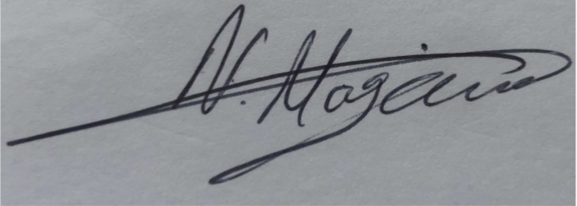

**Date: 14/10/2022**

**Print Name:** Niall Maguire…………………………………………………….

**Position:** Clancy Group, Pre-Construction Project Manager

*(Note: Once the Demolition phase commences N Maguire will be replaced by the Clancy Construction phase Project Manager who will then gain Project Manager responsibilities for this document and its revisions.*

Please submit to: [planningobligations@camden.gov.uk](mailto:planningobligations@camden.gov.uk)

**End of form.**V2.8