122 Greencroft Gardens NW6 3PJ

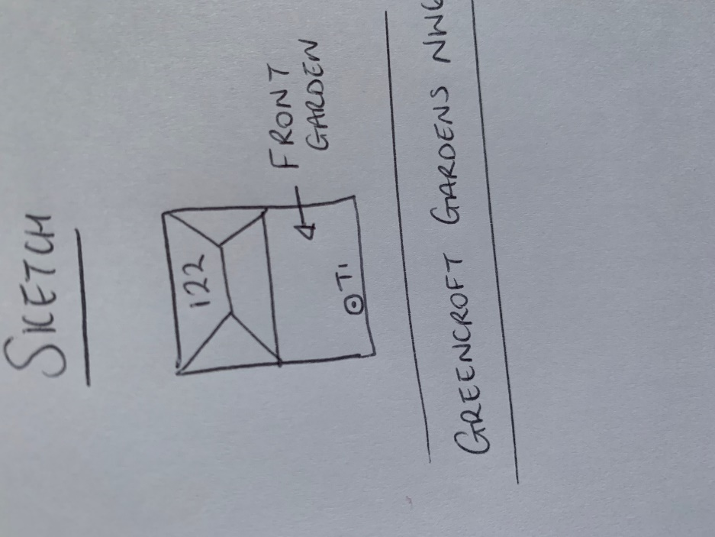

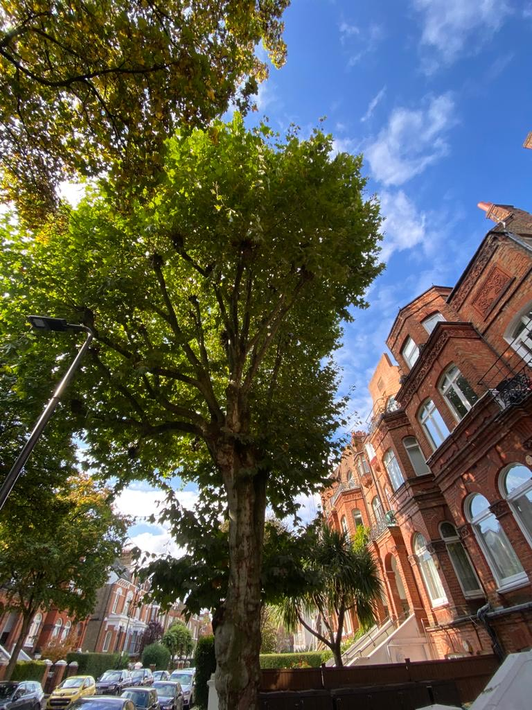

T1: Plane (22m): Re-pollard to previous points removing 3m of re-growth to keep at a size suitable for its location and as part of regular maintenance.