34 Delancey Street NW1 7NH

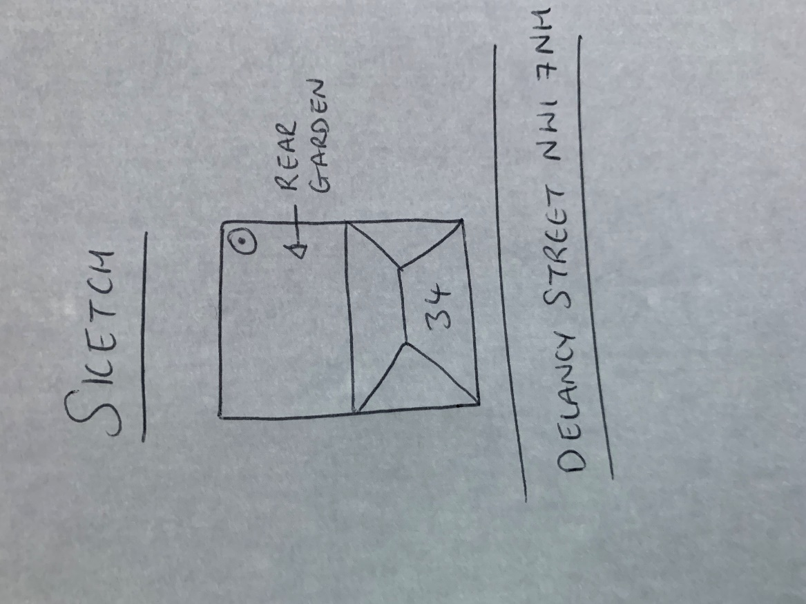

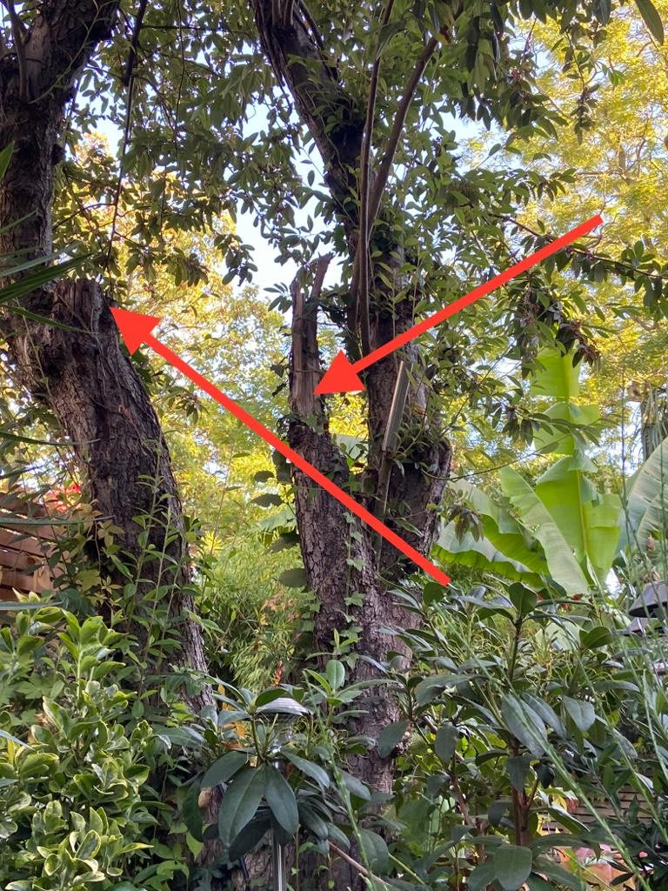 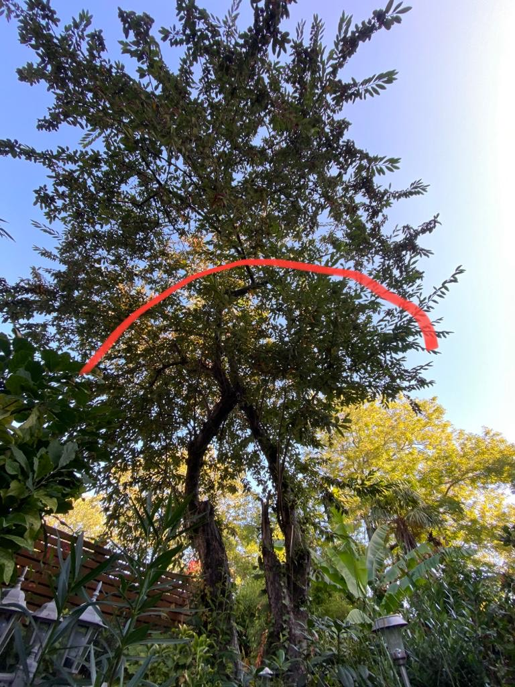

Snapped branches Approximate height after pruning

T1: Cotoneaster (8m): Reduce height by 3m and shape, tree has lost several over extending limbs and a more compact shape would reduce the risk of further limb snaps and keep tree at a size suitable for location