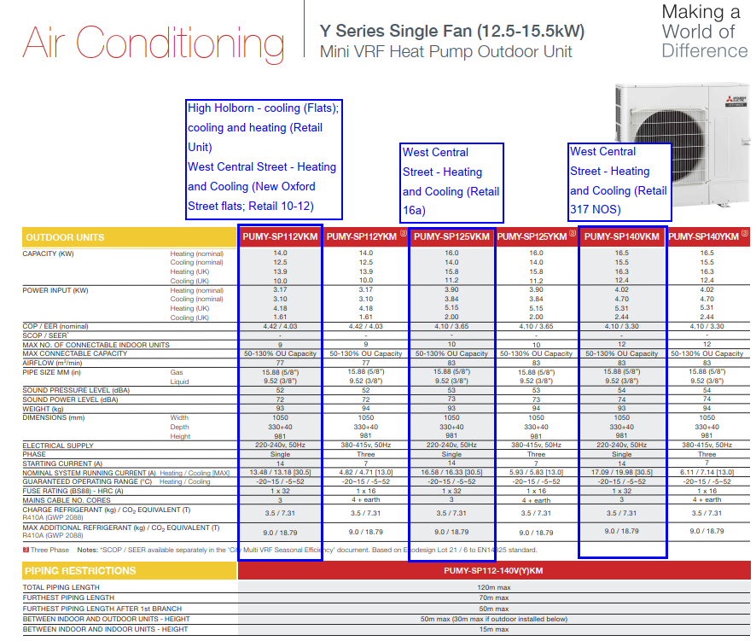

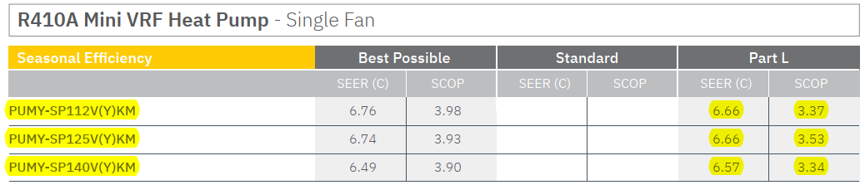

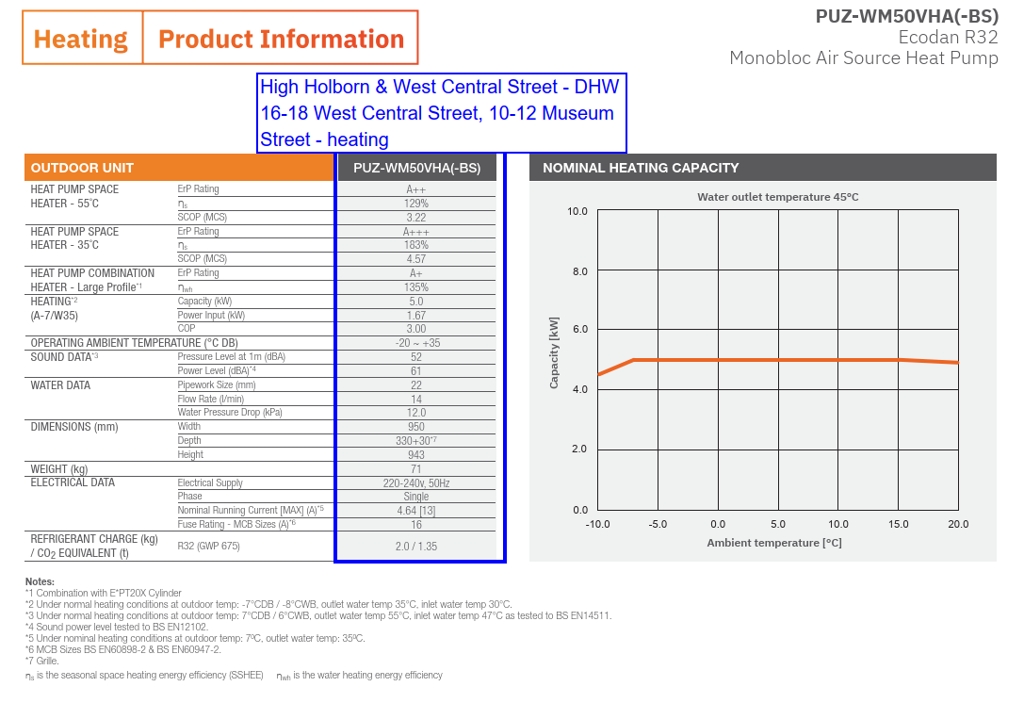

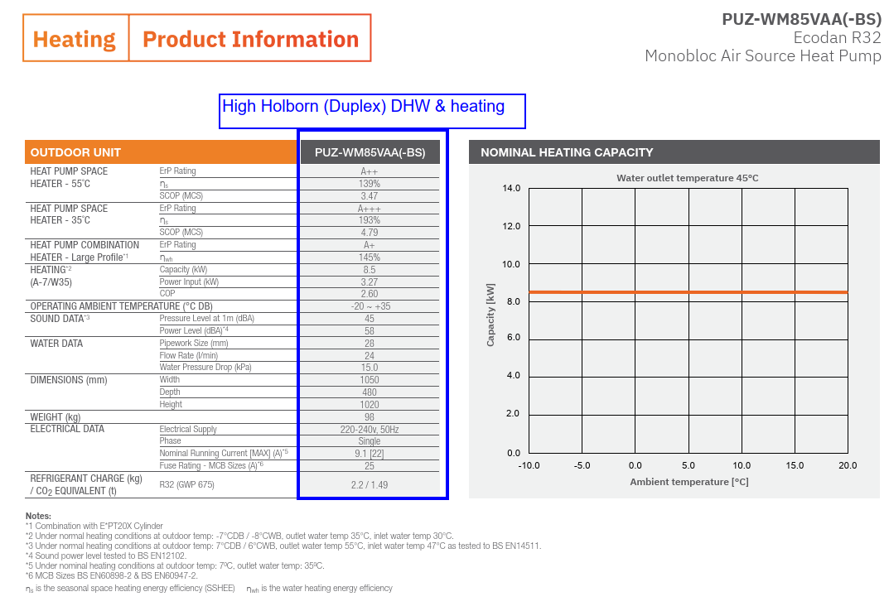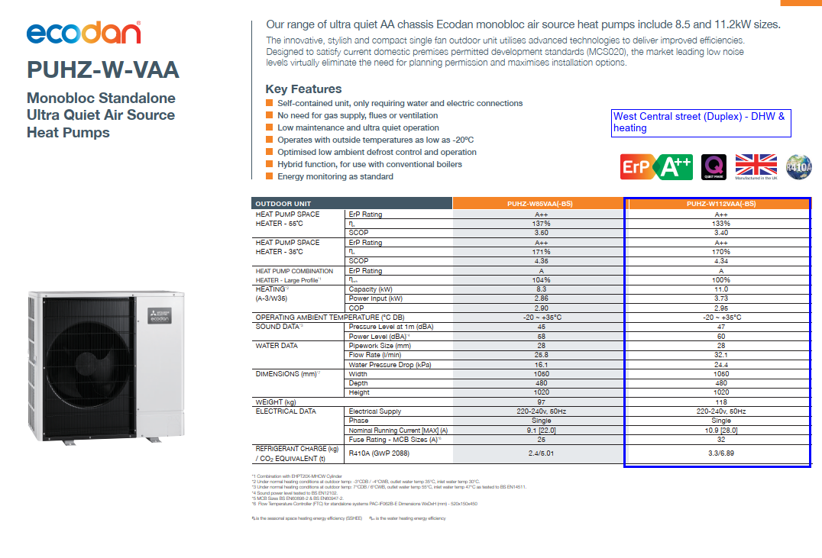

***West Central Street*** *– Heating and Cooling (Retail Unit 218)*

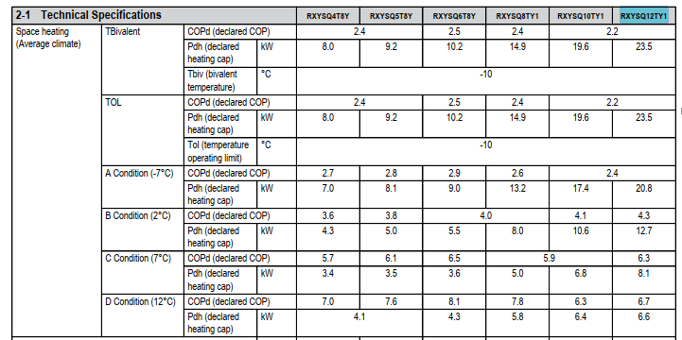

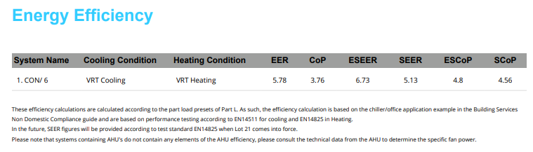

***1 Museum Street and Grape Street buildings*** *are proposed to be served by a cascade type system with ASHP connected to a condenser loop system, also called ‘Ambient loop’. A separate spreadsheets ‘1MS & VL SEER SCOP Calc’ details how overall SEER and SCOP for this system were calculated.*

*Water Source Heat Pump - PQHY-P450YLM-A (due to the size of the manufacturer’s data sheet only extract below is shown)*

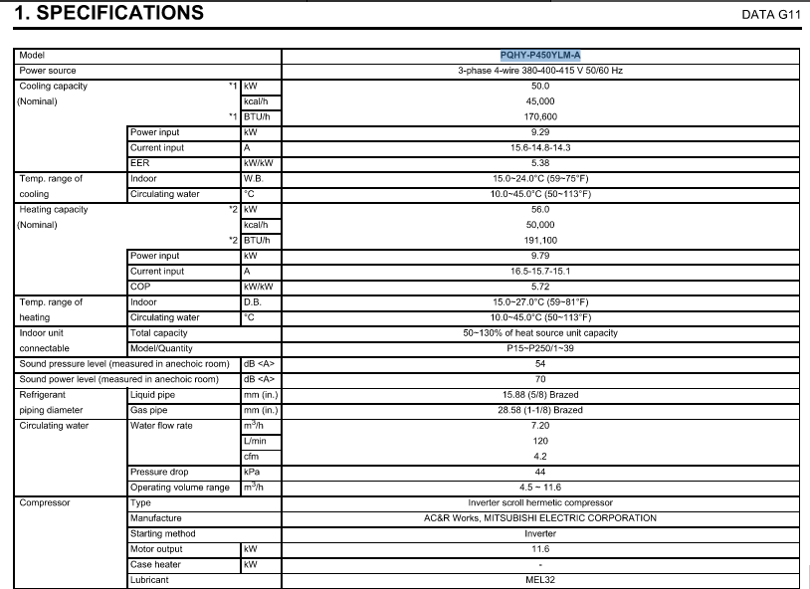

*Air Source Heat Pump - EAHV-M1800YCL(-N)(-BS) (due to the size of the manufacturer’s data sheet only extract below is shown)*

