Objections Oliver Froment - 9th October 2022:

Reference: Planning application ref. 2022/2398/P

12 Pilgrim’s Lane, London NW3 1SN

Dear Cameron Banks-Murray or colleague,

In the posting of various documents on the Camden Planning portal since the 26 September 2022, it is strikingly noticeable that there are no comments from the planning department on a substantial number of points raised in my objections to the Council on 11th August 2022.

The same applies also to many of the objections raised by 15 other residents/ resident associations. Such omissions contradict proper transparent procedure.

Please find below some of the many planning issues which I had previously communicated in writing on 11 August 2022 to the Council, and which have not been addressed i.e.:

“This application for a substantial development for a single residential house in the middle of Hampstead village, in an area known for its biodiversity, amenity and quietness, violates many policies and guidelines on Amenities, Sustainability, Climate Change mitigation, and Basements.

The internal square footage would increase from 3725 feet to 6760 feet and the garden area would be very significantly reduced at the expense of existing protected areas on a green corridor and in a prime conservation area.

This application would have a very negative impact on the environment. It does not constitute sustainable development.”

**Most of these objections have not been addressed at all in the documents posted by the Council’s officers or improperly addressed.**

**Policies on biodiversity and the environment:**

No mention is made in the officer’s comments on the impact on biodiversity and related matters which were previously raised and as per below:

“Camden Policy A3 on biodiversity aims to incorporate additional trees and vegetation. Under the proposed development the garden space would be drastically diminished, and vegetation and trees would also be removed”.

Camden Policy A3 on biodiversity and other national and local policies on the environment are contradicted by way of the following i.e.:

1. The significant and enlarged footprint that is increased by over 38% [increased from 1746 to 2412 square feet at ground level] causes a large loss of green space and violates the green corridor which this site is part of. **This therefore contradicts Camden Policy A3 on biodiversity**
2. The scale of the proposed increased footprint has excessive areas that are hard landscaped and paved which substantially reduces the existing rich biodiversity of the existing garden and landscape that is part of the recognised green corridor. The proposal would diminish the effectiveness of the biodiversity corridor between the rear gardens of Downshire Hill and Pilgrim’s Lane. **This contradicts Hampstead Neighbourhood Plan Policy NE3 and NE4.**
3. The Proposed Site Plan, on page 32 of the Design and Access Statement submitted by the applicant, shows the extent of the encroachment of the hard surface (in brown and grey colours) and the resulting drastically reduced garden (green colour). **This contradicts Hampstead Neighbourhood Plan Policy NE3.**
4. The applicant has not shown how they plan to enhance biodiversity and habitats in the garden area, nor in the southern part of the property. **This contradicts Hampstead Neighbourhood Plan Policy NE3.**
5. This development would also be contrary to Policy NE4 for the following reasons as it would [1] decrease the area of permeable surface; [2] fail to protect or enhance the status of priority habitat and wildlife movement; and [3] fail to use restrained exterior lighting in low blue content or yellow light only
6. This application would also significantly reduce soft landscaping contrary to paragraph 4.32 of Policy NE4 of the HNP.
7. The significant reduction of garden space and the elimination of vegetation will negatively impact the environment.
8. This application does not meet the environmental objectives of the National Planning Framework either.
9. This application also breaches Camden Policy D1 paragraph j on Design that states that “The Council will require that development: … preserves gardens and open space”.

**Trees**

The removal of several trees and plants in front of the house and their replacement by a hard surface was not supported by Camden’s Planning Officer during the pre-application ref: 2022/0417/PRE of 11/5/2022.

**Loss of amenity**

Policy A1 of the Camden Plan and Policy DH1 of the Hampstead Neighbourhood Plan would not be abided by as this development would not protect the amenities of neighbouring properties both in Pilgrim’s Lane and Downshire Hill. Please also refer to the objections of the Downshire Hill Resident Association.

Please refer to my objections of 11th August as well as that of many other residents and resident association which have not been commented upon. For example, the current quite garden setting will be severely compromised by noise from the proposed swimming pool, which would open to the outdoor.

**Climate Change Mitigation**

Camden Policy CC1 on climate change and other related policies on climate change are not abided by way of the following i.e.

1. The applicant has not demonstrated either how this development of more than 500 square meters of gross internal floor space will achieve 20% reduction in carbon dioxide from on-site renewable energy generation contrary to paragraph 7 of Camden Planning Guidance on Energy efficiency and adaptation which forms a Supplementary Planning Document (SPD) which is an additional “material consideration” in planning decisions.
2. The applicant has not demonstrated that he would use the best practice levels of insulation contrary to Camden Guidance on Energy efficiency and the Mayor’s Sustainable Design and Construction SPG.
3. The applicant has not provided a Sustainability Statement either, contrary to the Local Plan policy CC2.

**Ground Source Pumps:**

I see no comments whatsoever on my previous objections: “Instead of Air Source Heat Pumps, the applicant should use Ground Source Heat Pumps.

**Camden Planning Guidance on Energy efficiency and adaptation in paragraph 3.14, page 10 recommends: “Ground source cooling is provided by a “Ground Source Heat Pump”,** in the summer the ground stays cooler than the air and the difference in temperature can be harnessed for cooling.” “The proposal for a swimming pool will exacerbate the requirement for cooling. “

“Ground Source Heat pumps are far more energy efficient ([source: Kensa Heat Pumps](https://www.kensaheatpumps.com/air-source-vs-ground-source-heat-pumps/)). They release less Carbon Dioxide into the air than Air Source Heat Pumps. They play a vital role in helping the UK Government’s target of net-zero carbon by 2050 and to comply towards policy GG6 of the London Plan. They comply more towards Camden Policy CC1 on Climate change mitigation than Air Source Heat Pumps. The application does not comply with Policy CC1 that requires all developments to reduce Carbon Dioxide emissions through following the steps in the energy hierarchy. This is a large residential development that would have significantly in excess of 500 square metres ofgross internal floor space.

- We discussed the viability of a Ground Source Heat Pump at this location with <https://www.betterplanet.co.uk/> and they recommend **a hybrid solution of both horizontal and vertical Ground Source Heat Pumps and this would be compatible with the size of the garden and the proposed building site.**

- They run quietly and discreetly and unlike Air Source Heat Pumps are located inside the building. They do not generate any outside noise unlike air pumps.

- Unlike Air Source Heat Pumps, Ground Source Heat Pumps need very little maintenance and have a much longer life span, while the buried ground they are connected to is entirely unobstructive and can last 100 years ([source: Kensa Heat Pumps](https://www.kensaheatpumps.com/air-source-vs-ground-source-heat-pumps/)). Air Source Heat Pumps tend to have a much shorter life cycle and typically require yearly maintenance.”

“The proposed plan to install three Air Source Heat Pumps “ASHP” and one Air Handling Unit show an Indicative site plan that is both inaccurate and misleading.

**None of the above objections and comments have been addressed let alone commented by the Environmental Health Officers**

Clement Acoustics, writes in paragraph 2.0, page one of its report: “if there are any receivers closer to that identified within this report then a further assessment will need to be carried out”. This is the case and therefore a further assessment should have been carried out.

We marked with a red circle in Appendix 4 where some of the other windows of our property (as well as our glass roofed dining room) are located at a much closer distance to the proposed indicative plan than shown on page 12 by the applicant.”

**Character of the Conservation Area**

I see no precise comments by the planning officers on the following points that I and other residents raised:

“The existing gap in the built form as seen from Pilgrim’s Lane, is an important element in the general character of the conservation area.

The proposed side extension of the building along Pilgrim’s Lane would destroy the balance between built form and green space and impact the mature treescape in the conservation area.

The applicant should not materially increase the footprint of the house. Doing otherwise would be contrary to NPPF paragraph 185, Camden planning policy D1 on Design and improving the character and quality of an area and policies NE3 and NE4 of the Hampstead Neigbhrohood Plan which seek to protect the green corridor.”

**BIA and risk of flooding**

This application does not properly demonstrate how the development would not cause harm to ground or water conditions of the area, contrary to Camden’s Policy A5.

**Campbell Reith has totally ignored in its audit and the assessment of the BIA to precisely comment or address the following points that were raised in my previous objections:**

“There is also documented evidence of high to medium surface water flooding in both Pilgrim’s Lane and nearby Downshire Hill. This is shown in the map in Appendix 5. There has been incidence of damages caused by natural water flows to properties in both Pilgrim’s Lane and Downshire Hill caused by new basements.”

Furthermore, the UK government’s website Flood Map for Planning has identified that the properties located at 24, 26,28, 30, 32, 34, 38, 40, 42, 44 Pilgrim’s Lane in the same street and postcode as having a medium risk of surface water.

Please note that the property is located along the border of a high vulnerability, secondary aquifer. This is shown in page 109 of the site investigation and BIA Appendix D compiled by GEA, reference Landmark Information Group. There was no comment from Campbell Reith on this fact either.

Furthermore, the BIA in page 2.5 also fails to mention that rainwater was encountered close to the surface at 8 Pilgrim’s Lane both during the borehole measurements and subsequently during the trial pit investigation which were conducted in March during essentially dry days.

**In such circumstances the BIA is wholly unsatisfactory as underground borehole tests should also have been conducted in periods of sustained and heavy rain and contrasting weather but were not.**

**The groundwater test was carried out on 14th June 2022. Looking at** [**http://nw3weather.co.uk/**](http://nw3weather.co.uk/) **, please note that there was no rain that day or at any time since 9th June. This is shown in Appendix 5 further below**

**Campbell Reith has also totally failed to comment on the fact that there was only one day when borehole investigations were conducted, and it was a day without rain and the previous days had also been dry days with no rain at all. This is totally contrary to good practice as well as to the Camden Planning Guidance Jan 2021 reference stage 4 and contrary to paragraph 7.2.3 monitoring written by Arup for Camden in November 2010.**

One will also note that this terrain is in a downward sloping terrain hence the gardens of the neighbouring properties located are exposed to significant risk of flooding in period of heavy rain. There was no comment either on the matter in Campbell Reith’s report.

Conclusion:

The scheme should be refused in its entirety for the above reasons.

Regards,

Oliver Froment

10 Pilgrim’s Lane NW3 1SL

**Appendix 1**

[Appendix 4 Open Spaces and Biodiverstiy Corridors- Hampstead Neighbourhood Plan 2018-2033](https://d3n8a8pro7vhmx.cloudfront.net/hnf/pages/206/attachments/original/1568277343/27_July2018_Appendix_4.pdf?1568277343)

D Rear gardens Downshire Hill and Pilgrims Lane Rear gardens between Downshire Hill north and Pilgrims Lane south. See reference A in maps, pages 3, 4 and 5.

**Appendix 2**

Partial aerial view of the green corridor between Pilgrim’s Lane and Downshire Hill showing the extent to which 12 Pilgrim’s Lane gardens sit squarely into the green corridor.

**Appendix 3**

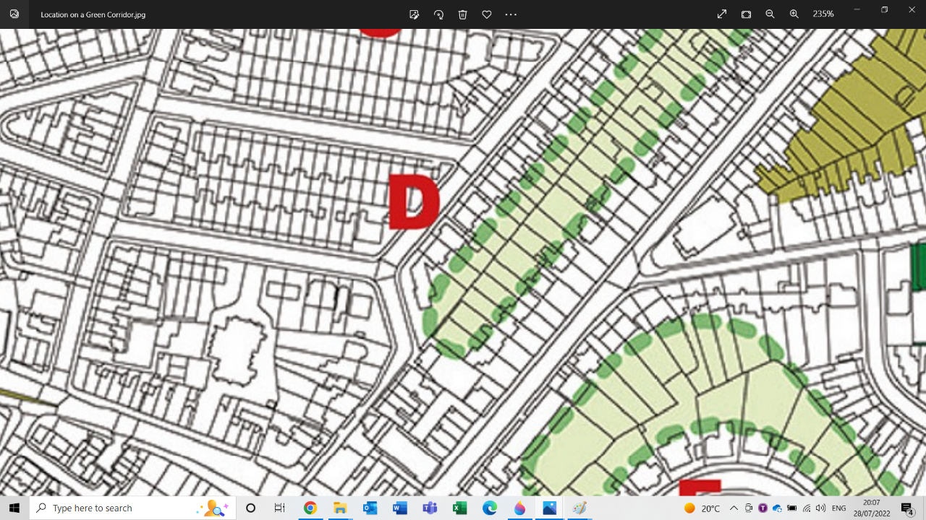

12 Pilgrim’s Lane: Garden sits squarely on the Green Corridor – Source Hampstead Neighbourhood Plan, page 27

**Appendix 4**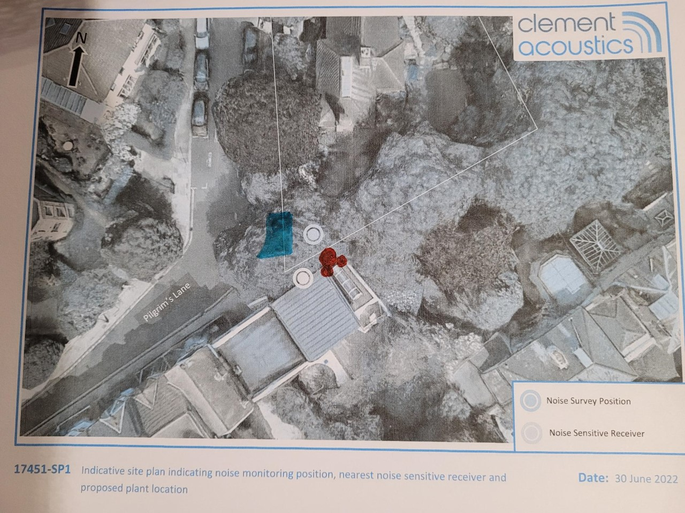

The noise Sensitive Receivers on our property at 10 Pilgrim’s Lane are several and some are located at a much closer distance (reference red circles in the above plan) than Clement Acoustics is showing on its “indicative site plan”. Furthermore, passers-by along the pavement on Pilgrim’s Lane (reference blue marked area in the above plan) would also be negatively impacted by the noise of the three proposed Air Source Heat Pumps and the Air Handling Units at the proposed location.

**Appendix 5**

Source: UK Government Map on long-term flood risk – Extent of flooding from surface water.

<https://check-long-term-flood-risk.service.gov.uk/map?easting=526849&northing=185669&map=SurfaceWater>

Blue spots along Pilgrim’s Lane and along Downshire Hill.

The dark blue spots at the end of Pilgrim’s Lane correspond to high risk of flooding from surface flooding.