Photo 1

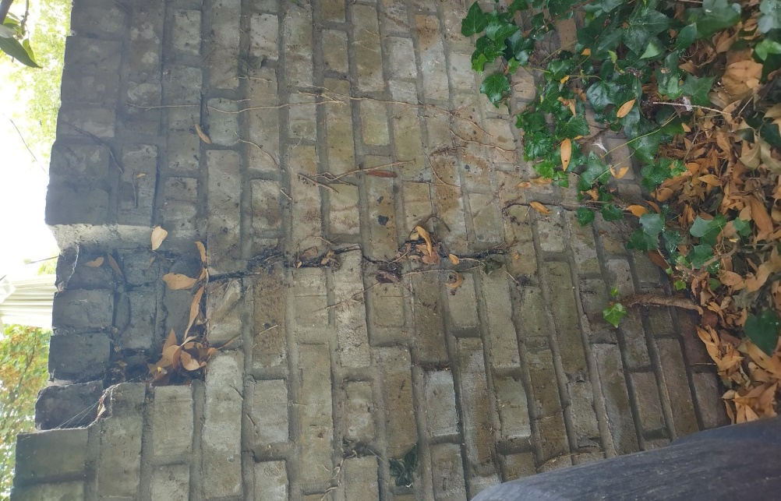

Photo 2

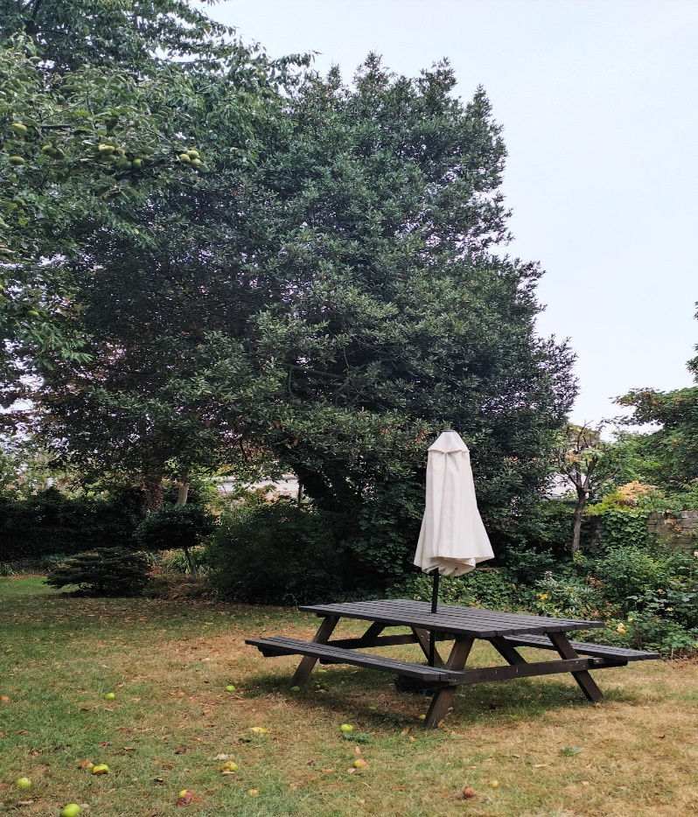

Photo 3

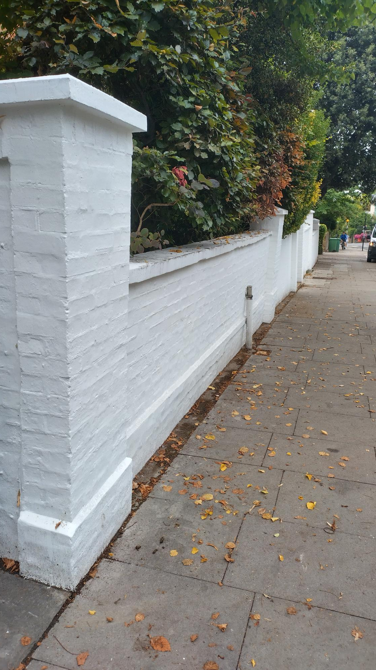

Photo 4

Photo 5

Photo 6

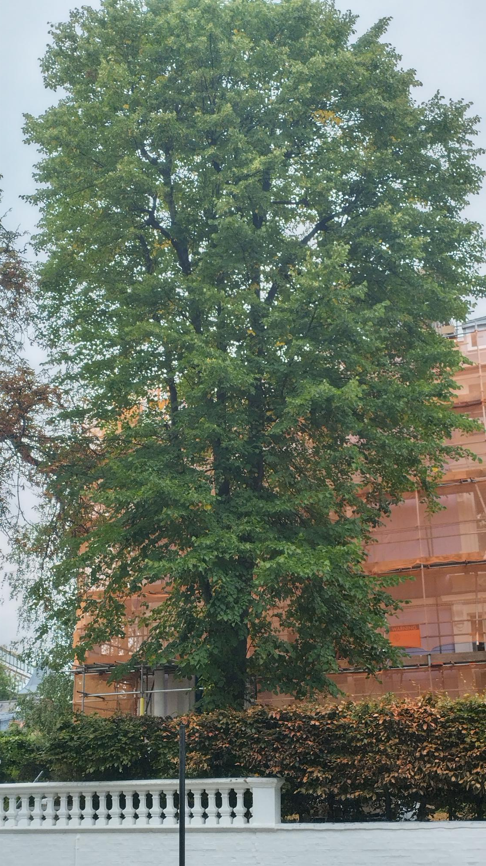

Photo 7

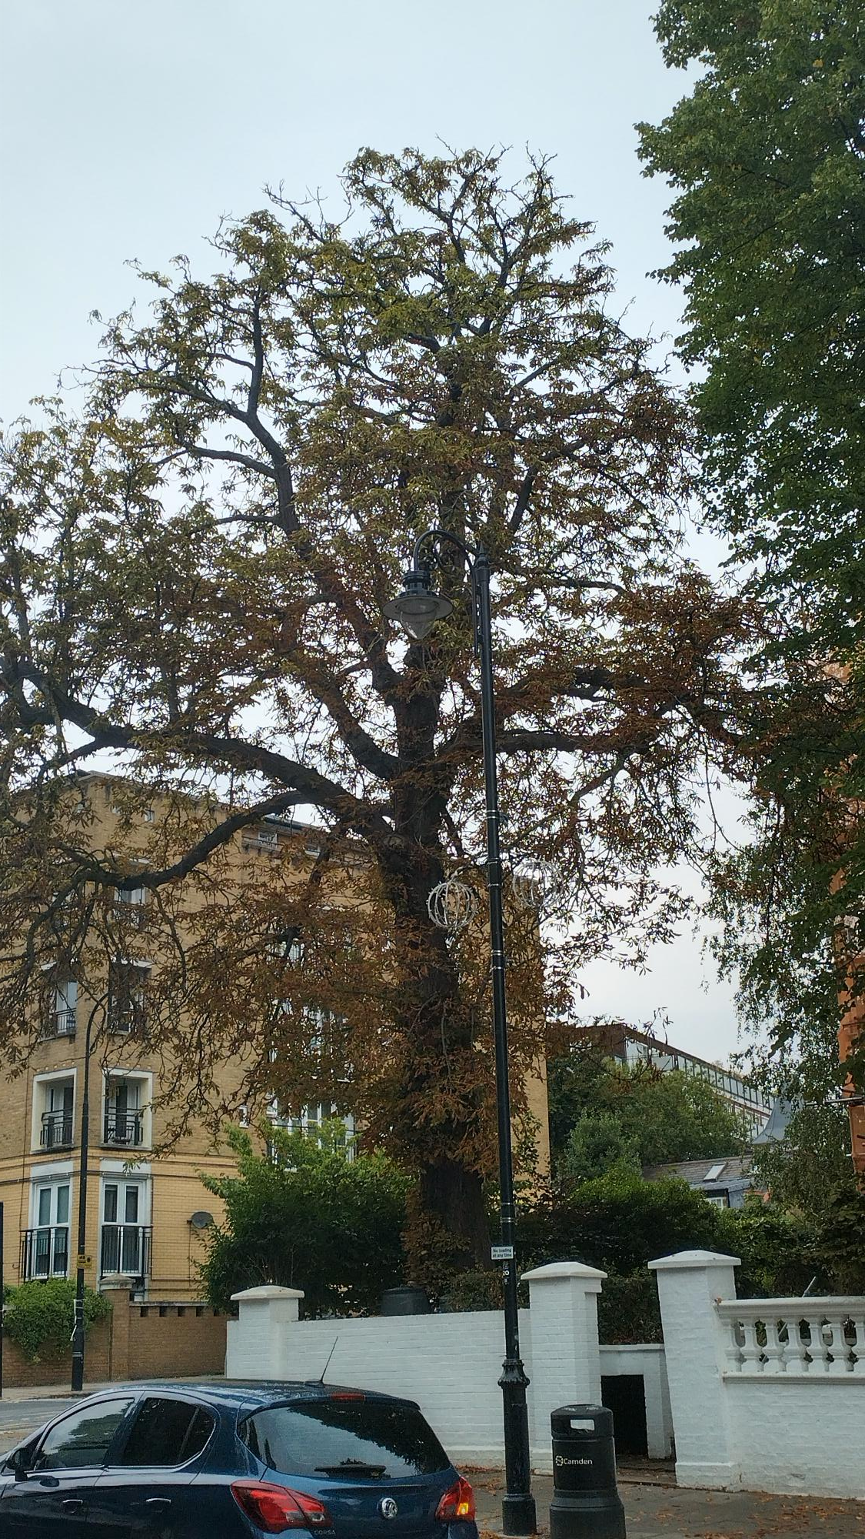

Photo 8

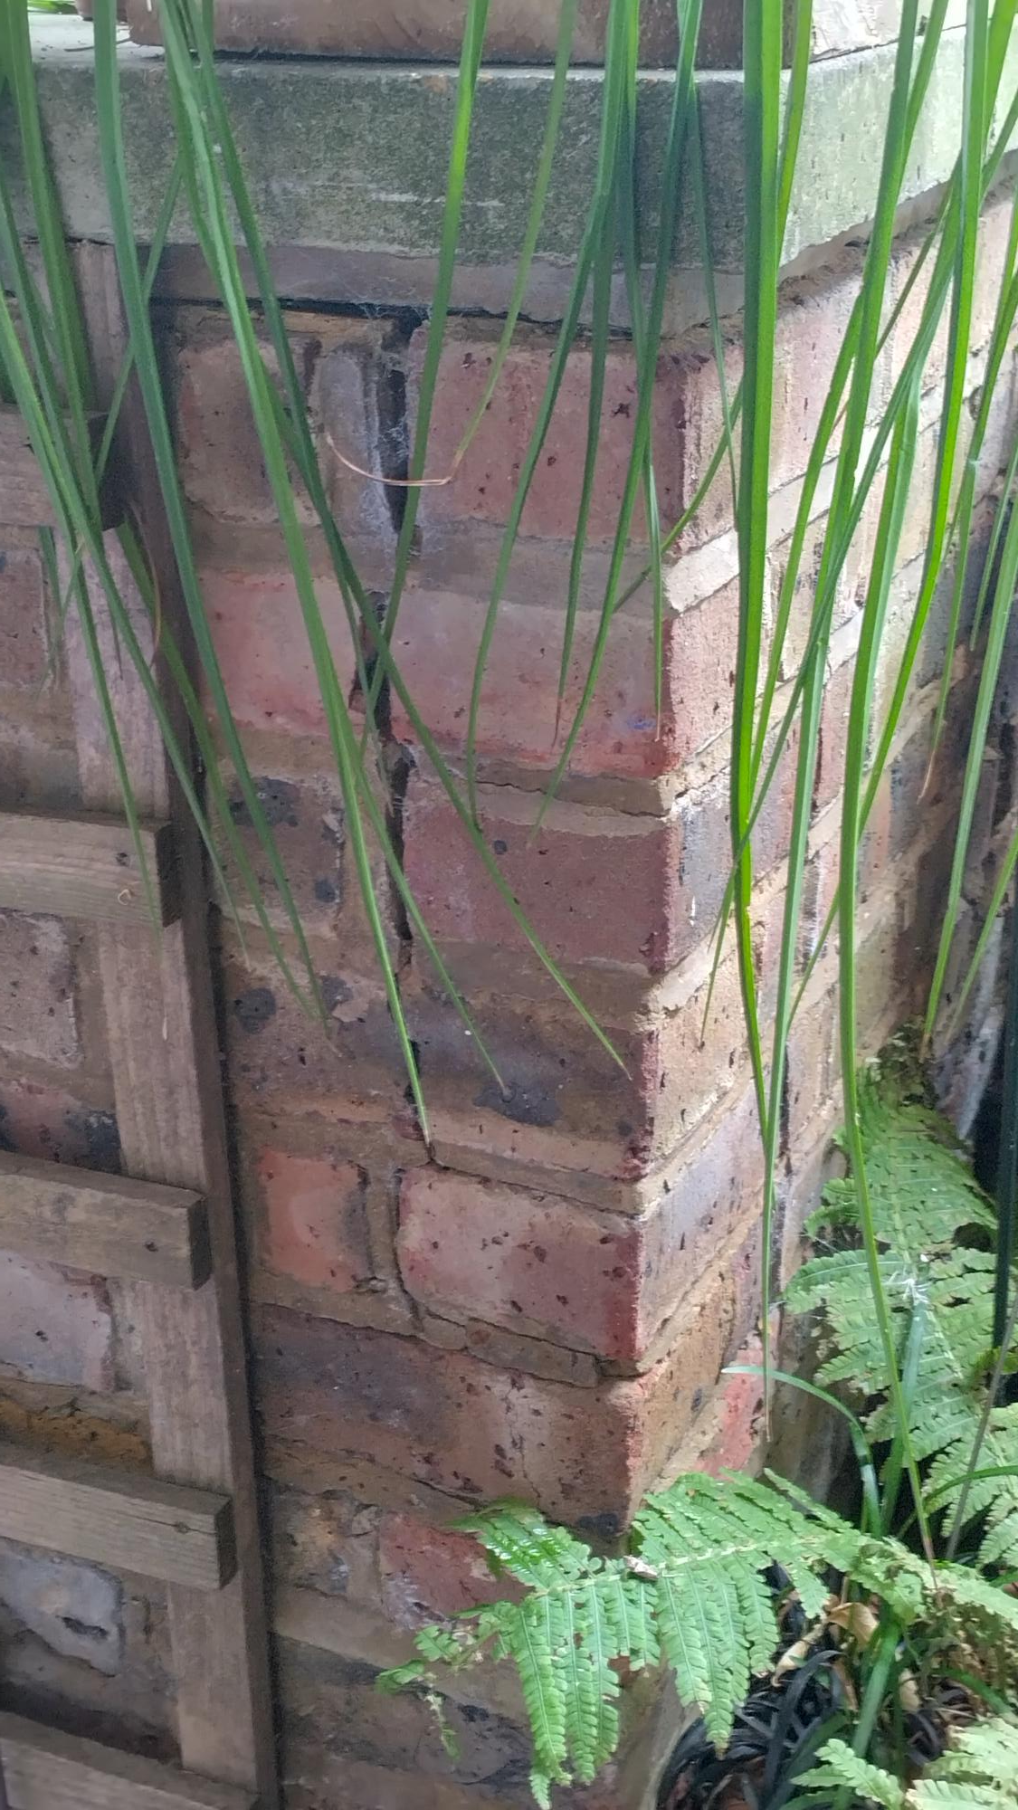

Photo 9

