**DESIGN, ACCESS & HERITAGE STATEMENT**

SITE ADDRESS: TOP FLOOR FLAT (2ND FLOOR) 195 GOLDHURST TERRACE, LONDON, NW6 3EP

**CONTEXT AND STATEMENT OF HISTORIC SIGNIFICANCE**

The Sash Window Workshop has been contracted to replace the windows to the top of the property.

The current windows are White timber with single glazing and a decorative bar section to the top. To the front elevation.

The plan is to replace these windows with Timber sliding sashes that will closely match the originals in design whilst incorporating Heritage (Individual) double glazing which will provide improved thermal performance.

The property falls into the South Hampstead Conservation Area and as such the proposed windows will need to be in keeping with the area and its surrounding properties.

The South Hampstead Conservation Area is described in the guide as:

*“Formally known as the Swiss Cottage Conservation area until February 2011. South Hampstead is a well-preserved example of a leafy Victorian suburb, almost exclusively residential in nature and largely homogenous in scale and character. The area is characterised by large semi-detached and terraced late Victorian properties, in red or gault (white cream) brick with particularly distinctive and attractive roofscape including turrets, gables and tall chimneys. Houses are made special by a variety of decorative treatments including terracotta panels and brickwork ornamentation, tiles and patterned footpaths, delicate ironwork and elaborate timber doors and windows including some original stained and leaded glass.”*

*There is also lots or vegetation in the form of hedges and mature specimen trees. Open green spaces in private rear gardens which contribute to providing wildlife corridors. The rigid street pattern is enlivened by elaborate architectural detail in roofscapes, boundary walls and gardens. Negative impact on the conservation area must be avoided. This would include the use of PVCu windows. The design guide clearly states that the alteration of windows to the property would require a planning application.*

SURROUNDING AREA: The surrounding properties are very similar in style and design with the white timber windows and decorative bars.

WORKS: As per attached schedule of works

Item 1 & 2 Rear elevation

Item 4 Front elevation

Item 5 Front elevation

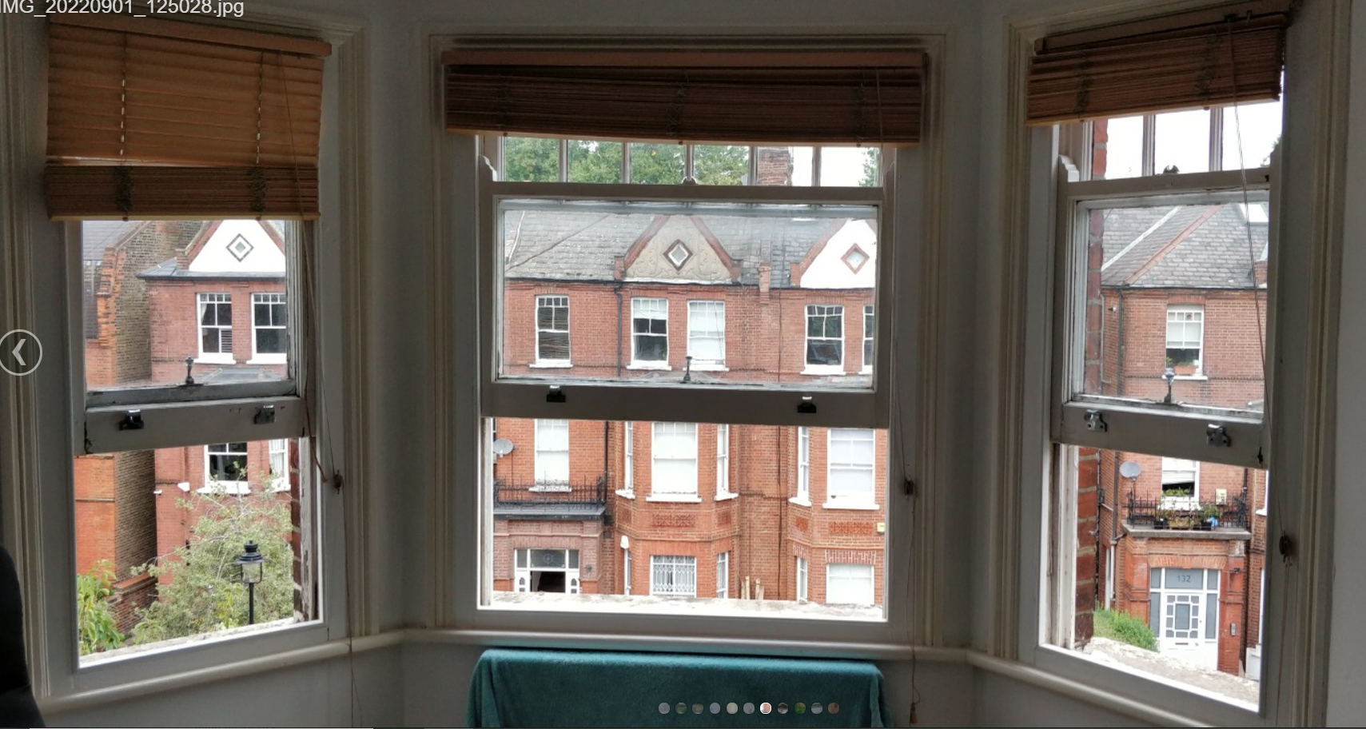

LAYOUT:

Item 1 and 2 - The completely new windows will replace the ones in situ as the frames are beyond repair. There will be no change in the aperture sizes or configuration.

Item 4 and 5 – New sashes to replace existing within the existing frames and renewal of cills. There will be no change in the aperture sizes or configuration.

SCALE: The windows will be in proportion to the house as they will be in the original openings. The windows will match in style and design as closely as possible.

LANDSCAPING: Our proposal will not require any landscaping as these are replacement windows only.

ACCESS: Access will be gained by entering the property via the main entrance in agreement with the occupants

APPEARANCE: The importance of maintaining the appearance has been sympathetically observed using the correct material - Timber, the aesthetics – Painted white and the configuration and ensuring the glazing bars are made with traditional integral design with “putty” facing

BENEFITS: The inclusion of Heritage double glazing and draught sealing to the windows will provide the necessary update to the windows improving their thermal performance thus enhancing the quality of the property and the occupants; as well as providing obvious environmental impact and much improved sustainability highly sought these days.