**Design and Access Statement**

**66a Fortess Road, NW5 2HG**

**Secondary Glazing on two windows on Grade II listed property**

**Adam Crymble**

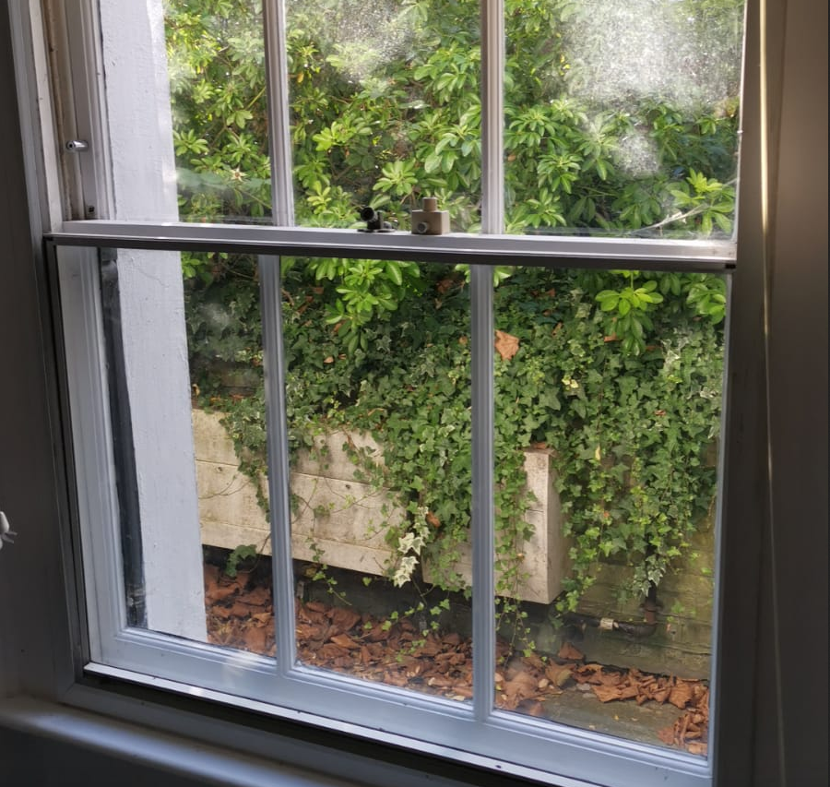

**Window to have secondary glazing replaced.**

1. **What are the features on the existing site?**

The two windows are at the front of the property, one on the lower ground floor and one directly above it on the upper ground floor. The original sash windows have had secondary glazing for several decades (possibly 1970s).

**2. Please provide details of how access issues have been addressed**

The site is accessible from the main door to the flat, at the lower ground entrance. Parking for site workers is available through the local council. WC for workers is available in the property.

3. **Please provide details of the layout of proposed development**

The development is a like-for-like replacement of the existing 1970s secondary glazing units on two windows.

4. **Please provide details of the scale/appearance of the proposed development**

The lower ground floor window is missing a pane of glass and has been since I bought the property in 2017. The tenants have complained that this makes the room draughty, so I would like to replace it with a like-for-like aluminum framed, custom made unit. The new unit will look and function like the old one, and will not be visible from the from of the property, as its cross-bar will be set behind the existing wooden window frame. This window is 94cm wide by 127cm tall.

The upper ground floor window has become bent over the years, and occasionally slips when left in the open position. I am worried this is a health and safety issue and could clamp someone’s fingers, so I would similarly like to replace it with a like-for-like replacement as described above. This window is 93cm wide and 175cm tall.

The result of the change will be increased safety for the tenants, increased energy efficiency, and no visible change to the property.

**5. Please provide details of the landscaping in the proposed development**

not applicable

**6. Please provide details of how Heritage Assets issues have been addressed**

The existing secondary glazing has been installed sympathetically to the existing original windows, so that they are not visible from the outside of the property. This will also be the case in the like-for-like replacements.