Flat 2, 4 Acol NW6 3AH

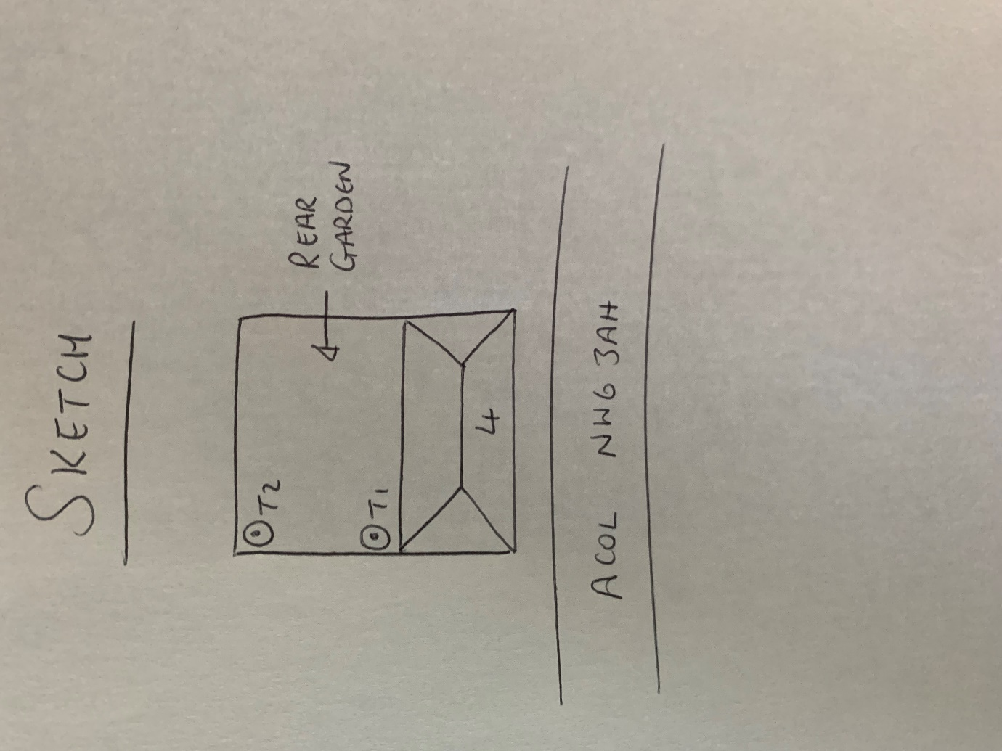

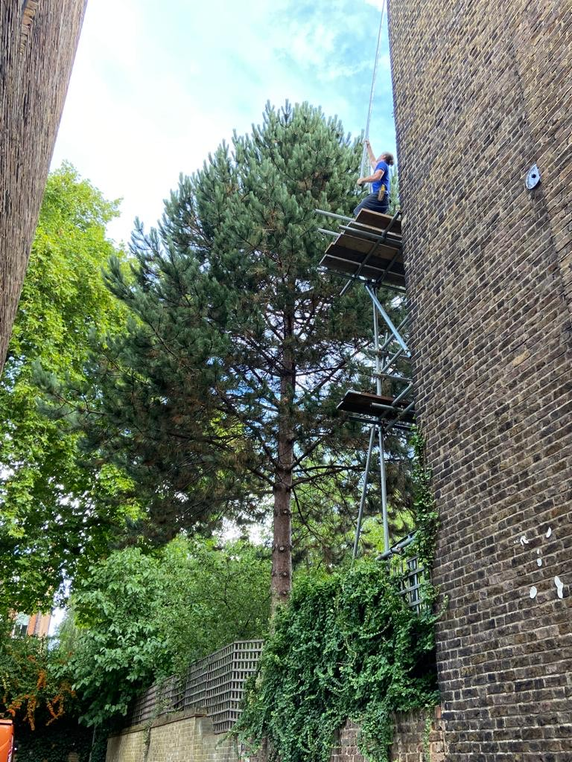

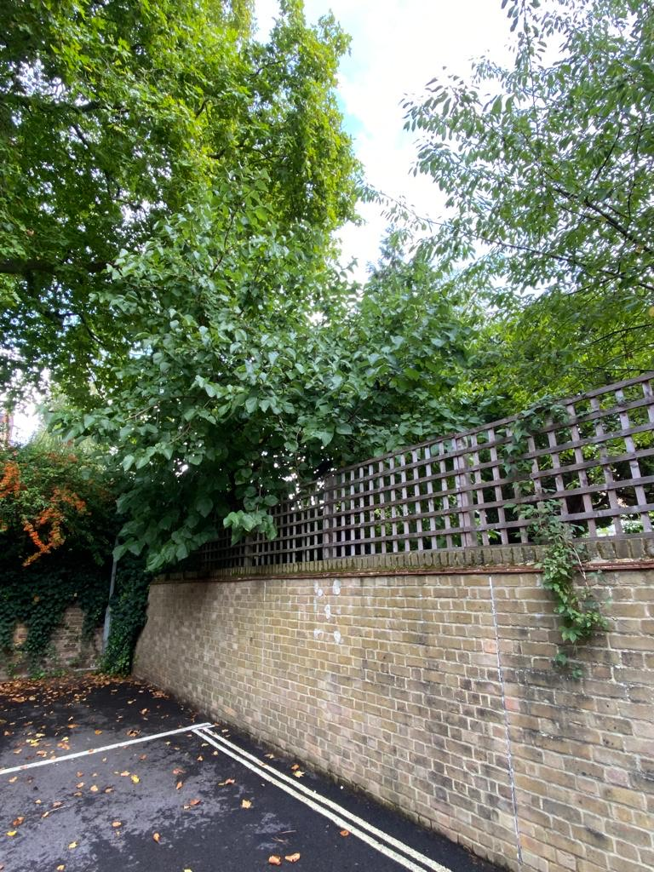

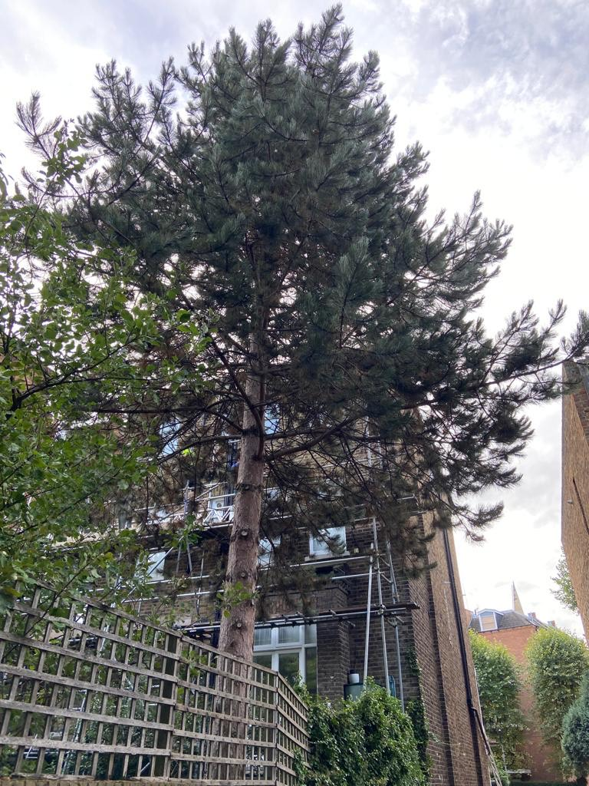

T1: Pine (18m): Crown reduce by 2m due to proximity to house

T2: Mulberry (5m): Reduce back to boundary removing 1m of growth to prevent encroachment into neighbouring car park