**Design and Access statement**

**Site:**  
The site is a terraced dwelling house located at 4 Glenbrook Road, London NW6 1TW  
  
**Proposal:**  
The proposed scheme involves using the remainder of the outrigger’s flat roof as a roof terrace and replacing the window in the extension (approved under application 2021/1315/P and currently under construction) with a door.  
  
There are several properties in Glenbrook road alone that use the outrigger as a roof terrace and many more in the neighbouring streets.  
- A similar scheme has previously been approved at 2 Glenbrook Rd through planning application: 2020/0446/P  
- A roof terrace has been approved at 1 Glenbrook Rd through planning application: 2011/6418/P.  
- A roof terrace has been approved at 38 Sumatra Road (adjoining Glenbrook Rd) via application 2015/4106/P  
  
Blue circle: 4 Glenbrook Rd  
Red Circles: Neighbouring properties with roof terraces on outrigger  
  
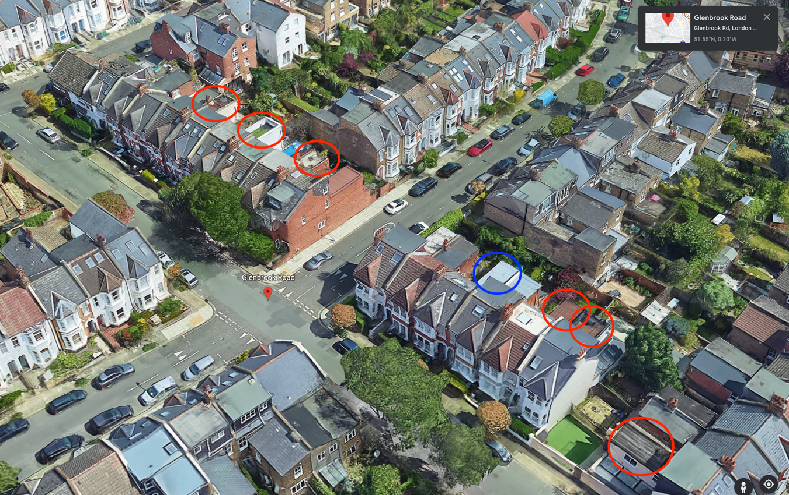  
  
  
**Appearance:**  
The proposed terrace will use iron railings that are 1.1M high so that they are in line with Camden Council Home Improvement guidance updated in 2021. Also so that they are similar to the materials used at neighbouring properties. They will integrate well with the building’s character, be more resilient and require low maintenance.  
  
**Use:**  
The existing usage of the house will be maintained. The proposed terrace is smaller than those in neighbouring properties and therefore will not have the capacity needed to create significant noise disturbance to neighbours.  
  
**Landscaping:**  
This proposed development would not have any landscaping issues or features to be explained or justified. There is not a living roof on this structure.   
  
**Access:**  
Access to the property will be unaffected as access to the new development is from within the existing house.