**2022/0815/P**

The Cottage, Mount Tyndal, Spaniards Road London NW3 7JH

*Erection of 1st floor side extension above existing garage; part 2-storey rear extension; replacement windows and insulated rendering system to external fabric with plant enclosure at roof level housing air source heat pumps.*

**Site and surroundings**

The property appears to date from the late 1940s and was constructed in the grounds of Mount Tyndal House. The original Mount Tyndal was demolished in 1890. A new house, called Mount Tyndale, was built in the 1920s and occupied in 1938 by Viscount Knollys. This has again been demolished, and the site is now occupied by the 1970s flats known as Mount Tyndal.

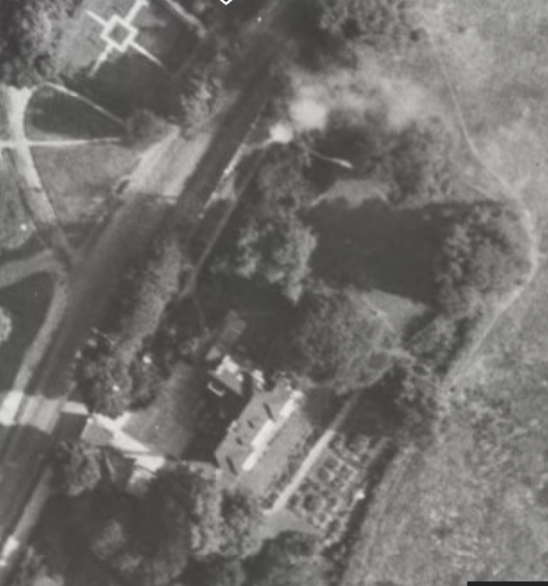

*Mount Tyndal House, photographed in the mid-1940s but prior to the construction of the Cottage*

The site is within the Hampstead Conservation Area. The Council has a statutory obligation to ensure that development within the Hampstead Conservation Area preserves or enhances its character and appearance.

**Proposals**

The proposals consist of Erection of 1st floor side extension above existing garage; part 2-storey rear extension; replacement windows and insulated rendering system to external fabric with plant enclosure at roof level housing air source heat pumps.

A proposal was granted permission in 2010 for the following works:

2010/2060/P *Erection of first floor side extension above existing garage; first floor front elevation extension (infilling existing balcony); two-storey rear extension with associated first floor side and rear elevation balconies; associated alterations including replacement windows and rendering of first floor level, all to single family dwellinghouse (Class C3)*

While some of the works under the current application are similar to those proposed under the 2010 scheme, there are significant points of difference, namely the form of the extensions, the inclusion of new areas of glazing, the rendering of the entire building and the alterations at roof level, i.e. the rooflights and enclosure for air source heat pumps. The current application can be broadly summarised as follows:

• First floor side extension over the existing garage to comprise bedroom and en-suite, and an additional en-suite to the principle bedroom.

• Part ground and first floor extension to rear garden elevation comprising enlarged open plan kitchen and additional bedroom over.

• Minor amendments to structural openings to include the reinstatement of the original front entrance.

• Reconfigured stair to allow side access to the property from inside the double garage and at first floor into the first floor extension.

• Replacement of fenestration in period style but with double glazed units up to current standards for sustainability.

• External insulated render system for reason of sustainability to increase the thermal capacity of the building envelope.

**Heritage Impacts**

The existing building is of modest architectural quality but it is distinctively mid-century in style and has a consistent design character due to not having been greatly altered or extended since the 1940s.

The property is concealed from the public realm. While public visibility is not the only criterion for assessing acceptability of proposals within a conservation area, it is true to say that the proposals will have a limited impact on the streetscape character of the surrounding area.

However, the Conservation Area Management Strategy has regard to the acceptability of extensions and alterations notwithstanding public visibility:

H17 In all cases, existing/original architectural features and detailing characteristic of the Conservation Area should be retained and kept in good repair, and only be replaced when there is no alternative, or to enhance the appearance of the building through the restoration of missing features. Original detailing such as door/window pediments and finials, porches, ironwork (window cills, railings), timber framed sash windows, casement windows, doors, tiled footpaths, roof tiles, decorative brickwork, bargeboards, stained glass, boundary walls and piers, where retained add to the visual interest of properties. Where details have been removed in the past, replacement with suitable copies will be encouraged. Original, traditional materials should be retained wherever possible and repaired if necessary.

H19 Original brickwork should not be painted, rendered or clad unless this was the original treatment. Such new work, whilst seldom necessary, can have an unfortunate and undesirable effect on the appearance of the building and Conservation Area and may lead to long term structural and decorative damage, and may be extremely difficult (if not impossible) to reverse once completed. Re-pointing if done badly can also drastically alter the appearance of a building (especially when “fine gauge” brickwork is present), and may be difficult to reverse.

H26 Extensions and conservatories can alter the balance and harmony of a property or of a group of properties by insensitive scale, design or inappropriate materials. Some rear extensions, although not widely visible, so adversely affect the architectural integrity of the building to which they are attached that the character of the Conservation Area is prejudiced. Rear extensions should be as unobtrusive as possible and should not adversely affect the character of the building or the Conservation Area. In most cases such extensions should be no more than one storey in height, but its general effect on neighbouring properties and Conservation Area will be the basis of its suitability.

H27 Extensions should be in harmony with the original form and character of the house and the historic pattern of extensions within the terrace or group of buildings. The acceptability of larger extensions depends on the particular site and circumstances.

SIDE EXTENSIONS H42 Planning permission may be required for the erection of side extensions. Modest single storey side extensions to single family dwellings may be exempt from permission under the General Permitted Development Order 1995 depending on the proposed volume and height and location. It is advisable to consult the Planning Service to confirm if this is the case. H43 Normally the infilling of gaps between buildings will be resisted where an important gap is compromised or the symmetry of the composition of a building would be impaired. Where side extensions would not result in the loss of an important gap they should be single storey and set back from the front building line.

The principle of extending the property is acceptable as this is a detached dwelling with a relatively large garden and it is set back from the road and the Heath.

However, the proposals will require revision if they are to have an acceptable impact on the host building. The rendering/external insulation of brickwork is contrary to policy H19. While it is understood that there is a thermal benefit to the proposed external insulation, it is unlikely to be acceptable as a solution given that internal insulation is likely to be achievable, and would not have an impact on the external appearance of the building.

The proposed rooftop alterations are concerning given that the flat roof of the existing building is part of its modernist character. Given that the property has a garden it would be expected that the proposed plant could be accommodated at ground level. Likewise, while the principle of a rooflight is likely to be acceptable, the proposed pyramid structure is at odds with the character of the host building, and roof lighting could be provided by a much lower structure.

The proposed extensions are acceptable in principle, but the design of the elevation of the first floor side extension over the existing garage is overly glazed and does not successfully relate to the proportions of the host building. The permitted scheme was much more successful in this regard.

David McKinstry

30.06.22