NAGANJOHNSON ARCHITECTS
2 Pontypool Place
London SE1 8QF

020 7633 0200
www.naganjohnson.co.uk

Application ref: 2020/3405/P

In response to conditions 4 and 5 b) for the above application please see below information and the following enclosed drawings and documents:
Drawings
PROV_PP_180_2021 07 21 – 1:10 plan of extension
PROV_PP_181_2021 07 21 – 1:10 Roof plan of extension
PROV_PP_185_2021 07 21 – 1:10 (long) detailed section of extension
PROV_PP_186_2021 07 21 – 1:10 (short) detailed section of extension
PROV_PP_186_2021 07 21 – 1:10 (short) detailed section of extension
Literature
Bauder Single Ply System Technical Guide
Bauder Extensive Green Roof System Maintenance Procedure
Bauder Flora Seed Mix Range
VM Zinc Standing Seam

The key Materials are:
Living Roof / Extensive green roof system
The green roof is to be a Bauder system. Using a Bauder single ply membrane. Please refer to the attached literature.
The living roof with be planted with using Bauder Flora 5 Seed Mix GB ‘Urban’. The seeds will be saw by hand.
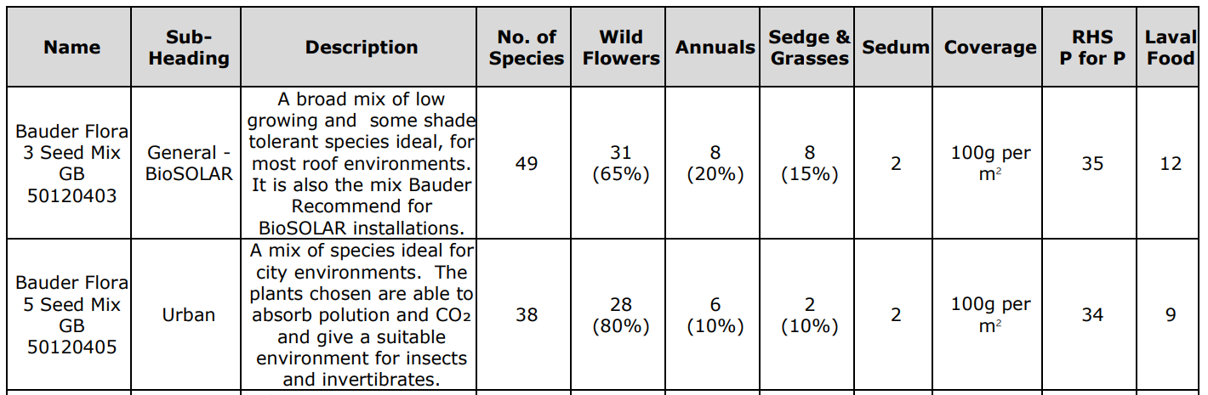

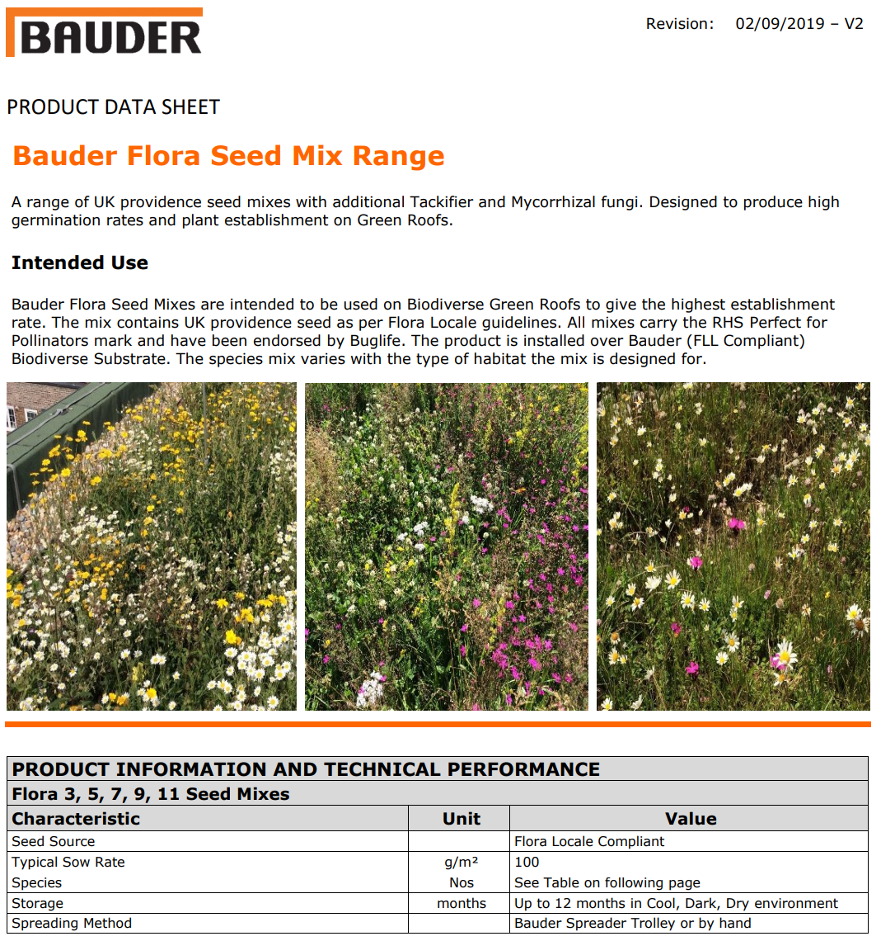
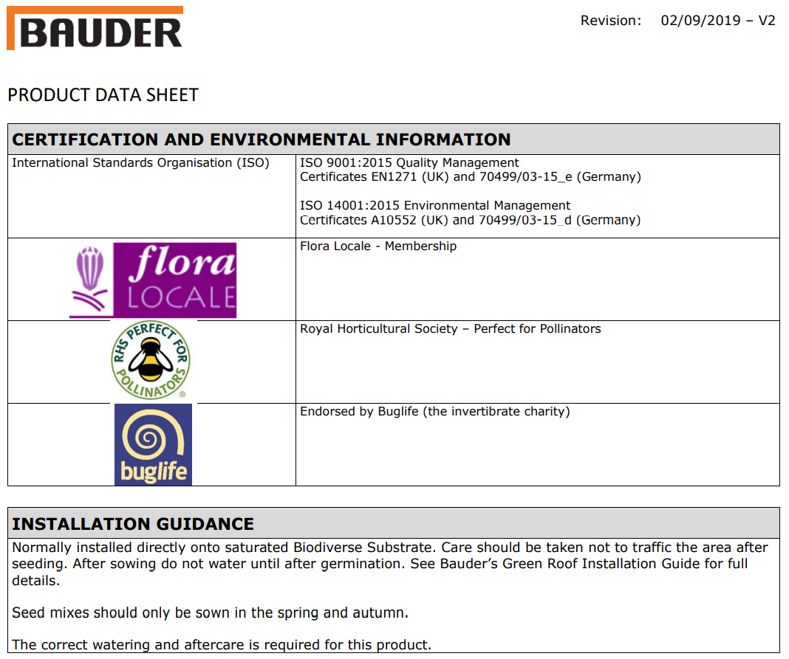
The Living roof will be maintained in accordance with Bauder ‘General maintenance, Green Roof Extensive System’, which is attached for reference.

Stone
The stone is to be Valanges limestone. Fabricated and installed by the Stonemasonry Company.
The Stonemasonry Company Ltd

Zinc
The zinc is to be standing seam VM Zinc Pigmento in Storm Grey. Installed in accordance with the attached literature.
