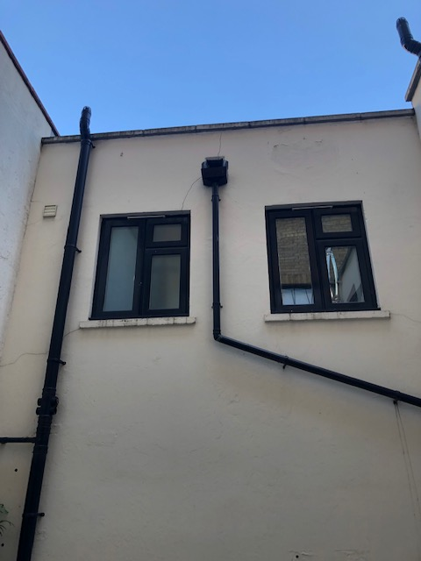

Courtyard Photos – 1 (temporary door to inspect sub floor void for damp)

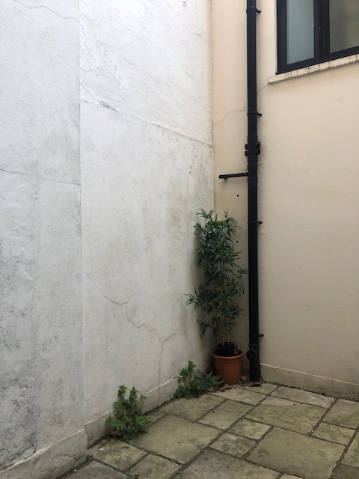

Courtyard Photo 2 – Party Wall (open up for structure review etc)