Godwin and Crowndale Godwin Green Space Consultation - Engagement Summary Report

Executive Summary

1. Introduction and Priorities

Aim/Parameters of community engagement   
Strategy

1. Summary of Process

TMO workshop with Tenant Management Association  
Resident Drop In Event  
Door-Knocking

1. Stakeholder Feedback

Paper surveys

Online surveys

Consultation Boards

Quotes

Findings

Additional concerns

4.0 Appendix A

Invitation to engage

Survey Monkey responses

Consultation boards

**Executive Summary**

In 2021, using initial conceptual landscape drawings from Land Use Consultants (LUC), London Borough of Camden’s (LBC) Community Investment Programme (CIP) team consulted residents of the Godwin & Crowndale Estate on how best to improve the courtyard at the rear of the Godwin building should the proposal to build 10 x 4-bedroom socially rented residential units on the current site of a Multi-Use Games Area (MUGA) be approved. LUC proposed the introduction of a mixture of new greening, play structures, seating, and exercise equipment. Following the planning approval for the housing scheme, the CIP team again consulted residents and through those findings, detailed in the following report, LBC has recommended to supply a mixture of play, leisure and natural landscaping improvements that reflect the priorities of residents, meet the budget of the scheme, and can be managed by the Tenant Management Organisation (TMO).

**1.0 Introduction and Priorities**

The courtyard at the rear of the Godwin and Crowndale estate was presented as a potential site for the development of affordable homes for London Borough of Camden residents in 2011. A variety of different options have been considered during the last 12 years. Full planning permission was granted 14 May 2021 for the proposal to build 10 new homes, including one wheelchair accessible unit. As part of the fulfilment of the planning conditions, the Camden engagement team set out to consult residents of Godwin & Crowndale estate on landscape improvements focusing on the Godwin greenspace. The loss of the Multi-use Games Area (MUGA) to supply the land for the proposed development is a key driver for engaging young people and children and working closely with the tenant management organisation (TMO) to ensure meaningful feedback reflecting the priorities of estate residents was received.

**The Key Aims**

* Meet and exceed Camden standards for consultation and provide evidence that young people and children were consulted in the landscape and play area per planning conditions and in terms of ensuring that their views feed in to the design process.
* Comprehensively gather and accurately represent the views expressed by all participating stakeholders to go on to inform the landscape improvements design.

**Strategy**

* Consult in a proportionate manner to the scale and impact of the scheme, providing varied opportunities to share perspectives on landscape design proposals that are inclusive and accessible, and the purpose of activities and feedback are communicated clearly and transparently.
* Positively engage stakeholders with those aspects of the project that they can influence and how, while being transparent about the limitations, how inputs are being used and how and when decisions will be made.
* Show how this activity fits into the bigger picture of housing provision and local amenity improvements, and that the Council is serious about utilising its resources in the most meaningful and efficient way to realise transformational change.
* Focus on learning from previous engagement. Work from the empirical experience and analysis of what is already there to inform updated consultation and build evidence base to inform priorities for landscape improvements.

**2.0 Summary of Process**

**TMO workshop with LUC architects**

A landscape design workshop was set up with Godwin and Crowndale TMO on 11 May 2022. The aim was for LUC architects to reintroduce priorities established during past consultation and discuss the process forward. The items that were on the agenda are as follows:

* Landscape Proposal 2021
* New planting
* New outdoor fitness
* New play features
* Layout options

There were a few concerns from the TMO, first about the raised food planters and how that would be managed, and demand for contents to be flexible. The question of how access to the courtyard would be regulated was also raised.

**Resident Drop in Event**

On Saturday 21 May 2022, the LBC engagement team for Godwin & Crowndale and a representative from LUC held a resident drop in event in the Godwin & Crowndale TMO hall from 11:00 – 13:00. Residents were invited via a letter dropped off at their doors a week prior to the commencement of the consultation period. (See appended image of letter). LUC provided consultation boards with site drawings and landscaping options for participants to interact with, surveys tailored toward young and adult residents were distributed, and light refreshments were provided while conversations on existing site concerns and proposed improvements took place.

As indicated in the Stakeholder Feedback section, residents of all ages shared their perspectives on the findings of the 2019 engagement process, the landscape design elements and the play elements that could be improved in the courtyard. These views were collected on the boards themselves, in the survey packs as well as through direction to the online surveys made available. Information on accessing the online survey as well as opportunities to fill out one in person were available in the TMO office. The engagement period and opportunity to contribute via the surveys concluded June 10th.

**Door-Knocking**

To promote the survey, representatives from the Council undertook a of door-knocking exercise to speak with young people directly. The TMO helped with a tenant profile of the estate which guided door knocking to target households with young people. However, many of the conversations were conducted in the public entrances to the estate, where children were leaving with parents or coming back from school.

When asked about how often they use the Godwin green Space, 70% of respondents said they use the greenspace quite infrequently, less than month. Parents noted that they would feel more secure with play provision closer in the Godwin Green Space and welcomed the improved surveillance this will achieve.

**3.0 Stakeholder Feedback**

**Paper Surveys**

A total of 10 paper surveys were received over the course of the engagement period. These surveys were tailored to all ages of participating residents. The main opportunities highlighted focused on: Extended play area, more dedicated seating areas . The most popular of concerns focused on: extended play areas.

**Online Surveys**

A total of 8 responses were received via the Survey Monkey questionnaire. Key opportunities identified included: more dedicated seating areas. The main concerns of residents surrounded: security and access to the improved landscaped area. Full response metrics can be found in Appendix A.

**Consultation Boards**

Participants voted during the drop in event by placing stickers and adding written insights on the consultation boards available during the drop in event. The most popular elements from reviewing the 2019 engagement, the landscape design and the play component identified included play equipment for younger children, raised planters with integrated seating, the inclusion of a small flower tree, a multi-age climbing frame, and table tennis. Please see appended photographs of the consultation boards.

**Quotes**

See below some of the perspectives shared by residents during the drop in event:

**Findings**

Overall, key priorities were the maintenance of green space, replacing that which may be removed, while ensuring adequate lighting in the courtyard and for the units, having varied opportunities for play and exercise inclusive of different ages, and regulation of courtyard access.

The online survey collected the priorities and perspectives of 8 residents, with an additional ~15 people attending the drop in event and 9 young people spoken to during the door knocking exercise. Of 173 households in the estate total, approximately 18% percent were engaged with.

Of the young resident respondents, identifying as 60% male and 40% female, over 60% never or rarely ever use the green space at all. Those that do use the space said it is largely to play and to meet friends.

Of the older residents surveyed, half said they used the courtyard “Not very often,” and uses were mostly to play on the grass or sit outside and socialise. The top priorities they identified for improvement were extending children’s play area, the addition of gym equipment, more dedicated seating areas and improved accessibility.

The feedback from surveys and consultation boards was tallied and analysed by the Camden engagement team in consultation with landscape architects from LUC to ensure the proposed design incorporated the identified priorities of residents as appropriately and equitably as possible while also fulfilling key planning conditions.

**Additional concerns**

Godwin doorways with access to courtyard are currently blocked off. Participants have requested that access to improved courtyard by Godwin residents should not be restricted.

Discussion surrounded the introduction of a southern access gate to the courtyard following the construction period, adjacent to the new residential units. There was a persistent question over who manages that gate, who is given access and how that is regulated.

There was also the request to have the derelict storage sheds removed from the site.

**4.0 Appendix A**

Invitation to engage

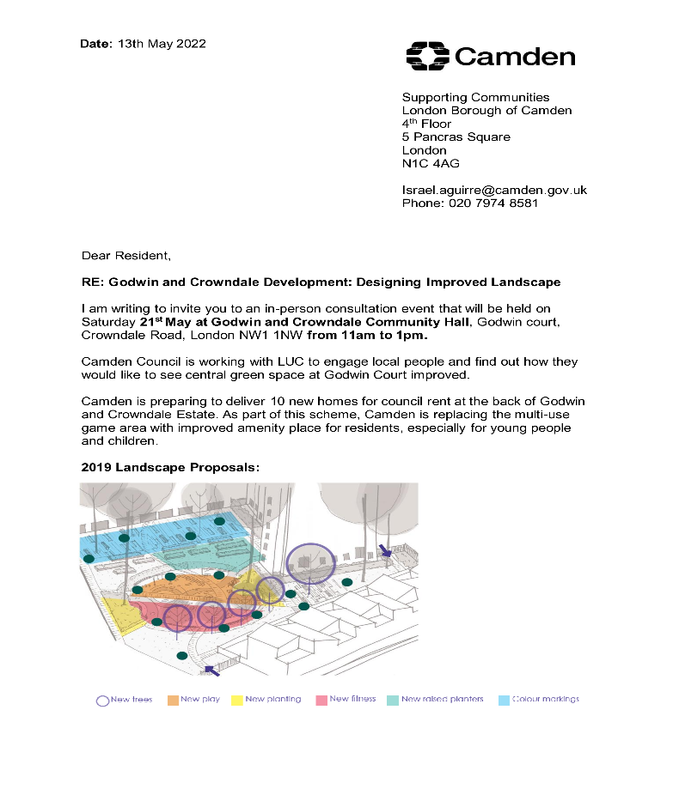

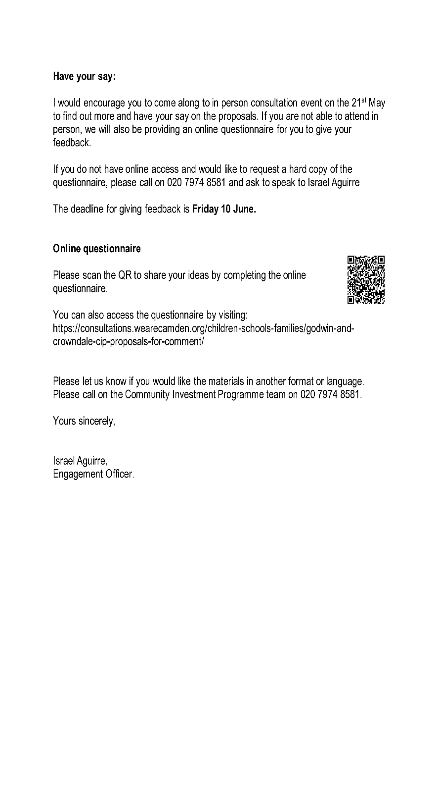

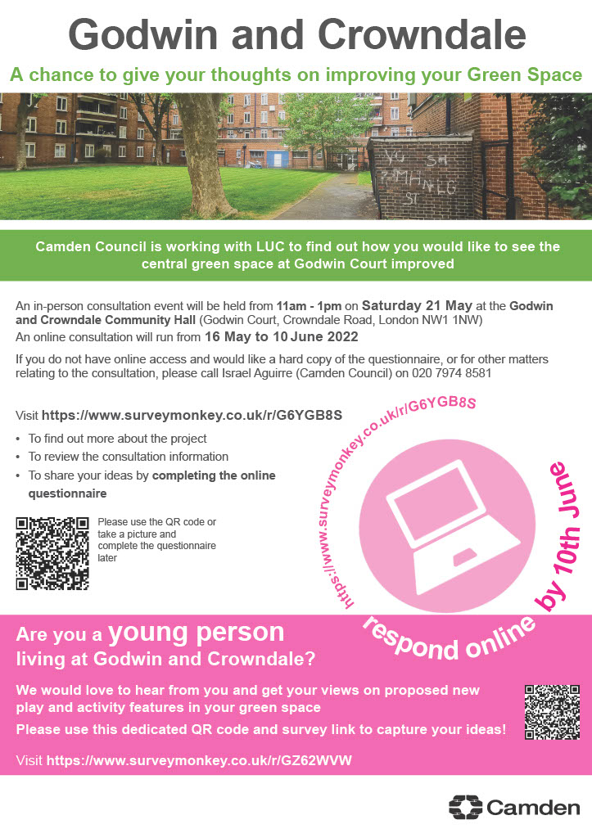

Appendices B: Survey Monkey responses

Young participants:

|  |  |  |
| --- | --- | --- |
| **What is your age group?** |  |  |
| Answer Choices | Responses | |
| <15 | 81.82% | 9 |
| 15-17 | 9.09% | 1 |
| 18-21 | 0.00% | 0 |
| 20-30 | 0.00% | 0 |
| 22-25 | 9.09% | 1 |
| 25+ | 0.00% | 0 |
|  | **Answered** | **11** |
|  | **Skipped** | **0** |
| **How would you describe your gender?** | |  |
| Answer Choices | Responses | |
| Male | 60.00% | 6 |
| Female | 40.00% | 4 |
| Non-binary/other | 0.00% | 0 |
| Prefer not-to-say | 0.00% | 0 |
|  | **Answered** | **10** |
|  | **Skipped** | **1** |
| **How often do you use the green space?** | |  |
| Answer Choices | Responses | |
| Never | 25.00% | 2 |
| Rarely/less than once a month | 37.50% | 3 |
| Once a month | 0.00% | 0 |
| Every couple of weeks | 25.00% | 2 |
| Once a week | 0.00% | 0 |
| Two or three times a week | 12.50% | 1 |
| Every day | 0.00% | 0 |
|  | **Answered** | **8** |
|  | **Skipped** | **3** |
| **What do you use the green space for?** | |  |
| Answer Choices | Responses | |
| Through-route | 0.00% | 0 |
| Walking | 12.50% | 1 |
| Relaxation/Reflection | 25.00% | 2 |
| Enjoying nature | 12.50% | 1 |
| Informal recreation | 0.00% | 0 |
| Play | 62.50% | 5 |
| Meet friends | 62.50% | 5 |
| Playing on the grass | 12.50% | 1 |
| Workout/exercise | 0.00% | 0 |
| Dog walking | 0.00% | 0 |
| Running | 12.50% | 1 |
| Other (please describe) | 0.00% | 0 |
|  | **Answered** | **8** |
|  | **Skipped** | **3** |
| **Please select your favourite for play/games** | |  |
| Answer Choices | Responses | |
| Climbing Frame | 60.00% | 6 |
| Natural Play Stone | 0.00% | 0 |
| Table Tennis | 20.00% | 2 |
| Toddler Swing | 20.00% | 2 |
|  | **Answered** | **10** |
|  | **Skipped** | **1** |

Other participants:

|  |  |  |
| --- | --- | --- |
| **Age** |  |  |
| Answer Choices | Responses | |
| under 10 | 0.00% | 0 |
| 10-15 | 16.67% | 1 |
| 15-20 | 0.00% | 0 |
| 20-30 | 0.00% | 0 |
| 40-60 | 33.33% | 2 |
| 60+ | 50.00% | 3 |
|  | **Answered** | **6** |
|  | **Skipped** | **1** |
| **What is your interest in Godwin and Crowndale Green Space?** | | |
| Answer Choices | Responses | |
| Resident of Godwin and Crowndale | 100.00% | 7 |
| User of the MUGA | 0.00% | 0 |
| Visiting family or friend | 14.29% | 1 |
| Other (please state) | 0.00% | 0 |
|  | **Answered** | **7** |
|  | **Skipped** | **0** |
| **How often do you use the Godwin and Crowndale Green Space?** | | |
| Answer Choices | Responses | |
| Every day | 33.33% | 2 |
| A few times a week | 16.67% | 1 |
| Once a week | 0.00% | 0 |
| Every few weeks | 0.00% | 0 |
| Not very often | 50.00% | 3 |
|  | **Answered** | **6** |
|  | **Skipped** | **1** |
| **What do you use the green space for?** | |  |
| Answer Choices | Responses | |
| To play on the grass | 28.57% | 2 |
| Dog walking | 14.29% | 1 |
| Walking | 28.57% | 2 |
| Running | 14.29% | 1 |
| Relaxation / reflection | 42.86% | 3 |
| Sitting outside | 42.86% | 3 |
| Informal recreation | 0.00% | 0 |
| Passing through | 14.29% | 1 |
| Yoga / meditation | 0.00% | 0 |
| Enjoy nature | 28.57% | 2 |
| Meet friends | 28.57% | 2 |
|  | **Answered** | **7** |
|  | **Skipped** | **0** |
| **Which types of improvements do you think should be prioritised? Pick up to 5.** | | |
| Answer Choices | Responses | |
| Extended children’s play | 71.43% | 5 |
| Outdoor games / social recreations | 42.86% | 3 |
| Artistic or cultural installations | 28.57% | 2 |
| Space for seasonal events and activities | 14.29% | 1 |
| More dedicated seating areas | 57.14% | 4 |
| Improved accessibility | 57.14% | 4 |
| Space for food growing with raised planters | 28.57% | 2 |
| More or improved lighting | 42.86% | 3 |
| Improved recycling facilities | 14.29% | 1 |
| Covered seating area | 42.86% | 3 |
| Outdoor gym equipment | 57.14% | 4 |
| More planting or improved ecology | 28.57% | 2 |
| Composting area | 0.00% | 0 |
| Other (please state) | 0.00% | 0 |
|  | **Answered** | **7** |
|  | **Skipped** | **0** |

Appendices C: Consultation boards

