Site Name: | The Red London | ATM Location  Front of ATM  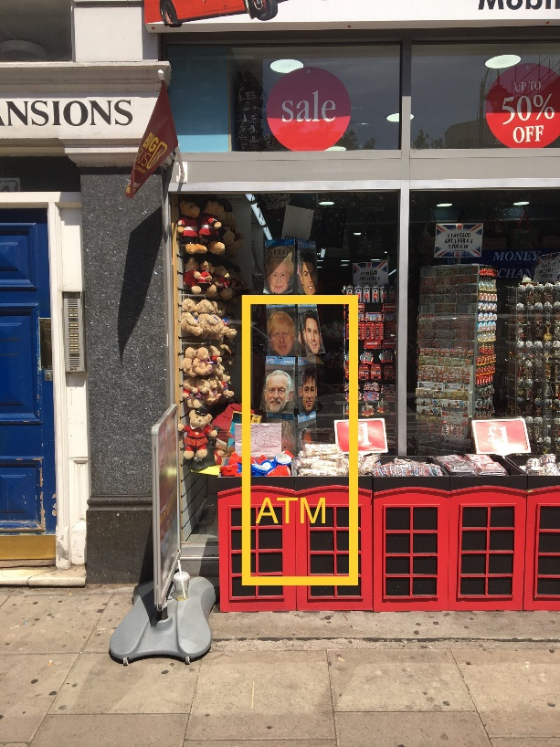Back of ATM    Front of Shop  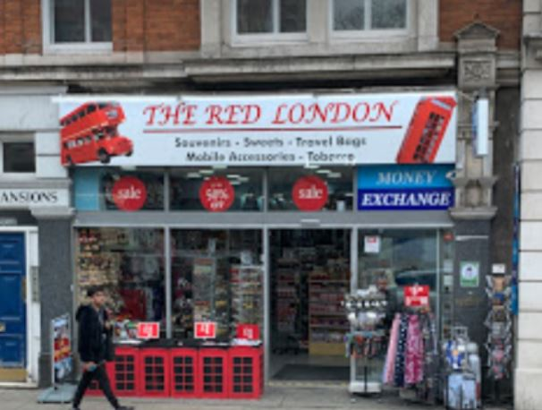
Address: | 100 Southampton Row, London, WC1B 4BB
Site Contact: | Mr Riyad Khader
Phone: | M: 07404767764
Email: | riyadkhader@live.co.uk
ATM Type: | NCR SS26 External
Opening Hours: | Mon-Sun 1000-2100
Signage: | ATM Euronet Standard, Plus non illuminated sign
Notes: Good TTW area with no competition. Next to the Hilton Hotel on Southampton Row and close to the British Museum. This site is close to Russell Square and Holborn Tube Stations. There are also other hotels in proximity. Site has slightly changed and now has a small convenience store inside along with all the gifts and souvenirs.
ATM Location:
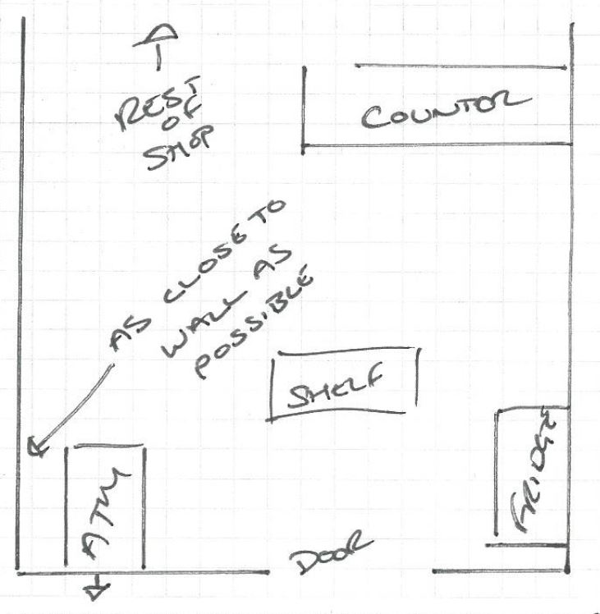

Wall Sign Lightbox location
