111d Goldhurst Terrace NW6 3HA

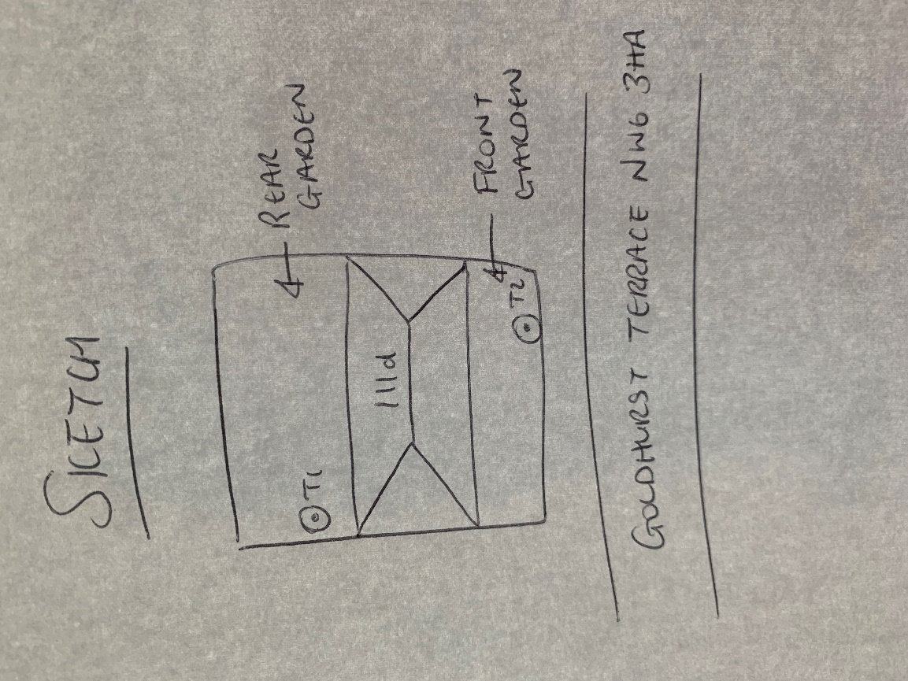

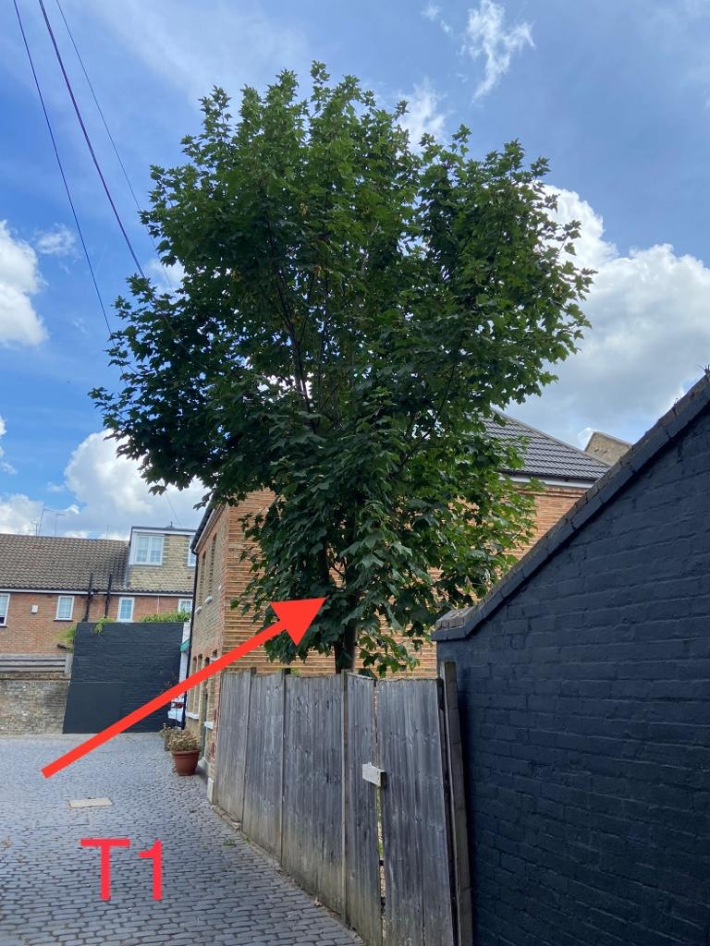 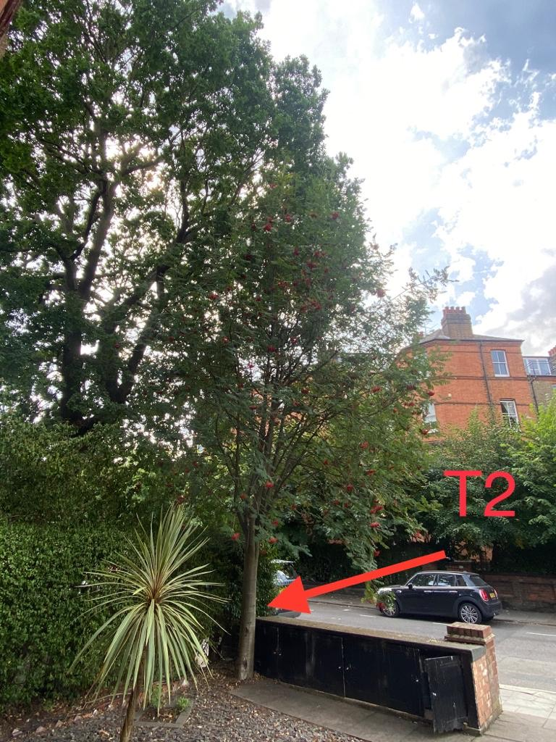

T1: Sycamore (8m): Fell to ground level due to close proximity to house as regular pruning to keep it at a size suitable for its location is encouraging growth

T2: Rowan (10m): Reduce height by 3m to previous points and shape as part of regular maintenance