FLASK WALK NEIGHBOURHOOD ASSOCIATION Hampstead London NW3

**(Representing the interests of residents of:**

**Back Lane, Boades Mews, Flask Walk, Gardnor Road, Lakis Close, Lutton Terrace, Mansfield Place, Murray Terrace, New Court and Streatley Place)**

[***flaskwalkna@gmail.com***](mailto:flaskwalkna@gmail.com)

Adam Greenhalgh Esq

Planning Officer, Camden Council

5 Pancras Square N1C 4AG

04/08/2022

**Objection** re: 71b Flask Walk – Planning Application Number **2022/1289/P**

Dear Adam

This is to notify you that the members and committee of the Flask Walk Neighbourhood Association (FWNA) have authorised me to object in the strongest possible terms to this Planning Application.

As you know, it concerns installation of a Daikin air conditioning unit including an external chiller unit within an acoustic attenuation enclosure at the rear of 71B Flask Walk.

The principal grounds of our objection are the proposal’s adverse impact in terms of visual amenity and noise upon the neighbouring properties, in particular, 73 Flask Walk.

We also consider that the proposal would cause unacceptable harm to amenity contrary to Policy A1 of the Local Plan 2017.

As viewed from Flask Walk, number 73 FW lies to the right of the application property as can be seen from fig 1 of the applicant’s Acoustic Report. To the rear of 73 FW is a first-floor roof terrace immediately adjacent to the single storey rear extension of 71B where it is proposed to site the air conditioning unit.

The living room of 73 has full width folding glass door opening onto the terrace. Photographs provided to FWNA by the owner of 73 are attached.

The proposed unit would constitute a serious visual intrusion to those using 73’s rear terrace and living room. The D&A Statement suggests that “the external plant has been sited at the rear of the property in an enclosed courtyard surrounded by solid brick walls that is not overlooked by neighbouring properties”.

In fact, it would be so close to the top of the wall as to make little difference and when built out may be visible over the wall. Fig 1 of the applicant’s Acoustic Report refers to “proposed plant location on roof of proposed additional story (sic)”. Is there going to be another storey added to the rear of No.71B?

The constant low-level humming from the unit would be intrusive to the users of the terrace. We note that all noise calculations are based on a location representative of the noise environment at the most affected neighbouring residential windows which are to the left of the application property: see fig 1 of the applicant’s Acoustic Report. If this is the most affected, it is one of the more remote locations on the photo. No attempt has been made to calculate the noise that would affect 73’s rear terrace which is adjacent. Moreover, we note, even using the applicant’s own figures:

1. Without attenuation, the unit operates at a sound level of 48 dBA. That would be the absolute minimum level, assuming that the unit is in perfect working order, which frequently they are not.
2. The noise from the unit should not exceed 21dBA (31dB – 10 dB) during the day or 18dBA (28dB – 10dB) during the night.
3. The maximum attenuation achievable by the enclosure would be 21dB: see table 2 of the Acoustic Report. If the application is granted, there would clearly need to be conditions limiting the time during which the unit could be used and requiring the provision of an acoustic enclosure which, after construction, does in fact achieve that attenuation when measured over an appropriate time span.
4. However, the attenuation assumes “propagation losses” of 17dB due to “Hemispherical spreading over 7m to rear windows of neighbouring property”. Such losses would not be applicable in respect of a receptor on 73’s rear terrace. Note that hemispherical spreading would not be appropriate to the confined acoustics at the rear of No.73.
5. The calculated noise levels pertaining at the rear terrace of 73 must be provided before Camden even considers this application.
6. No provision for regular service and maintenance of the unit has been included.

In addition, there is a roof terrace at 36 New End which is directly above and close to the proposed unit and a roof terrace at 34 New End which overlooks the unit. Both are likely to be adversely affected by this proposal.

In summary, this communication is intended to express and explain the FWNA’s strong support for the objections raised by the occupants of 73 Flask Walk and adjacent properties, to request that the democratic opinion of the local community be respected, and hence to ensure that the above application be rejected.

With kindest regards

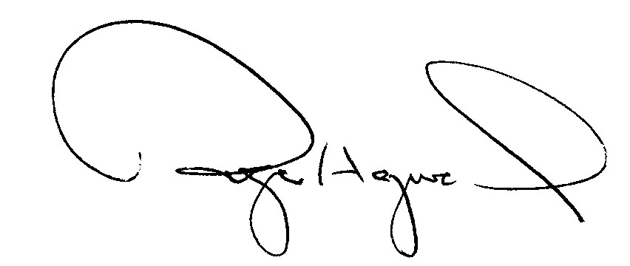Yours most sincerely

Roger Hayward MD FRCP FESC

Chair, FWNA

Attached: 2 Photos of rear terrace at 73 FW

73 roof terrace – looking towards 71B and proposed site for air con unit

73 roof terrace: no.71B is to the left.