

Heritage Statement & Design and Access Statement

SITE ADDRESS: 134 Goldhurst Terrace London NW6 3HR

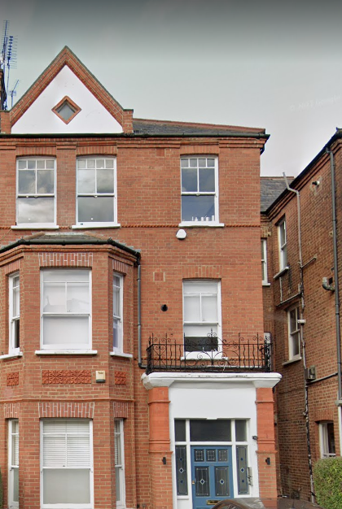

Proposal: Anglian Home Improvements have been contracted to
replace the existing doors and side windows to lounge and rear
door.

Surrounding Area:
South Hampstead is a well-preserved example of a leafy Victorian suburb, almost exclusively residential in nature, and largely homogenous in scale and character. The area is characterised by large, semi-detached and terraced late-Victorian properties, in red or gault (white / cream) brick, with a particularly distinctive and attractive roofscape including turrets, gables, and tall chimneys. Houses are made special by a variety of decorative treatments including terracotta panels and brickwork ornamentation, tiled and patterned footpaths, delicate ironwork, and elaborate timber doors and windows, including some original stained and leaded glass.

Heritage/History

The South Hampstead (formally known as the Swiss Cottage Conservation Area) was originally designated on 15th November 1988.

Constraints: The property is a flat and falls within the Conservation Area for which we have been advised there is an Article 4 Direction in place restricting permitted development hence the requirement of the application.

Design Principles/Justification:

The applicant has chosen our white timber flush fit double glazed windows to sit above the new rear door and new proposed French doors. It is proposed to replace the existing single door and side windows with 2 larger timber French doors. This change will allow more light into the property and offer a better form of fire escape. The existing doors do not offer adequate security and allow for significant heat loss.

The photos below show the poor condition of the existing windows and doors. Due to their current condition, they do not easily open and close make them a health and safety concern as well as a security risk.
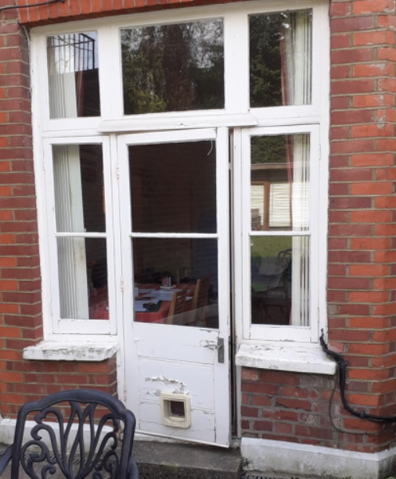

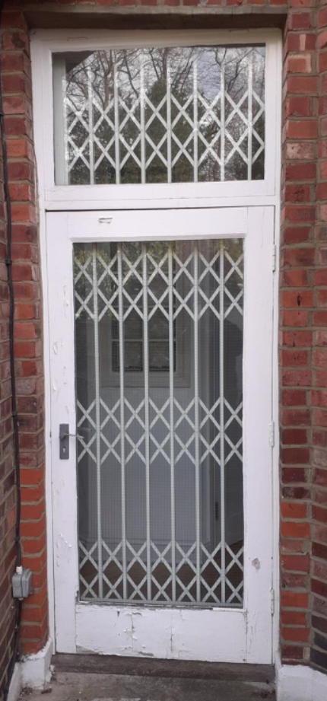
The scale and visual appearance will be mostly unchanged and will therefore be in keeping within the conservation area and the property. The existing windows and doors are in a poor condition and as such the new proposed windows will provide better weather proofing and thermal efficiency. This improvement therefore will protect the internal and external fabric of the property.

The changes proposed are to the rear of the property and are therefore not visible from the public realm.

The property is near the edge of the conservation area and it has been noted that there are other properties in the area which have replaced their windows/doors with uPVC.

In addition, draught proofing, sound insulation and security measures will all be improved upon to the benefit of the quality of the life of the homeowners.

All of our wooden windows are sustainably sourced, then individually designed and manufactured by our skilled joiners to create a window specific to the applicant’s and local authority requirements.

Access: No change to the property to the existing access.

Landscaping: N/A

To conclude with the above in mind we trust the windows proposed will be considered favourably by the council as we do not believe they will have any detrimental impact on the conservation area. We look forward to your reply and positive co-operation.

