planning@camden.gov.uk
Transport for London
Crossrail 2
Safeguarding Manager
5 Endeavour Square
LONDON
E20 1JN

Phone: 020 3054 7018
www.TfL.gov.uk
Regeneration and Planning
London Borough of Camden
Town Hall
Judd Street
London
WC1H 9JE

29 July 2022
Crossrail 2 Ref: CR2-4308-2022

Dear Elaine Quigley,

2022/2683/P : 62-64 Hampstead Road London NW1 2NU
Erection of a mansard roof extension and roof terrace at no. 144 Drummond to provide additional habitable floor space for 3rd floor flat.

Transport for London administers the Crossrail 2 Safeguarding Direction made by the Secretary of State for Transport on 24 March 2015.
Thank you for your letter to TfL Spatial Planning dated 25 July 2022, requesting the views of the Crossrail 2 Project Team on the above application. I confirm that the application relates to land within the limits of land subject to consultation by the Crossrail 2 Safeguarding Direction.
I have no comment on the application.

The latest project developments can be found on the Crossrail 2 website www.crossrail2.co.uk .

I hope this information is helpful, but if you require any further information or assistance then please feel free to contact a member of the Safeguarding Team by email to crossrail2@tfl.gov.uk .
Yours sincerely,
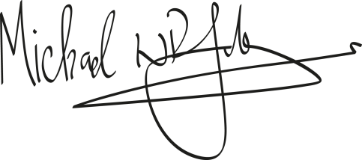
Michael Johnson
Safeguarding Manager

