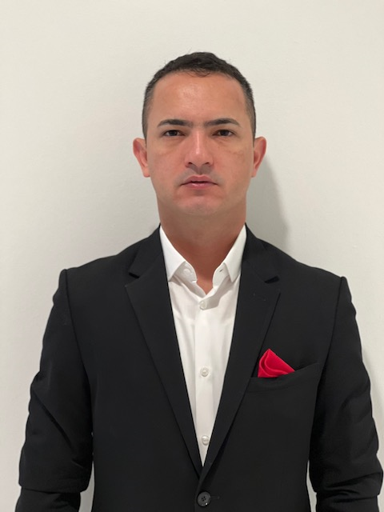 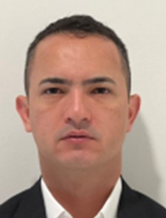

This is to certify that

This is a true likeness of

**JHON MOREIRA DE ANDRADE**

Signed



Karen Lonergan

Director

Due Diligence Systems Ltd

Dated 20/072022