1-32 Brookes Court Fabric Retrofit:-

Camden, London

Pre-App Design Statement for London Borough of Camden

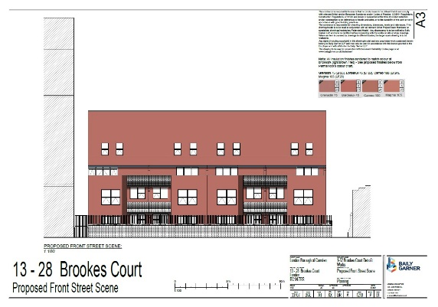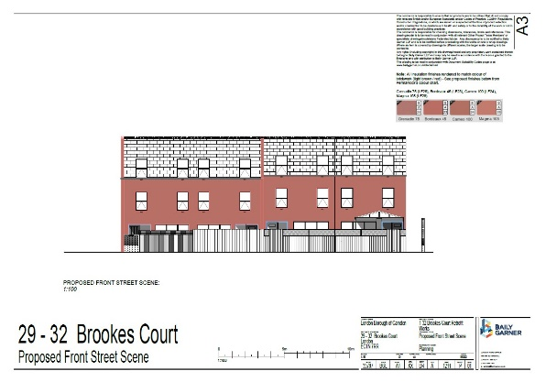

## Prepared by Baily Garner LLP for LB Camden, July 2022

**Baily Garner LLP**

146-148 Eltham Hill

London SE9 5DY

t: +44 (0)208294 1000

w. www.bailygarner.co.uk/

contact: Matthew Allcock

# Introduction

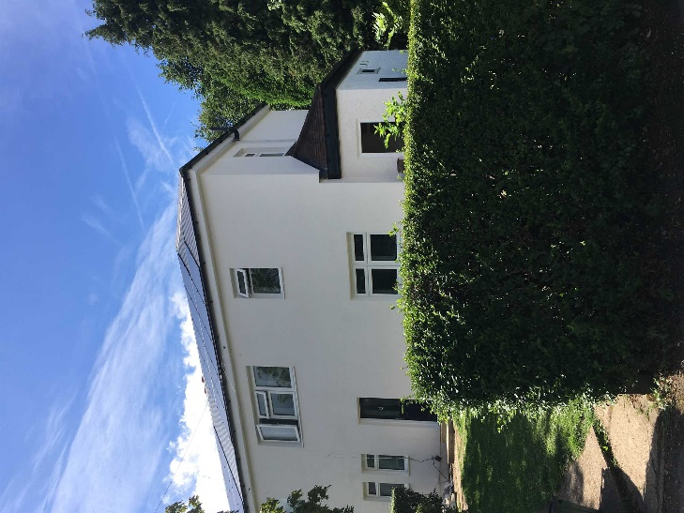Baily Garner LLP are commissioned as designers and specifiers for the External Wall Insulation led whole house deep fabric retrofit of 1-32 Brookes Court, London EC1N 7RR, on behalf of the London Borough of Camden, with PAS 2035 compliant ventilation upgrades.

The scheme targets are to achieve a maximum 90kWh/m2/yr heating demand and EPC C rating or above.

Baily Garner LLP has experience designing a whole-house deep Retrofit solution.

The project aims to reduce resident fuel bills, create desirable, warm, affordable & healthy homes for life, and:-

### QUALITY

* Net-zero energy homes with long performance warranties

### NON-INTRUSIVE

* Refurbishment within a limited time on site

### AFFORDABLE

* Financeable from energy cost savings

### LOOK & FEEL

* Attractive and comfortable homes

The scheme is also looking to enhance the appearance and comfort of the homes as they want residents to love where they live. It is equally important that the retrofitted homes are affordable to run and are able to display tangible benefits to the health and wellbeing of their residents.

As-built example retrofit in Sutton

# Camden Brookes Court: Site Location and Block Plan (32 properties)

# Camden – Aerial View of Site (1-32 Brookes Court)

1. **Camden Brookes Court: Existing House Types**

## 1-6 Brookes Court 7-12

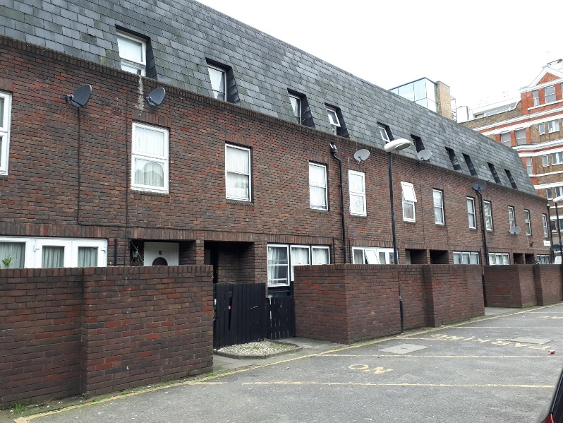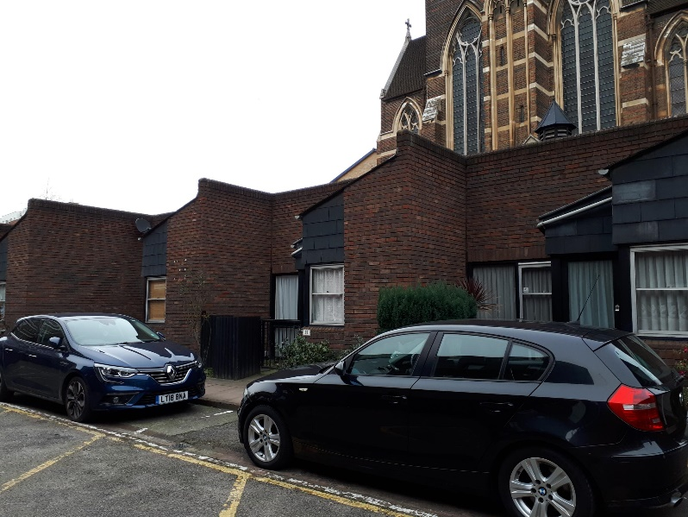

## 13-28 29-32

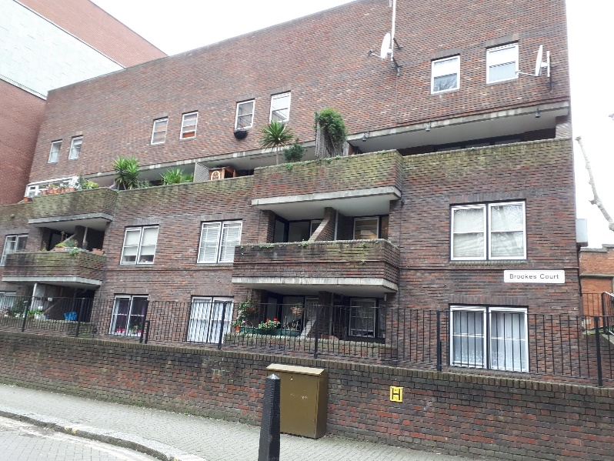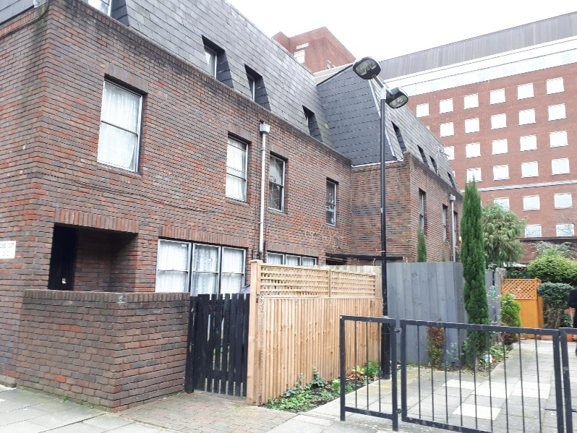

# Camden Brookes Court – Existing Street Scenes:

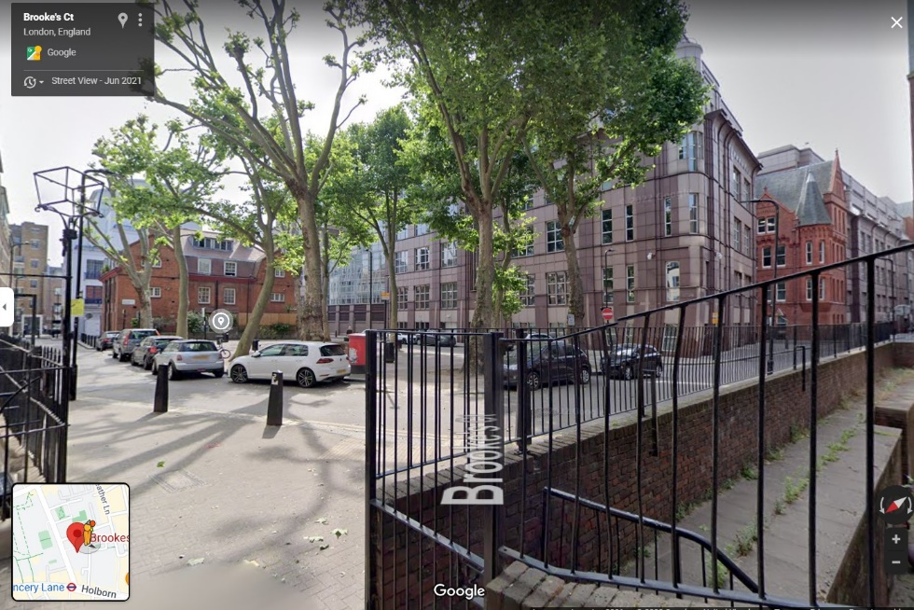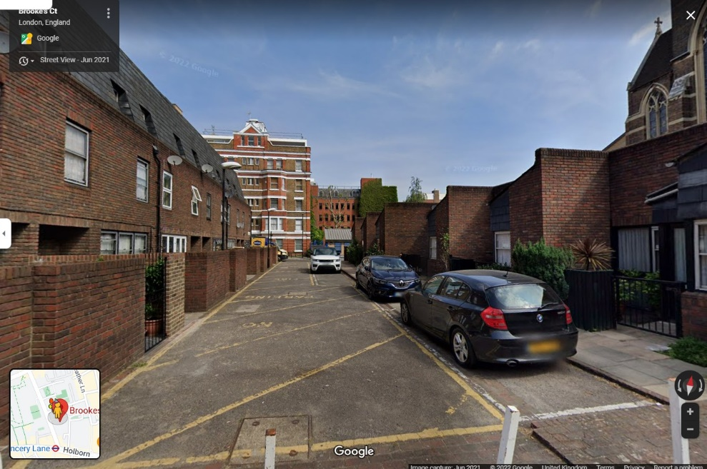

1. **Existing Property Before Retrofit:**

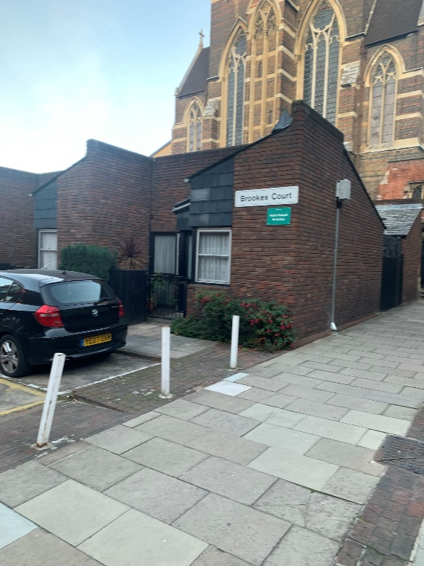

External Appearance

# Whole-House Retrofit – Proposals

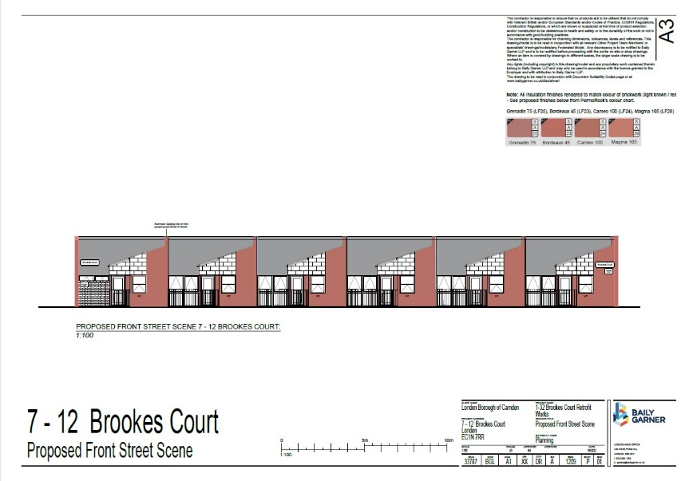

#### Before & After Retrofit: End-Terrace Elevations (*coloured to show insulation thickness post-works, door locations behind indicated*)

Before Retrofit:

* Poor insulation
* Draughty
* Expensive to heat
* Difficult to control ventilation

After Retrofit:

* Insulated wall EWI
* Air-tight membrane
* Reduced heating costs
* Consistent controllable ventilation

#### Retrofit Cross Section Drawing

#### Retrofit Detail Working Drawings

Windows

  

Roofs

  

Corner Detail

  

Foundations



#### Retrofit Component Upgrades: External Wall Insulation (Brick Slips to Match Existing)

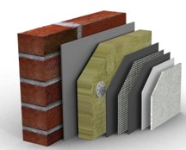    

#### Precedent Scheme – Denton EWI, 2015

#### Retrofit Component Upgrades: New Windows & Doors

* High Performance Windows
* High Performance Insulated Doors

‘High Performance’ in terms of insulation, air-tightness and opening operation

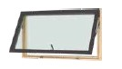

#### House Details: Ventilation Control & Renewable Energy

Whole House Ventilation:

* New airtight building fabric - less draughts
* Continuous background ‘trickle’ ventilation
* Energy efficient MEV – fresh air in, waste air out
* Openable windows – when extra ventilation is required

Net Zero Energy:

* Future medium-term plan (PVs, heat pump)

1. **Summary – Before & After Retrofit**

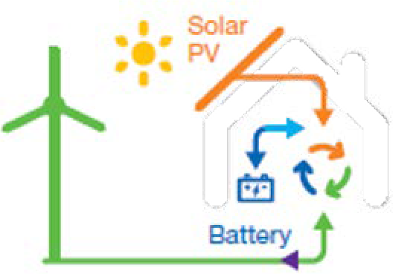

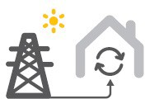**Existing House**

**Retrofit House**

Present draw from electricity grid and communal gas heating, energy requirements improved by upgrading fabric, and air quality and levels of moisture controlled by improved mechanical ventilation system, preparing the property for further future improvements…

… Future medium term improvements to install heat pump technology heating and renewable sources of power generation e.g. solar photovoltaic panels

**Thank you**