Design and Heritage Statement
Flat 6, 3 Cambridge Gate, Regents Park, London, NW1 4JX.

Listed Building Consent Submission for Installation of Secondary Glazing for thermal Insulation.

Author: KAM

Revision: Rev 01

Date: 10/06/22

Scope
This document relates specifically to Flat 6, 3 Cambridge Gate where internal secondary glazing is proposed to be installed. The property is a grade 2 listed flat within the Camden district.
This document considers the following proposals which require listed building consent.

Installation of internal secondary glazing to 15 windows over 3 floors (Third to fith) on the west and east façades.
Listing Description
List Entry Number: 1244289

Date of first entry: 14-May-1974

Statutory Address: NUMBERS 1-10 AND ATTACHED RAILINGS, 1-10, CAMBRIDGE GATE

National Grid Reference: TQ 28763 82469

Details

CAMDEN
TQ2882SE CAMBRIDGE GATE 798-1/92/142 (East side) 14/05/74 Nos.1-10 (Consecutive) and attached railings
GV II
Terrace of 10 houses. 1875-77. By T Archer and A Green. Built by Stanley G Bird. Bath stone; slated mansard roofs with dormers. Large slab chimney-stacks. 4 storeys, attics and basements. Symmetrical terrace in French Renaissance style with projecting end bays (Nos 1 & 10). EXTERIOR: each house with 1 window each side of a 3-window bay. Windows mostly recessed casements with enriched panels over. Square-headed doorways with enriched half glazed doors and fanlights (some with enriched cast-iron grilles). Nos 1 & 10 with prostyle porticoes. Canted window bays rise through lower 3 storeys with bracketed cornices and central pediments with pierced parapets over. Ground floor with pilasters carrying entablature with continuous balustraded parapet at 1st floor level. Console-bracketed balcony with balustrade at 2nd floor level with cast-iron balconies to bay windows. 3rd floor, 3 windows separated by pilasters above bay windows, with 1 window each side. Bracketed cornice and parapet. Above bay window bays, large dormers of single round-arched light with keystone, topped by segmental pediment and flanked by scrolls. End houses with attic storeys above cornice and tall mansard roofs enriched with cast-iron railings and large palmettes. Nos 8 & 9 with blind boxes. Left hand return with 8-light cast-iron conservatory bay window on bracketed stone base. INTERIORS: not inspected. SUBSIDIARY FEATURES: attached, cast-iron panelled railings with floral motif to areas. HISTORICAL NOTE: this terrace was built on the site of the Colosseum (1824-6, demolished 1875) by Decimus Burton. (Survey of London: Vol. XIX, Old St Pancras and Kentish Town (St Pancras II): London: -1938: 123).
Schedule of proposed works

GW01 & GW05
Internal secondary glazing to the Living Room
It is proposed that timber grounds are fitted to the existing timber lined reveal using No 8 wood screws. The secondary glazing will be fitted to the new timber grounds.

GW02 & GW04
Internal secondary glazing to the Living Room
It is proposed that timber grounds are fitted to the existing timber lined reveal using No 8 wood screws. The secondary glazing will be fitted to the new timber grounds.

GW03
Internal secondary glazing to the Living Room
It is proposed that timber grounds are fitted to the existing timber lined reveal using No 8 wood screws. The secondary glazing will be fitted to the new timber grounds.

GW06, GW07, GW09
Internal secondary glazing to the Kitchen.
It is proposed that timber grounds are fitted to the existing plaster reveals using No 8 plugs and screws and into the timber window board using No 8 wood screws. The secondary glazing will be fitted to the new timber grounds.

GW08
Internal secondary glazing to the Kitchen.
It is proposed that timber grounds are fitted to the existing plaster reveals using No 8 plugs and screws and into the timber floor using No 8 wood screws. The secondary glazing will be fitted to the new timber grounds.

1W01
Internal secondary glazing to the Office.
It is proposed that timber grounds are fitted to the existing plaster reveals using No 8 plugs and screws and the timber window board using No 8 wood screws. The secondary glazing will be fitted to the new timber grounds.

1W02
Internal secondary glazing to the Office.
It is proposed that timber grounds are fitted to the existing plaster reveals using No 8 plugs and screws and the timber window board using No 8 wood screws. The secondary glazing will be fitted to the new timber grounds.

1W03 & 1W05
Internal secondary glazing to the Bedroom.
It is proposed that timber grounds are fitted to the existing curved head plaster reveals using No 8 plugs and screws and the timber window board using No 8 wood screws. The secondary glazing will be fitted to the new timber grounds.

1W04
Internal secondary glazing to the Bedroom.
It is proposed that timber grounds are fitted to the existing curved head plaster reveals using No 8 plugs and screws and the timber window board using No 8 wood screws. The secondary glazing will be fitted to the new timber grounds.

2W01
Internal secondary glazing to the Bedroom.
It is proposed that timber grounds are fitted to the existing plaster reveals using No 8 plugs and screws and to the timber window board using No 8 wood screws. The secondary glazing will be fitted to the new timber grounds.

Design Consideration
Thermal Insulation: Secondary glazing is widely considered the most effective way to improve the thermal insulation of window openings, whilst retaining the historic primary windows and the associated embodied carbon. The addition of secondary glazing will reduce the u value from approximately 4.7 w/m2/K to 2.8 w/m2/K.

Noise mitigation. Whilst not the primary reason for specifying the secondary glazing. The addition of secondary glazing will reduce the noise ingress from road noise by approximately 12 – 15 dB Rw, bringing the internal of the property in line with World Health Organisation guidelines.

Historic England: Secondary glazing is considered an acceptable and beneficial adaptation by Historic England. Reference; Historic England’s publication: Energy Efficiency and Historic Buildings: Secondary Glazing for Windows.

Window design and materials: The secondary glazing windows will be manufactured from aluminium with a polyester powder coating. New timber grounds and subframes will be produced from FSC certified timber finished to match the secondary glazing colour.

Minimising external visual impact on existing windows: Secondary glazing will be installed internally on the proposed windows. The position of the secondary glazing frame will align with the original window frame and casement positions and sightlines to minimise visual impact when viewed externally. When viewed externally, the secondary glazing might be seen by a discerning person when viewed obliquely. Some reflection on the secondary glazing may also be evident from the original windows. The external visual impact on the significance of the heritage asset will be low to very low and is an accepted consequence of installing secondary glazing into historic buildings.

Reducing internal visual impact for the residents: The secondary glazing frame section size is minimised to ensure original glazing sightlines are maintained. The secondary glazing frame will be powder coated white to match the existing surrounding joinery.

Maintaining existing window functionality: The secondary glazing is openable for cleaning, maintenance, trickle and purge ventilation as required. All existing windows will remain operable with the secondary glazing installed.

Fixing the secondary glazing: The secondary glazing, timber grounds and subframes will be fitted with minimal discrete fixings to reduce the potential impact on any historic structure. No 8 plugs and screws will be used for fixing to masonry and No 8 wood screws will be used for fixing to timber.

Impact: The secondary glazing treatment is designed in such a way to have minimal impact on the historic features of the property. Apart from fixing holes there will be no damage to existing joinery, architrave, or moldings. The secondary glazing treatment is fully reversible; once removed the fixing holes into the reveals and timber sill can be sympathetically filled and decorate leaving no visible trace of the installation.

Photos
Front Elevation
1W05
W104
1W03
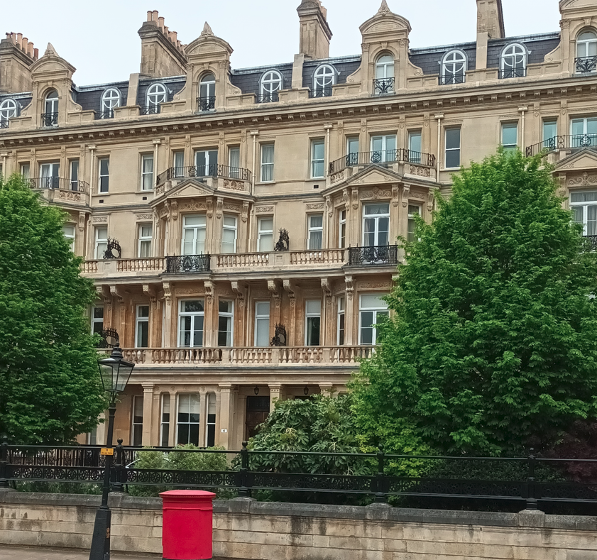
GW05, 04, 03, 02, 01

Rear Elevation
GW09 – not visible
GW08, GW07, GW06
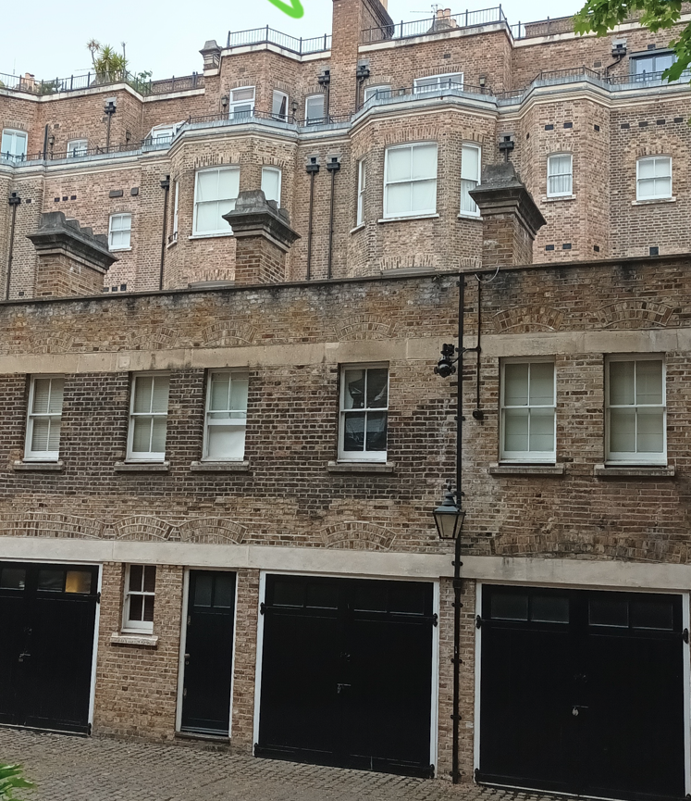

1W01, 1W02, 2W01 External
2W01

