**DESIGN AND ACCESS STATEMENT**

**For proposed outbuilding at the rear of 17a Crossfield Road, London NW3 4NT**

**Introduction**

This is a supporting document/design and access statement to accompany a full planning application for the erection of a single story timber garden studio at the rear of 17a Crossfield Road, London NW3 4NT.

1. **SIZE**

The proposed development has an area of 34.1m2 within a rear garden of 163.6m2. It is a timber-framed, single-story, eco-outbuilding for ancillary residential purposes.

1. **LAYOUT**

The proposed outdoor structure has no effect on the surrounding routes of the side or public realm as it is nestled withing fence lines and positioned approximately 18m away from the rear façade of the existing main building. No public spaces are being affected.

1. **SCALE**

The external dimensions of the outbuilding are 4.806m wide x 7.706m deep x 2.8m high from existing ground level.

1. **LANDSCAPE**

The proposed studio will sit in an area of disused garden space surrounded by high foliage (see image 1 below). A shed (with a smaller area of 20.64m vs this proposed area of 34.1m) stood in this site until last summer (see image 2 below). The shed was unsightly and in bad repair (see image 2); it is proposed to build a much more aesthetically appealing garden studio to replace it. The shed was 3.2m high (with eaves sloping down to 2.3m). The proposed height of the garden studio is 2.8m, lower than the shed at its highest point. A concrete base already stands in the area from the old shed. Following the arborio-cultural report attached to the planning permission application, pad/minipile/sleeper foundations may be used to extend the foundations to promote the continued health of the surrounding trees.

1. **APPEARANCE**

The timber outbuilding is a modest contemporary structure using natural sustainable materials. Premium grade thermo-abachi wood from Poland is used for the cladding on the front (the only visible side). The windows are doors have stylish grey aluminium frames. It is considered that the structure will enhance the site and surroundings. The sides (not visible) and back (not visible) will be covered in timber-effect vox cladding. It will fit with the style of the modern timber-cladded garden studios in 18 Crossfield Road (next door) and 15 Crossfield Road (two doors down).

1. **PROPOSED USE**

Ancillary residential purposes. The studio will be used as a home office and gym.

1. **ACCESS**

The access to the site will not be altered or replaced in any way. All materials can be brought through the front door of Flat 17a and out to the rear of the building through the back door (see floor plan of 17a at image 3 below).

1. **IMAGES**

IMAGE 1: Picture of surrounding area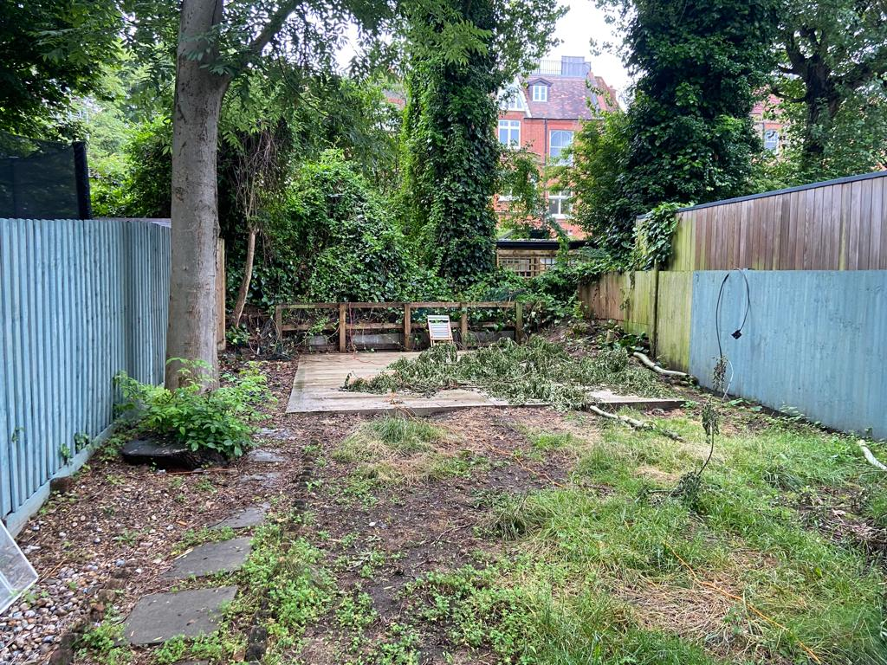

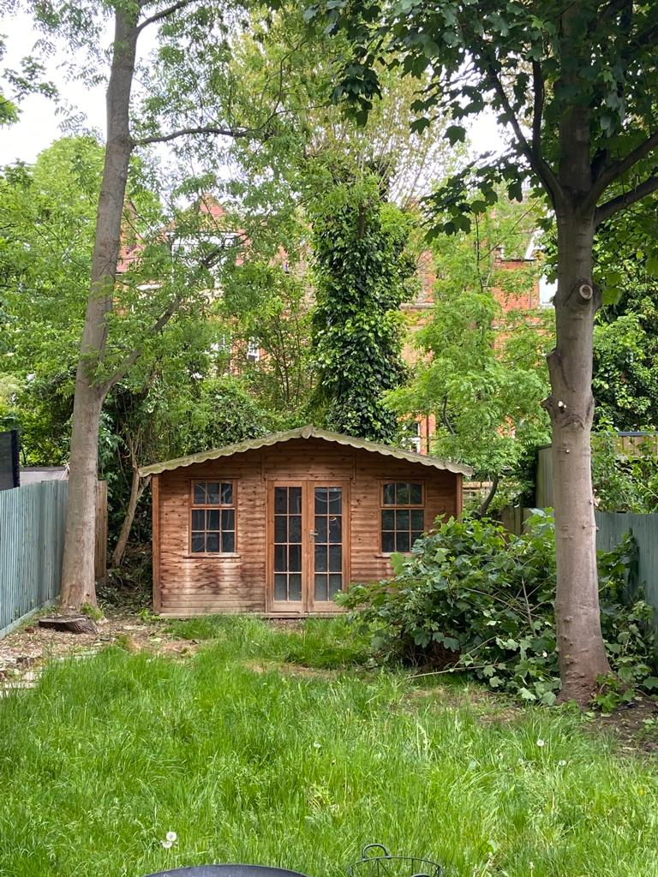IMAGE 2: Picture of old shed

IMAGE 3: Floor plan of flat 17aDiagram

Description automatically generated