Illuminating Sir John Soane’s Museum: Heritage Statement
1. Introduction
This document forms part of the planning application for Illuminating Sir John Soane’s Museum, a project to commission contemporary artist Nayan Kulkarni to create a light work which will illuminate the Museum’s façade in the evenings for approximately four months, from early October 2023 to late January 2024. This will involve the erection of colour-changing LED high precision waterproof theatrical profile lights installed three to four metres above ground level on two lighting poles in Lincoln's Inn Fields, opposite the Museum.
2. Background to project
Sir John Soane’s Museum hosts an inspiring programme of historic and contemporary exhibitions which highlight the continuing importance of Soane, his legacy and Georgian architecture more widely. This exhibition programme aims to engage new audiences with these themes and one element of this involves commissioning contemporary artists to engage with Soane and his work. This installation forms an element of the Museum’s contemporary exhibitions programme and complements the historic exhibition Georgian Illuminations at Sir John Soane’s Museum.
Georgian Illuminations (opening October 2023) will focus on the spectacular illuminations which were popular in the Georgian period. It will concentrate on the light shows themselves and the impressive and elaborate temporary architectural structures created for them, often by leading architects and artists including Soane himself. The exhibition will include loaned objects from the V&A and Royal Collection as well as items from the collection of Sir John Soane’s Museum, including Soane’s own designs for illuminating buildings. Nayan Kulkarni’s light work will provide a contemporary interpretation of these Georgian illuminations. It will engage both audiences who are likely to visit Sir John Soane’s Museum and those who may not.
3. Statement of Historical Significance
This proposal consists of the erection of two 4m-high lighting poles in Lincoln’s Inn Fields, which will be used to light the façade of No. 13 Lincoln’s Inn Fields.

The Façade of no. 13 Lincoln’s Inn Fields

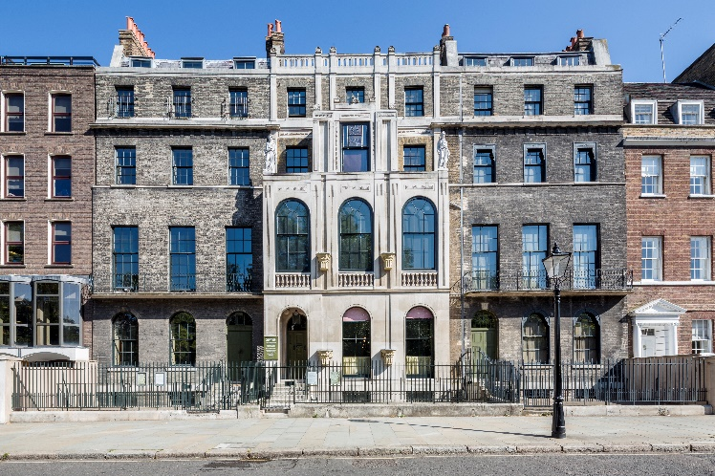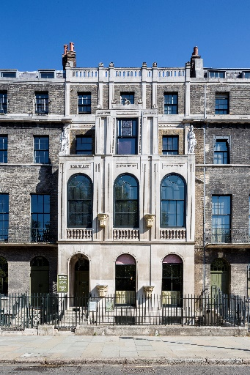

Sir John Soane is a key figure in the history of British architecture, often described as the ‘father of the architectural profession’ and his work still provides inspiration for architects across the world. His architectural style is characterised by its clean lines, simple form and massing, and use of light.

Soane bought No.13 Lincoln’s Inn Fields in 1807 and demolished and rebuilt it in two phases, in 1807–09 and 1812. In 1807–09 he constructed a ‘museum’ for plaster casts and antiquities at the rear of No. 13, linked to his existing house No. 12. In 1812 he decided to take over the whole of No. 13 as it was much larger. He then demolished the front part of No. 13 and rebuilt it.

The façade is of brick and Portland stone, the stone portion consisting of a ‘verandah’ projecting in front of the building line. This was originally open but the openings were glazed by Soane in 1829 and 1834, when the verandah became part of the internal space. The top storey of No.13 was originally a rear garret with a slated mansard roof at the front. In 1825 Soane raised the front façade to turn this into a complete extra floor, an addition that considerably altered the proportions of the façade. At second-floor-level are two figures in Coade Stone, free versions of the caryatids at the Erectheion in Athens. The Gothic pedestals built into the piers, between the windows, come from the 14th-century north front of Westminster Hall. The façade acts as an eye-catcher for anyone entering Lincoln’s Inn Fields from either the north-west or north-east corner and its caryatids and Gothic embellishments advertised Soane in his own day as an antiquarian, a collector and an architect familiar with the ancient world.

13 Lincoln’s Inn Fields is a Grade I listed building and therefore of outstanding architectural and historic interest. It is a fine example of Regency domestic architecture in London, that survives relatively unchanged. The building gains an extra level of significance because it is so well documented through Soane’s drawings and papers. Nos 12, 13 and 14 Lincoln’s Inn Fields are the only surviving examples of complete Soane townhouses.

Lincoln’s Inn Fields

The Museum fronts on to Lincoln’s Inn Fields, the largest garden square in London. The Fields provided Soane with a perfect setting for his house, in terms of delightful vistas of greenery and trees, and of St Paul’s, which he could see from his second-floor loggia before London’s skyline changed. He erected the façade of the Museum, in its projecting form, to be a picturesque eye-catcher in the Fields, directly opposite to George Dance’s Royal College of Surgeons.

Lincoln’s Inn Fields originally consisted of three open fields, used by the citizens of London for walking, sports (including jousting) and occasionally executions. In 1734 the residents of the square applied for an Act of Parliament enabling them to raise money to enclose the square, keep it clean and ‘adorn’ it. They appointed a Scavenger to collect the rubbish, installed iron railings, laid out a garden, installed lighting and appointed a Watchman. John Soane became a Trustee almost as soon as he moved into No.12 in 1794; he was later elected on to a small sub-committee and given responsibility for the pavement and the enclosure.

Gradually the care of the area, including policing and rubbish collection, was taken over by other bodies. After pressure to allow the public into the garden, an Act of 1894 handed responsibility to the London County Council and compensated the Trustees. For a long period prior to 1894 the Fields had been private. In the Act the Trustees give up their private space and the Fields become public with protective provisions. The Act aims to protect the distinctive character of the Fields and to protect the environment for those who live and work around the green space – in particular the quiet studious nature of a legal and learning environment. This use-pattern continues today.

The Fields have remained open space, despite several attempts to build on them including a scheme for new law courts. In the 1990s problems with the large number of homeless people using the square led to the replacement of the railings that had been removed in 1941 and the gardens are now locked at night. Recently the Friends of Lincoln’s Inn Fields (FLIF) was formed to campaign for the continued protection and enhancement of the square.

Sources:

Dorey, Helen, ‘12-14 Lincoln’s Inn Fields’ in Margaret Richardson and Mary Anne Stevens (eds.), John Soane Architect: Master of Space and Light, Royal Academy of Arts, London, 1999, pp.150-173
English Heritage, Official List Entry 1379327, Sir John Soane’s Museum, 12, 13 & 14 Lincoln’s Inn Fields WC2A 3BP: https://historicengland.org.uk/listing/the-list/list-entry/1379327?section=official-list-entry [accessed 20.06.2022]
Palmer, S., ‘From fields to gardens: the management of Lincoln’s Inn Fields in the eighteenth & nineteenth centuries’. The London Gardener. 10, 2004:10-27
Palmer, S. ‘Lincoln’s Inn Fields Part II: The Management of the Gardens in the Twentieth Century’ in The London Gardener. 12, 2006: 54-67
Sir John Soane’s Museum: A Complete Description, Sir John Soane’s Museum, London, 2018
Sir John Soane’s Museum Conservation Management Plan 2008, available upon request

4. Heritage impact statement
The façade of No. 13 Lincoln’s Inn Fields will be lit in the evenings only for a period of between three and four months. The installation will employ subtly changing coloured lighting based on light effects used by Soane in the Museum and other buildings he designed. The temporary nature of this installation means that there will be no lasting impact on the façade of No.13 Lincoln’s Inn Fields and Lincoln’s Inn Fields. During its display period, the light work will serve to highlight the features of the historic architecture in a way consistent with Soane’s own schemes to illuminate the buildings he designed, evidence for which exists in the Museum’s drawings collection. This scheme will draw attention to the building and its architectural features, encouraging existing and new audiences to engage with it and visit the Museum itself.
This installation is therefore considered to have a temporary, positive impact on the appearance and significance of the historic building and will have no permanent impact.
5. Justification and Mitigation
Nayan Kulkarni will spend the next twelve months visiting the Museum, observing the dramatic and changing light effects which were a hallmark of Soane's architectural style. This research will then inform the changing light effects used to illuminate the Museum's façade in autumn / winter 2023/4. As such, the illumination will be both sympathetic to the historic site of the Museum and its surroundings, and a fitting demonstration of Soane's continuing legacy in inspiring contemporary artists, architects and designers. There will be no light spill and minimal movement (only caused by slowly changing light effects which mirror those seen inside the Museum). As such, we do not anticipate any negative or lasting visual impact on Sir John Soane’s Museum or the surrounding street scene.
In order to negate the negative visual impact of using a large temporary aluminium truss system with its requirements for secure temporary fencing and the threat of vandalism, we are proposing to use two flange-mounted black-painted 4m-tall heavy duty lighting poles. Once installed these will disappear into the tree foliage behind and have a minimal visual impact upon the street scene (see photographs below for location). This site has been selected as secure and discreet. This is an area of low footfall and so the installation will not impinge on park users. The bases for the poles will sit above ground and will be removed when the installation finishes. Consequently, there will be no impact on existing fauna or archaeology.

