35 Crediton Hill NW6 1HS

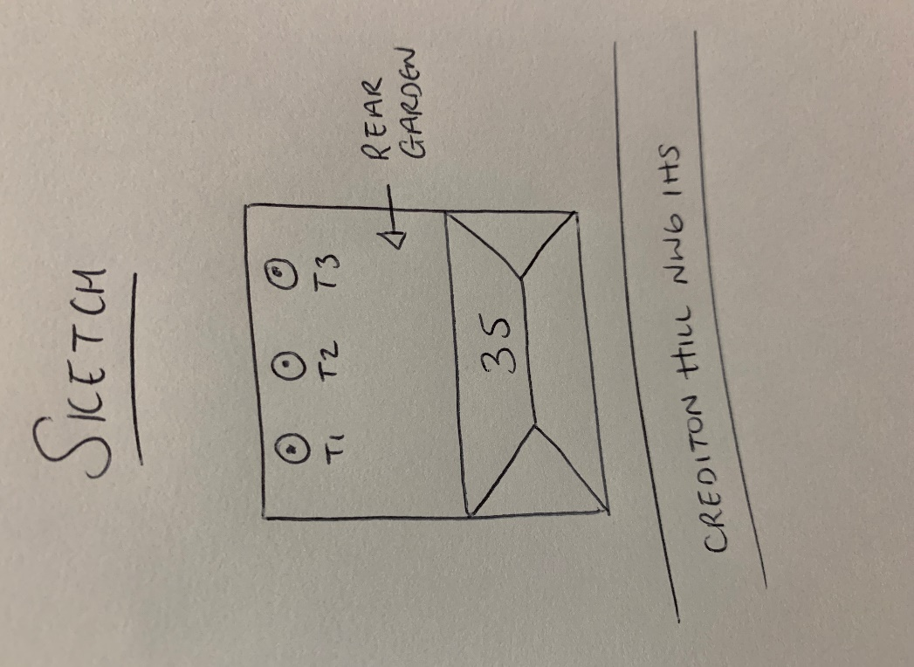

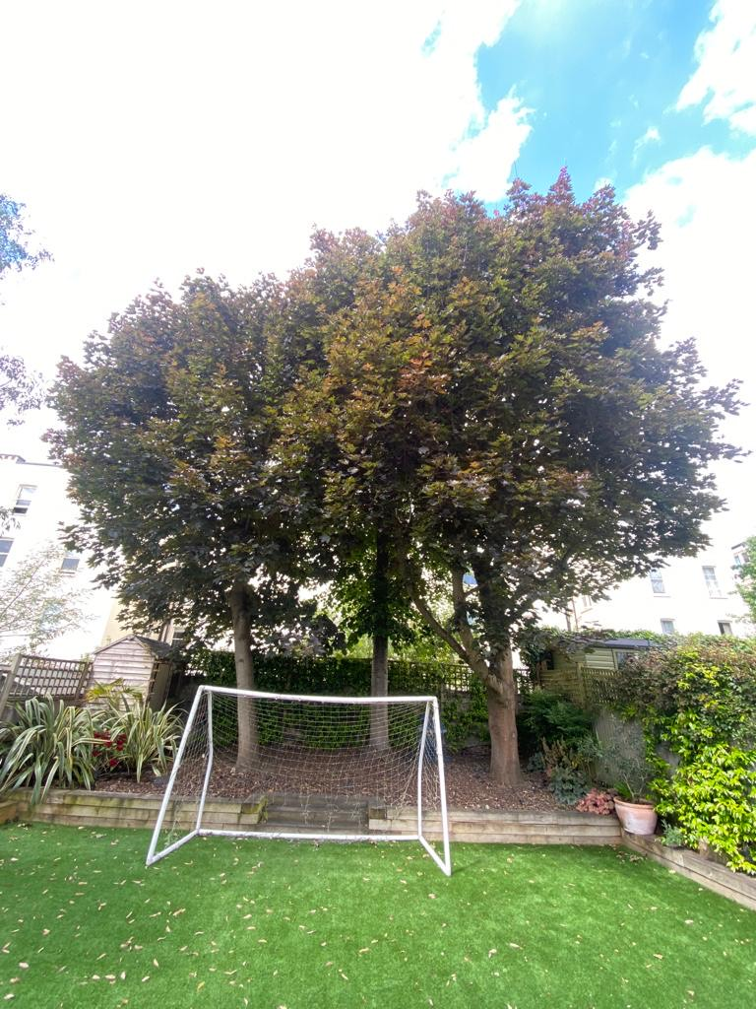

T1: Maple (10m): Crown reduce by up to 2m as part of regular maintenance and to keep tree at a size suitable for its location

T2: Lime (11m): Re-pollard to previous points removing up to 2.5m of regrowth as part of regular maintenance and to keep tree at a size suitable for its location

T3: Maple (12m): Crown reduce by up to 2m as part of regular maintenance and to keep tree at a size suitable for its location