REDINGTON FROGNAL ASSOCIATION
Umbrella body for residents’ groups in the Redington Frognal Conservation Area

17 June 2022

Dear Mr. Lawlor,

2022/1767/P Flat 2 12 Kidderpore Gardens - objection

Housing densities are at high levels within much of the Redington Frognal Conservation Area and development can have considerable impacts on neighbours.

While the pre-application adv ice appears to have considered the visual impact of constructing a first-floor terrace, it does not appear to have considered the intrusion to neighbouring habitable rooms in terms of noise =and disturbance.

Whereas the occupiers of adjoining flats currently have quiet enjoyment of the rear garden and a green outlook, this would be substituted by what would effectively be an outdoor room during fine weather.

New outdoor room adjoining kitchen-diner
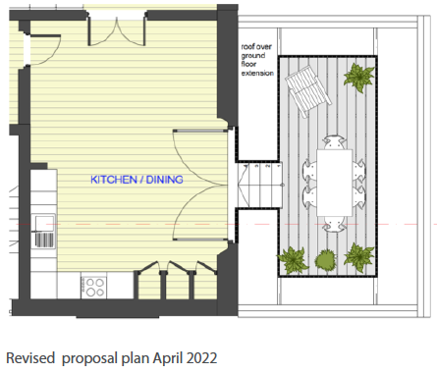

The loss of amenity occasioned to adjoining occupiers is very clear from the drawing below which forms part of the design and access statement.

Proximity of new outdoor room to adjoining habitable rooms at first and second-floor levels
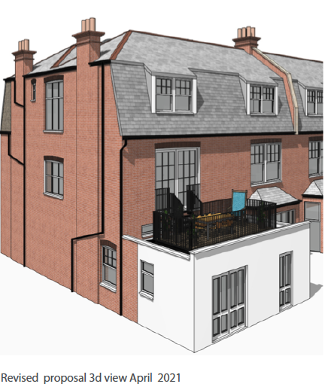

Terraces at first floor level are particularly problematic with considerable repercussions for the amenity of neighbours above and below and neighbours adjoining the proposed

terrace. In particular, the proposed extension would cause intrusion and noise to habitable rooms at Flats 1 and 3.

The proposal is therefore in conflict with Local Plan policy A1.

Yours sincerely,

Nancy Mayo

Secretary

Redington Frognal Association

http://www.redfrogassociation.org

